Foster carer recruitment campaign

Toolkit for foster and kinship carer agencies
The advertising campaign — We need more foster carers, like you — continues during 2024, featuring a series of advertisements and videos that share the stories of real foster carers. It includes carers from all walks of life including single, married or in de-facto relationships, and with or without their own biological children. These carers provide authentic and useful insights about what it’s like to be a foster carer.

The statewide advertising campaign will be broadcast across a range of channels, including free-to-air TV, catch-up TV and social media during April-May 2024. This is complemented by always-on digital advertisements, which will appear continuously during the year on various channels including YouTube, Yahoo and Google. Advertisements will also appear in Koori-Mail and QNews.

People who are interested in becoming a foster carer are encouraged to visit the website at www.qld.gov.au/fostercare, where they can view the stories of the carers, learn more about foster care and submit an expression of interest, or contact Queensland Foster and Kinship Care on 1300 550 877.

The department will be regularly publishing foster care content on its social media channels should you wish to share these posts on your own channels. Departmental channels include:
- Facebook: Child and Family Queensland — www.facebook.com/childfamilyqld
- LinkedIn: Department of Child Safety, Seniors and Disability Services — www.linkedin.com/company/dcyjma

This toolkit includes YouTube links to the foster carer videos and social media tiles and content to support you with your own foster care promotions. Tips on how to use the social media tiles are also provided.

For further information about the campaign, please contact:

Elizabeth Millsteed
Ph: 3097 6459
elizabeth.millsteed@cyjma.qld.gov.au

General social media content
Images are available to download at https://www.dcssds.qld.gov.au/campaign/foster-care-recruitment/resources
Facebook

Foster carers come from all walks of life, but no matter who they are, they all have one thing in common. Foster carers have a place in their heart for a child who needs support and understanding. Fostering starts with care. It’s not always easy, but training and support is available.

Fostering needs people with extraordinary hearts. People just like you.

Find out more about foster care, including the different types of care available and how to apply. Visit www.qld.gov.au/fostercare

X (formerly known as Twitter)
Foster carers come from all walks of life, but no matter who they are, they all have one thing in common. Foster carers have a place in their heart for a child who needs support and understanding. Find out more www.qld.gov.au/fostercare.

Real foster carer social media content, images and YouTube links
All images below are available to download at https://www.dcssds.qld.gov.au/campaign/foster-care-recruitment/resources
When using the below posts, it is requested that you be extra vigilant with social media moderation so that the carers are not subject to any racist or derogatory remarks.
Melissa and Scott  Having started their foster care journey many years ago, the addition of even more kids around the house has become second nature to Melissa and Scott and their biological children.  To find out more about becoming a foster carer, visit <insert agency website>.  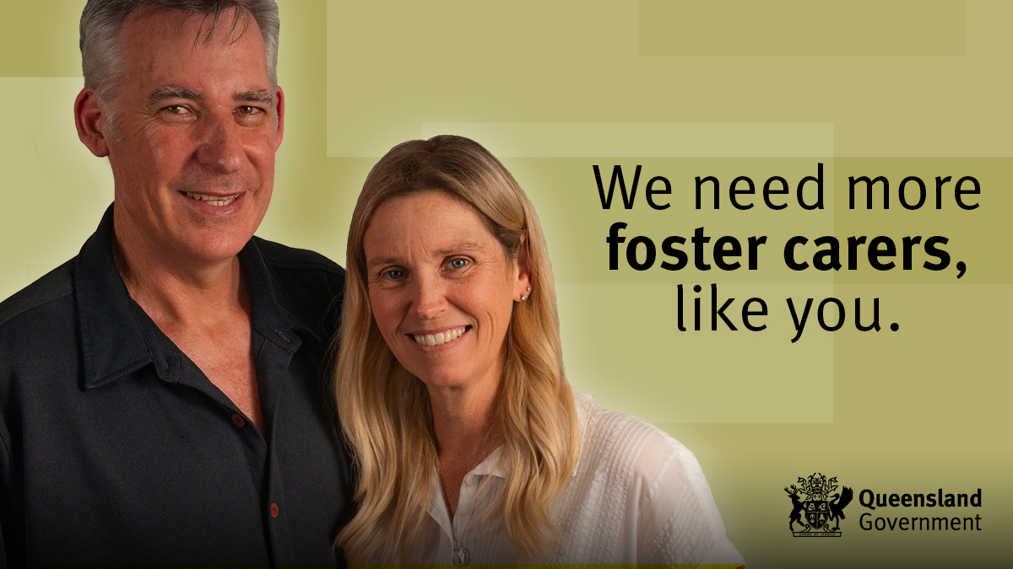  https://youtu.be/OPRD7AJdBEA | Lou and Amelia  Lou and Amelia started fostering as a way of experiencing caring for a child. While taking the first step was daunting at first, they’ve discovered the journey has brought reward and self-discovery.  To find out more about becoming a foster carer, visit <insert agency website>.  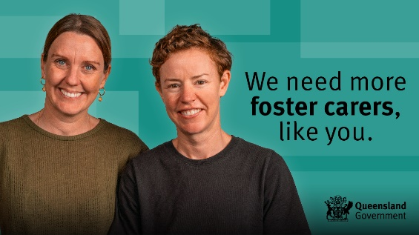  https://youtu.be/DnsqgWrntgk
Tahnee and Shailen  Tahnee and Shailen started fostering after being inspired by their friends. They’re now determined to improve the lives of as many children as they can.  To find out more about becoming a foster carer, visit <insert agency website>.  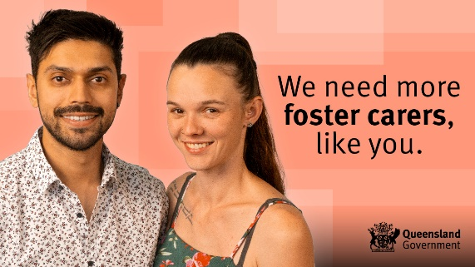  https://youtu.be/vLHEV8BIMCA | Jodie  Jodie's first experience of caring for a child melted her heart. Since then she's fostered as many children as possible, grateful for the opportunity to give them care, even for a short period of time.  To find out more about becoming a foster carer, visit <insert agency website>.  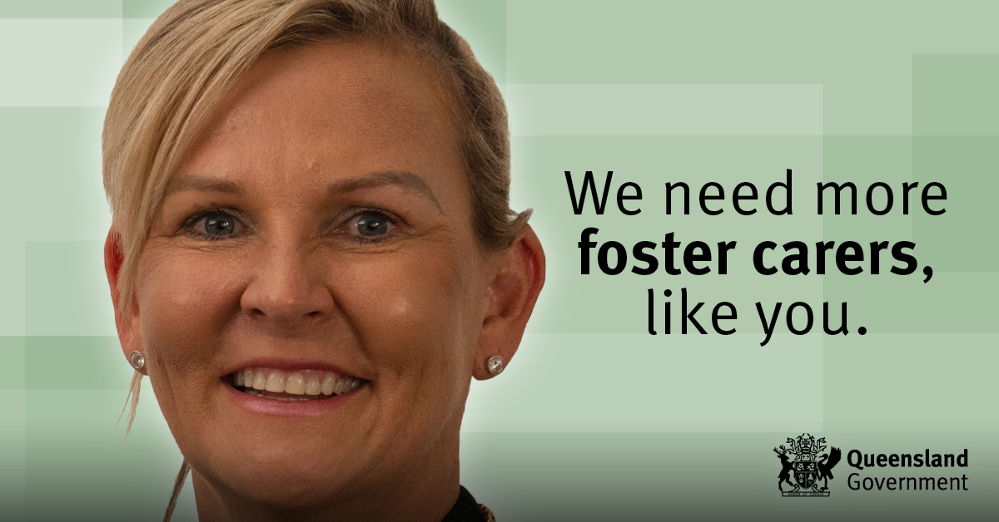  https://youtu.be/nAczElC4lZY
Sandra and Rick  Sandra and Rick had been married for 15 years with two beautiful children of their own when they decided to open their home to kids in need.  To find out more about becoming a foster carer, visit <insert agency website>.  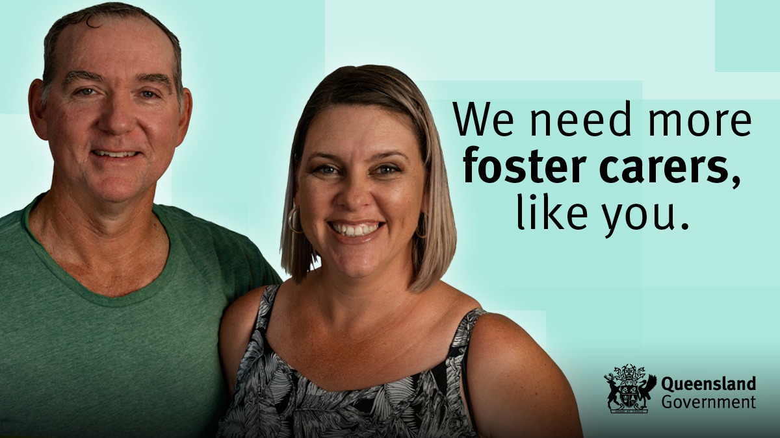https://youtu.be/KMeAyMU-2ec | Uncle Allan and Cheryl  Having been caring for Indigenous and non-Indigenous children for more than 20 years, Uncle Allan and Cheryl know it doesn't matter what age you are — foster caring is a life experience like no other.  To find out more about becoming a foster carer, visit <insert agency website>.  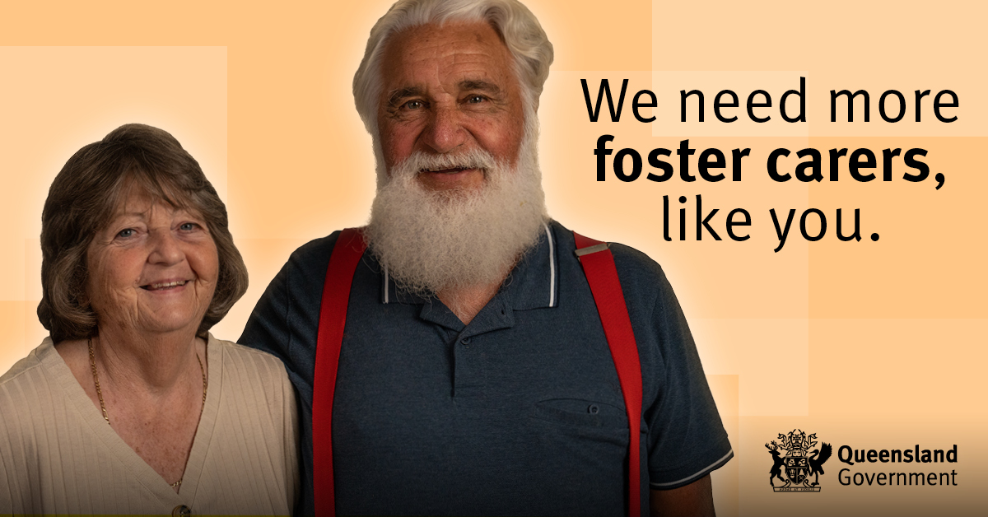  https://youtu.be/9SvFSZjryVI
Debbie and Steve  In addition to raising five children of their own, Debbie and Steve have been fostering for over 20 years. They say it's about opening up your heart and home to children in need and doing the best you can.  To find out more about becoming a foster carer, visit <insert agency website>.  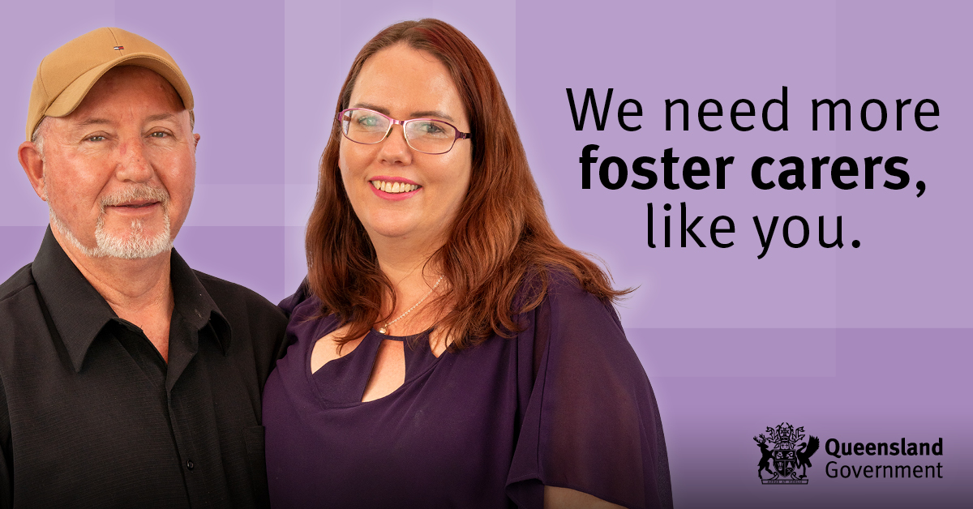  https://youtu.be/5mHXhjiwrV0 | Justin  Nothing prepared Justin for the emotional satisfaction of being able to give children in need a safe and happy space to call home.  To find out more about becoming a foster carer, visit <insert agency website>.  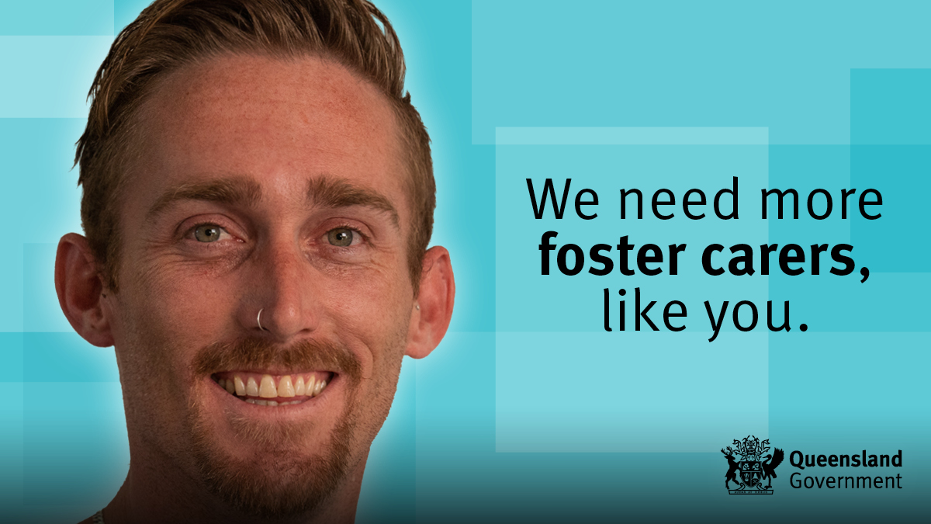https://youtu.be/zvKKBaFiig8
Karyn and Ron  When Ron met Karyn, he saw the amazing difference she was making in children's lives and was inspired to get involved. Now neither can imagine their lives any differently.  To find out more about becoming a foster carer, visit <insert agency website>.  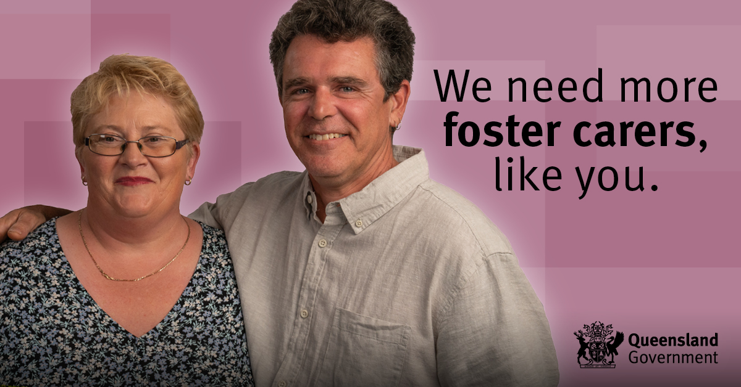  https://youtu.be/oRoXq6q1yC4 | Aunty Karmen  After receiving help when she was younger, Aunty Karmen was determined to give back through fostering. Now she proudly ensures the First Nations children she cares for maintain a connection to their culture.  To find out more about becoming a foster carer, visit <insert agency website>.  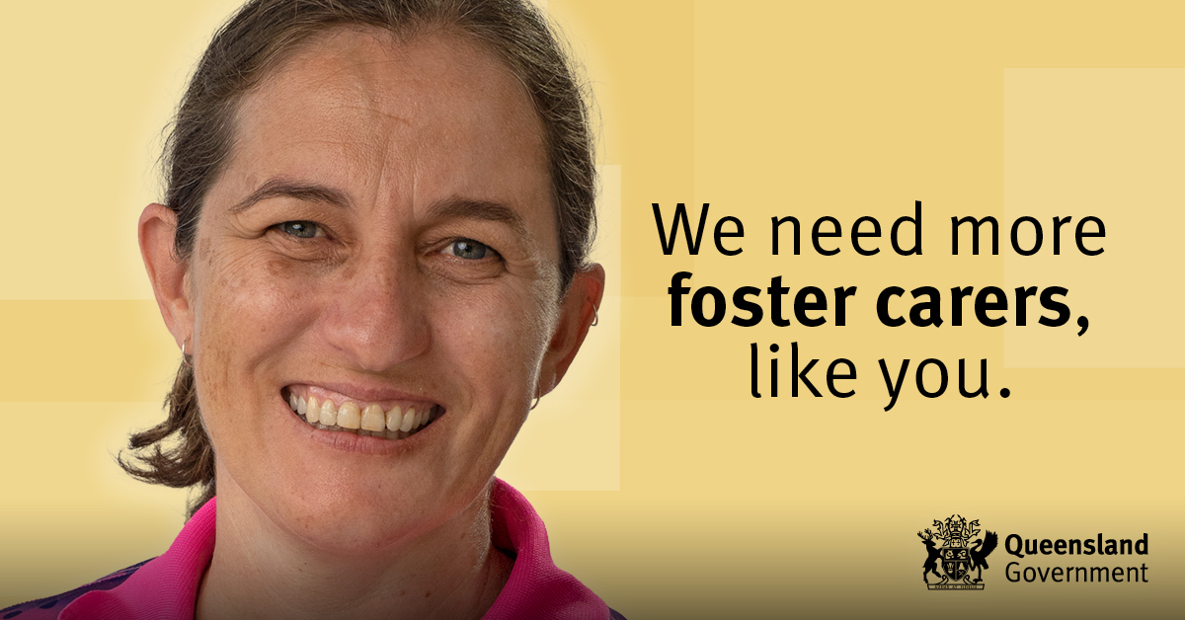https://youtu.be/YtB5BKDIzHI
Joy and Anthony
After welcoming a teenager into their home for the weekend 16 years ago, Joy and Anthony knew their lives would take on a new path.

To find out more about becoming a foster carer, visit <insert agency website>.

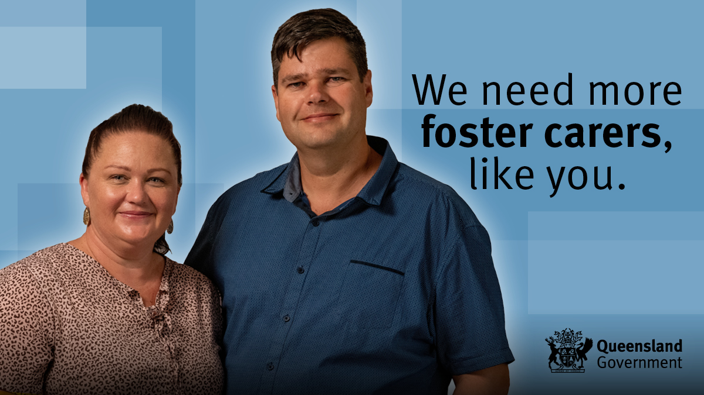
https://youtu.be/qneydKwALRk

YouTube playlist
This playlist includes all foster carer videos https://youtube.com/playlist?list=PL2_9nQkgOf0u6nyrpaoNux_fO0QodWZ2a

Additional content
Below is some additional content to educate and address some of the common barriers to fostering.

Images are available to download at https://www.dcssds.qld.gov.au/campaign/foster-care-recruitment/resources

Post 1: Top questions – couples

Do you have to be married to be a foster carer?
Can same-sex couples apply?
Can you still be a foster carer if you work full-time?
What if you already have kids?
We’ve answered your top questions about foster caring to help you work out if it’s right for you.
https://www.qld.gov.au/community/caring-child/foster-kinship-care/foster-kinship-care-become-a-carer/foster-kinship-care-top-questions

Post 2: Top questions – singles

Can you be a foster carer if you live alone?

What if you work full-time?

Do you need to have a big house?
What training and support is there?
We’ve answered your top questions about foster caring to help you work out if it’s right for you.
https://www.qld.gov.au/community/caring-child/foster-kinship-care/foster-kinship-care-become-a-carer/foster-kinship-care-top-questions

Post 3: Short breaks care

Interested in fostering but can’t commit to full-time care right now? Some carers provide short breaks for other long-term foster carers.
These carers choose when they provide care, such as on weekends or during school holidays. Short breaks carers also give children in care an opportunity to extend their support network.
Many new carers start out providing short breaks and then choose to become full-time foster carers after gaining some experience.
If short breaks care could be right for your family, find out more about becoming a foster carer by visiting www.qld.gov.au/fostercare.

Share our posts
Alternatively, you can share these Facebook posts:

- Short breaks care
- Types of foster care
- Top questions about foster care – same-sex couple
- Top questions about foster care – singles
- Top questions about foster care – house

Your agency can easily share these live Facebook posts and write your own introduction that includes your call to action and contact information.

Tips for using social media tiles and videos
- Whether you choose to share an image or share a video, you can use the content provided, or add your own call to action including your agency’s phone number and website.

- While we cannot supply the MP4 files for the videos, you can share the videos directly to your Facebook page from our Facebook playlist.
- You can also embed the YouTube videos or YouTube playlist on your agency’s website.

