A Roadmap for Residential Care in Queensland

Acknowledgement
We respectfully acknowledge the Aboriginal and Torres Strait Islander peoples in the state of Queensland.
We acknowledge the cultural and spiritual connection that Aboriginal peoples and Torres Strait Islander peoples have with the land and sea.
We respectfully acknowledge Aboriginal peoples and Torres Strait Islander peoples as two unique and diverse peoples with their own rich and distinct cultures.
We pay our respects to Elders past and present as well as the existing and emerging leaders who walk together in partnership on this journey.
The Roadmap for Residential Care in Queensland represents a collective commitment to supporting the unique needs and aspirations of Aboriginal and Torres Strait Islander peoples within care settings.

Contents

Minister’s message …………………………………………………………………….…………….……..4
Where are we and how did we get here? .………………………………………………………..………5
How did we undertake the review?…......………………………………………………………..…..……6
What does the data say? ……………………………………………………………………………..…….6
Where do we need to get to and how will we get there? ……………………………………..…………7
Domains for change ………………………………………….……………………………….…...………..8
- Listening to children and young people ………………………………………..…………………9
- Establishing the right care models …………………………………………….…………………11
- Keeping families together and connected ………………………………………………………13
- Culturally led responses for Aboriginal and Torres Strait Islander children and families ….15
- Improving support for kin and foster carers …………………………………………………….17
- Our workforce ……………………………………………………………………………………...19

Governance and accountability …………………………………………………………………………..21
Appendix 1: Terms of Reference – Queensland Residential Care Review ….………………………22

Minister’s message
All children and young people deserve to be safe, nurtured and cared for. If they are unable to live with their own families, it is our responsibility to ensure they receive the best possible help and support so they may fulfill their potential and live their best lives.
In July 2023, I listened to the concerns raised by the community about the growing number of children and young people living in residential care and I requested a review of the residential care system in Queensland to determine whether these care arrangements are suitable for meeting their needs.
The purpose of this review was to assess the effectiveness and quality of residential care services, identify areas for improvement, and ensure that the necessary support and resources were in place to meet the safety and wellbeing needs of children and young people in our care.
The review aimed to identify opportunities to reduce the number of children and young people placed in residential care with a priority to keeping them with family wherever possible, or if they couldn’t be with their own family, that they be placed in family-based care. For the small number of children and young people for whom residential care is the most appropriate care arrangement, I want to ensure their needs are met by a sustainable, flexible and caring system.
A series of regional forums and workshops were undertaken to engage stakeholders and provide an opportunity to inform and shape the review and its outcomes. I also hosted a Roundtable to hear directly from a broad range of experts about what was working well and where there were opportunities for improvements. By bringing together stakeholders from various sectors, including disability care, child protection, family support and transition services, a wide range of expertise and insights were harnessed to inform the development of the Roadmap for Residential Care in Queensland.
The roadmap addresses the systemic issues identified from these regional engagement sessions and provides a number of actions to improve and strengthen the delivery of residential care services for Queensland children and young people.
I wish to acknowledge Mr Luke Twyford, Principal Commissioner, Queensland Family and Child Commission (QFCC) for his important role in overseeing the review, and our partners PeakCare Queensland, the Queensland Aboriginal and Torres Strait Islander Child Protection Peak (QATSCIPP) and Queensland Foster and Kinship Care (QFKC) for their valuable input and support.
I also wish to thank the young people who shared their experiences in residential care. We would not be able to make the changes we need to make without hearing first-hand from young people who have experienced life in residential care. Your voices are crucial in shaping the future of care for children and young people.
The Hon Craig Crawford MP
Minister for Child Safety
Minister for Seniors and Disability Services

Where are we and how did we get here?
When children are unable to be safely cared for by their family and do not have a parent willing and able to protect them from harm, the Department of Child Safety, Seniors and Disability Services, on behalf of the Queensland Government, is responsible for providing alternative care arrangements.
Queensland is not unique – like all other jurisdictions, over the past few years, changing family and social circumstances have resulted in significant demand pressure on the child protection and family support systems. Families are facing increasingly complex challenges including the social and economic impacts of COVID-19, complex mental health needs, the impact of domestic and family violence, cost-of-living pressures and ongoing housing and rental market constraints. The child protection and family support systems are also impacted by the workforce availability issues affecting the entire human services sector across the country.
In Queensland, the number of children in care overall has continued to grow, particularly during the COVID-19 pandemic, largely attributable to the growth in the rate of Aboriginal and Torres Strait Islander children in care. This growth is putting pressure on all parts of the system, but particularly the placement system. The 2023 Report on Government Services reported that compared to other jurisdictions, at 30 June 2022, Queensland had the highest number of children and young people in residential care.
The department is committed to addressing the drivers of overrepresentation of Aboriginal and Torres Strait Islander children in the child protection system and increasing the use of family-based care, which is the most suitable arrangement for most children. The department is already undertaking placement reform, working to increase the number of children cared for by kin and decrease the number of children living in residential care. The sustained placement reform efforts, while early in their implementation, are resulting in an overall decrease in the use of residential care and an increase in the use of kinship care. The department will continue focus on these reforms over the coming years.
The review of the residential care system in Queensland provided an opportunity to reflect on what we are already doing and hear from our stakeholders about what more needs to be done to create a flexible and sustainable care system that meets the needs of children, young people, families and communities.
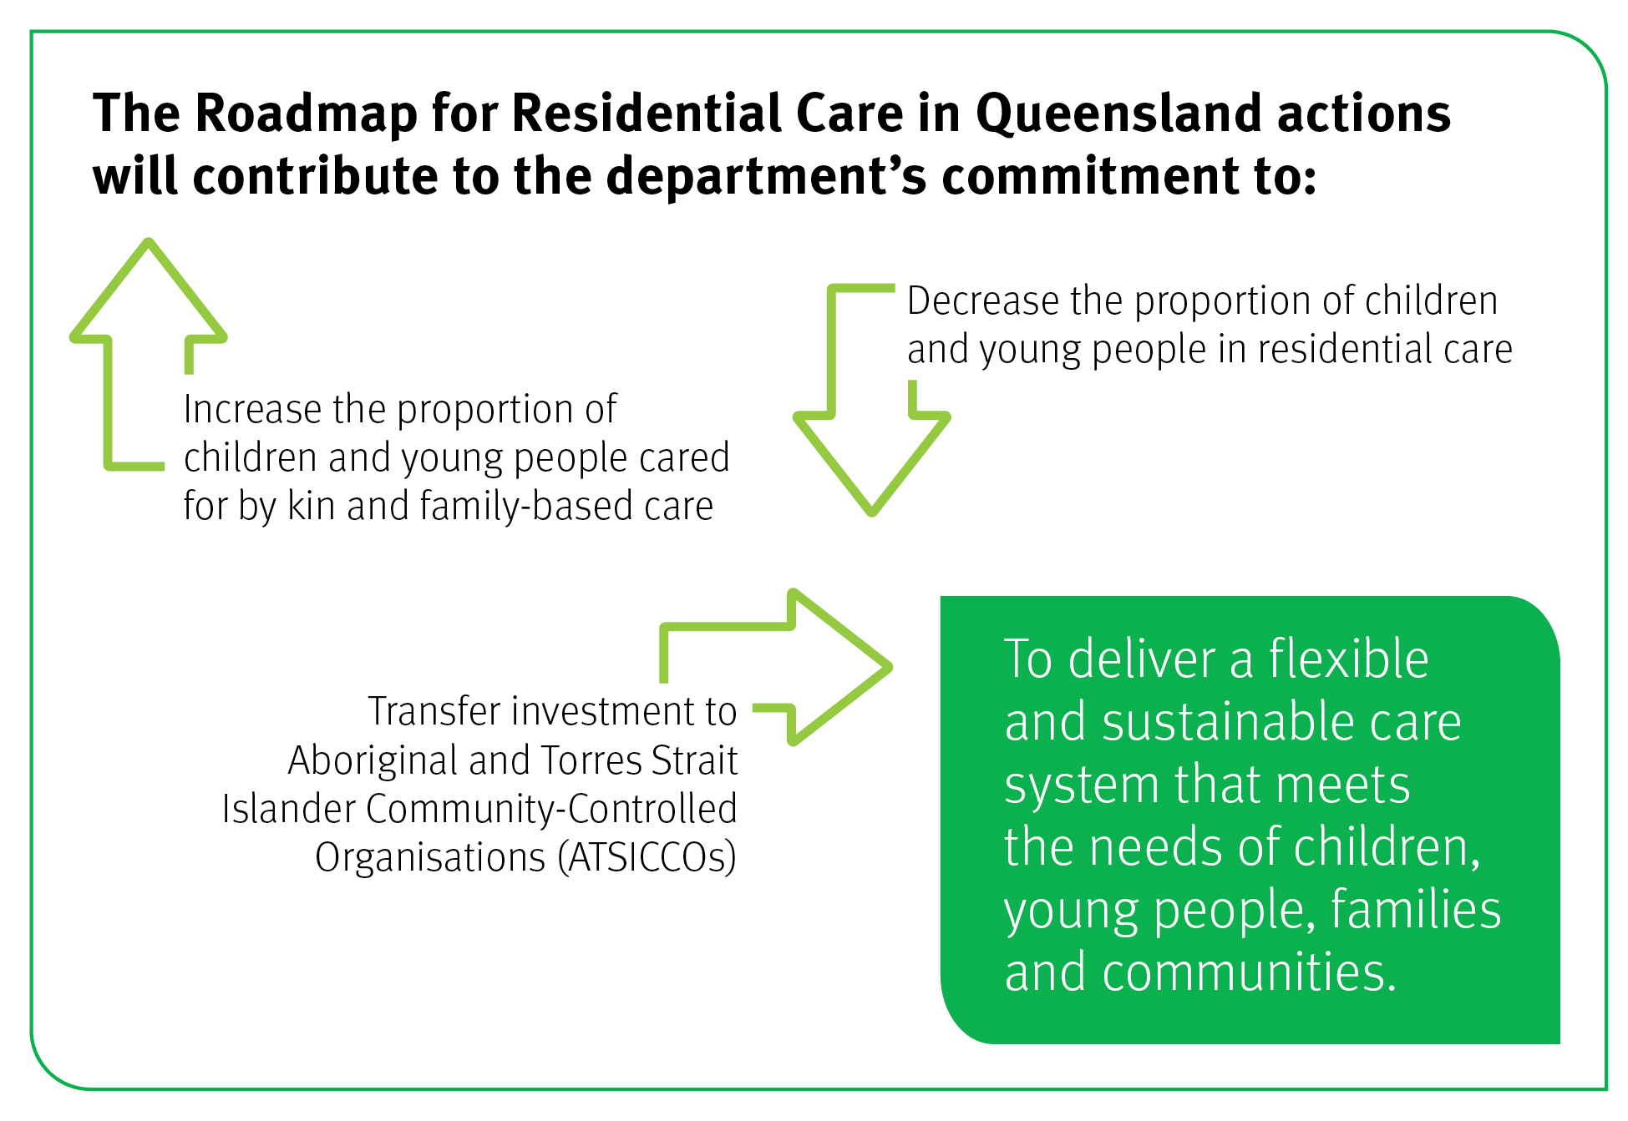

How did we undertake the review?
Over the past five months, we listened to more than 800 stakeholders and experts to understand how the residential care service system is working and to identify further areas for improvement. Those areas for improvement make up the roadmap’s actions.
Figure 1: Summary of consultation and engagement activities

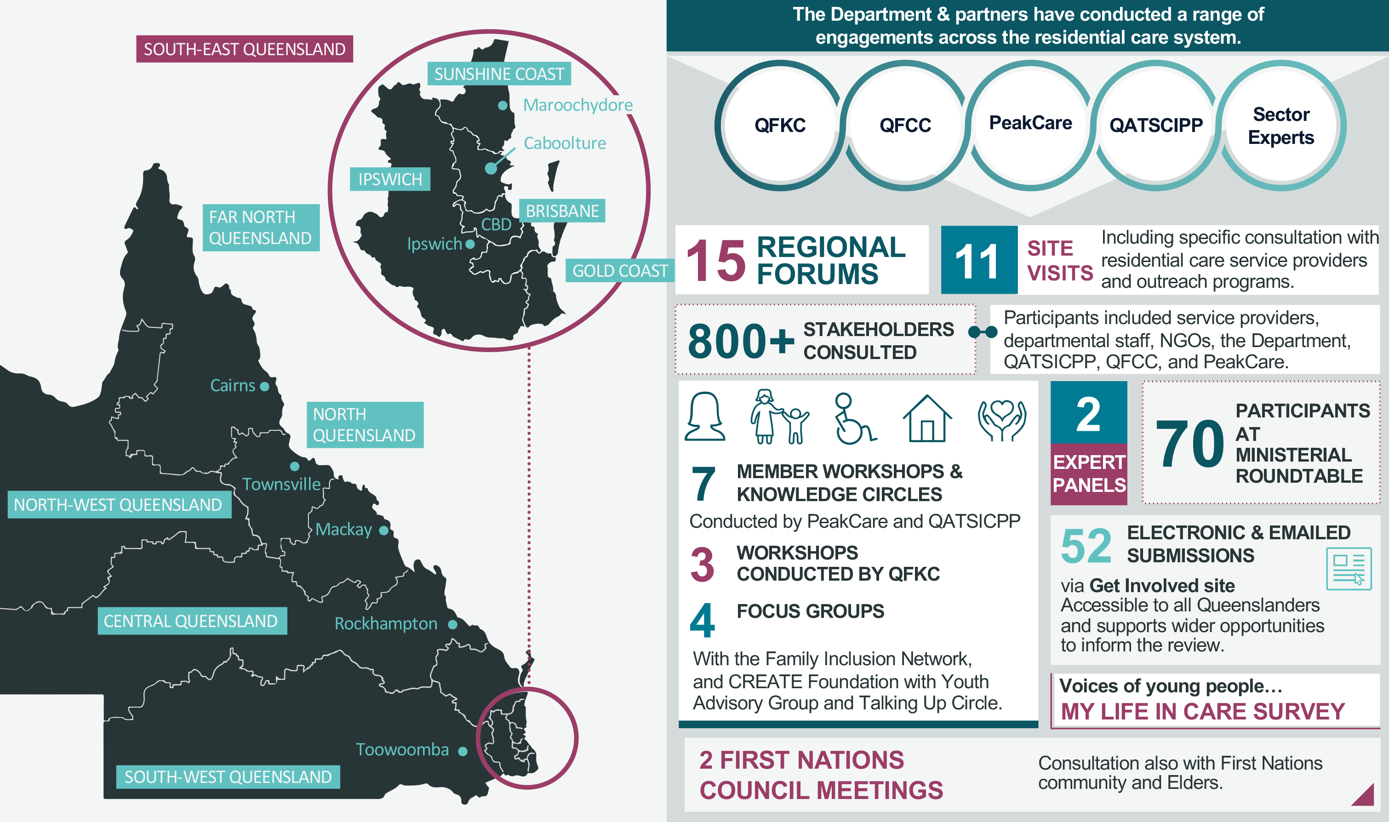

What does the data say?
At 30 June 2023, there were 11,593 children and young people in care in Queensland. As mentioned previously, the number of children and young people requiring care has increased significantly in the past few years, up from 9647 at 30 June 2019.
The increasing pressure this demand has placed on the foster and kinship care system, has resulted in a corresponding increase in reliance on residential care. At 30 June 2019, 951 children and young people were cared for by residential care services. By 30 June 2023, this number had almost doubled to 1763, with 747 of these children and young people identifying as Aboriginal and/or Torres Strait Islander.
The needs of children and young people living in residential care are different to the needs of children and young people living in family-based care. Children and young people in residential care are more likely to experience significant disability or mental health concerns; have experienced physical and/or sexual abuse; and be disconnected from pro-social relationships, including families and school.
Of the children and young people living in residential care arrangements, 30 per cent have a National Disability Insurance Scheme (NDIS) plan.
This data helps us understand the need to identify and develop a culturally responsive, flexible and sustainable suite of care arrangements to meet the needs of children and young people who are unable to safely live with their parents.
As mentioned, significant work is already underway to find family-based care for children and young people, particularly with kin. Since 30 June 2019, the number of children and young people placed with kin has increased by 1339, growing from 44.1 per cent of children and young people in care to 48.2 per cent, the highest on record. Work continues on finding, assessing and supporting kin to care for more children and young people.

Where do we need to get to and how will we get there?
The Queensland Government has carefully considered the role and use of residential care arrangements. This recognises that residential care arrangements offer a skilled workforce together with accommodation, which provides a safe and supported environment for children.
Criticisms of residential care centre on its appropriateness as a way of caring for children and young people in fundamental ways such as offering belonging, connection and a sense of home.
We have already started responding to some of the things we have heard – for example, following concerns raised at a regional consultation, one region has commenced a comprehensive analysis of educational attendance for children and young people in residential care in partnership with the Department of Education and local care providers. This reflects our strong commitment to review and improve attendance for all children and young people in residential care, including to reduce exclusions, suspensions and the use of managed attendance.
This roadmap will help us create a sustainable and contemporary model of residential care that exists within a suite of care arrangements, including foster and kinship care, that together meet the needs of children and young people. A system characterised by:
- processes that listen to the voices of children and young people in care
- the right mix of support and services to meet the individual needs and aspirations of children, young people and families
- families that are kept safe, together and connected
- the five elements of the Aboriginal and Torres Strait Islander Child Placement Principle (ATSICPP), being embedded and upheld to ensure culturally led responses for Aboriginal and Torres Strait Islander children, young people and families
- the specialist skill and care provided by kinship and foster carers, through appropriate supports
- a workforce that reflects the skills and expertise needed to not just provide accommodation for children and young people, but to respond to their unique circumstances and life experiences.

Domains for change
Figure 2: Domains for change

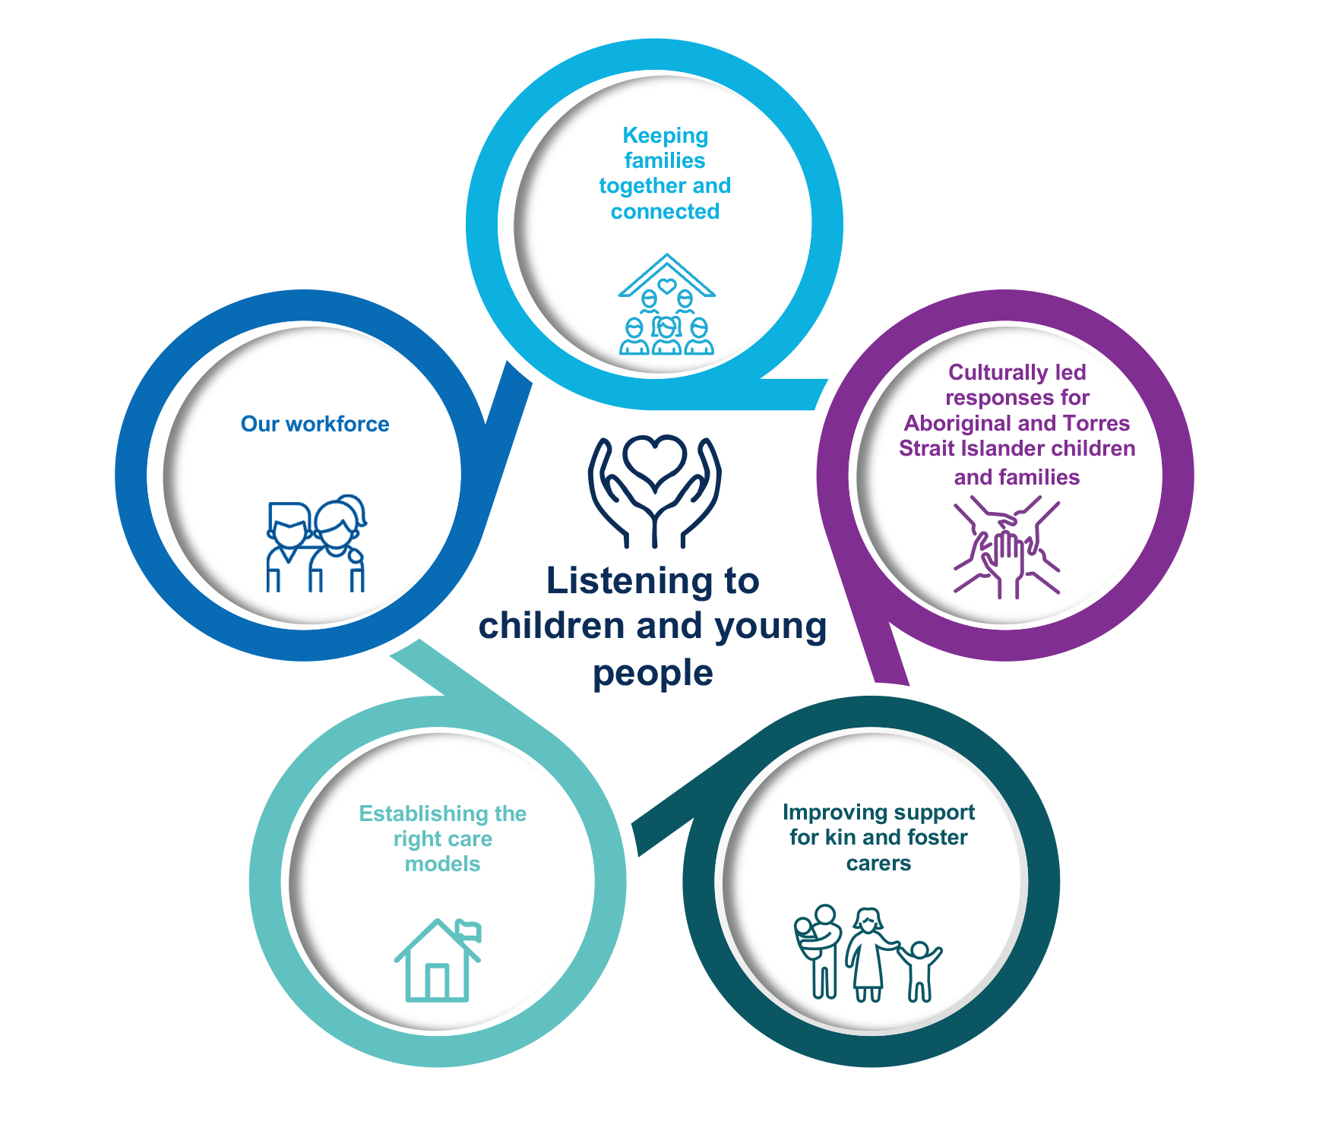

Listening to children and young people
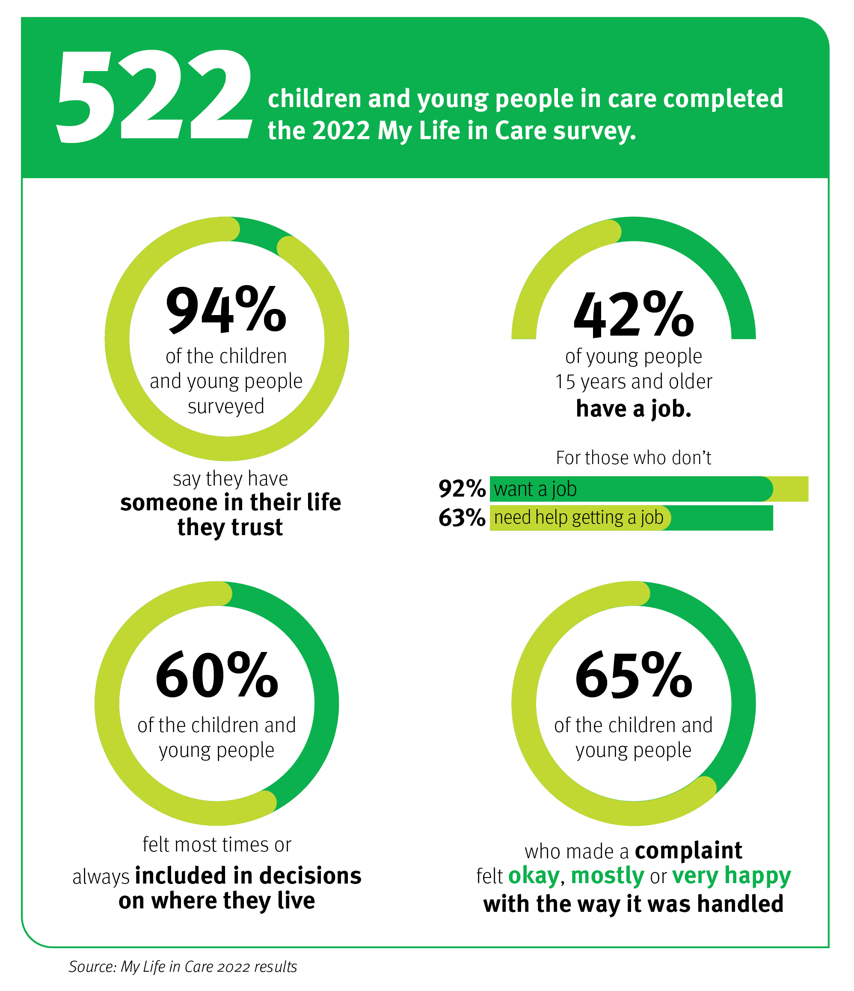

What we heard:
We heard more can be done to listen to the experiences of children and young people, to understand what matters, identify issues and fix them.
We need to focus on the voices of children and young people.
- Children and young people said they want to be involved in key decisions impacting their lives, like where they live, with whom, and how their home looks (including furniture and food).
- Children and young people want to try to learn new things and not to be excluded from playing and socialising with peers in safe environments.
- Children and young people need to have their complaints heard and taken seriously.
We can better share children and young people’s stories and identities.
- Children and young people want to know who they are and feel part of the community. Their identity, past, culture and connections are fundamentally important.
- Children and young people want to belong, they want the system to better recognise and support them to make their placement their home.
- Children and young people want to have critical information shared about them, at critical points.
We must recognise attachment and relationships as fundamental needs.
- It is important for children and young people to form relationships and connections with significant adults in their lives. Ideally this would be a person from their family or community who can nurture their connection to their history, culture and identity.
- Children and young people like having Community Visitors and want more access to them and other skilled professionals to help them navigate their experiences in care. They want more people to talk to about the quality of their care, their life, their needs and their wishes.

What we do now:
- Require an active case plan and cultural support plans for Aboriginal and Torres Strait Islander children to address the specific needs of every child and young person in our care.
- Partner with the CREATE Foundation to connect with and empower children and young people in care.
- Support children and young people to access independent advice and assistance through the Office of the Public Guardian’s Child Advocacy and Community Visitor programs.
- Gather and respond to the experiences of children and young people in care through the annual My Life in Care survey.
We are also:
- supporting improved practice to embed active efforts in the application of the ATSICPP for Aboriginal and Torres Strait Islander children and young people
- embedding in Queensland’s child protection legislation and practice the need for children and young people’s voices to be considered in decisions that affect them.

Next, we will:
Listening to children and young people
Action | Commence
Establish a Ministerial Youth Advisory Board to provide insights into children and young people’s experiences of care. | Year 1
Formalise the Queensland Family and Child Commission Expert Panel on Residential Care – comprising 12 young people with lived experience in the system as a governing body – to inform the Ministerial Youth Advisory Board, monitor the implementation of this roadmap, and hold regional forums that give young people in residential care opportunities to voice their experiences. | Year 1
Codesign a child-friendly complaints process to empower children and young people to give feedback and raise their concerns. | Year 1
Support young people having more choice about their environment, routine and experiences. | Year 1
Design and pilot a peer navigator initiative to increase peer support and connection for children and young people in residential care. | Year 2
Design and trial new baseline health, wellbeing and educational assessments for all children and young people entering residential care. | Year 3

Establishing the right care models
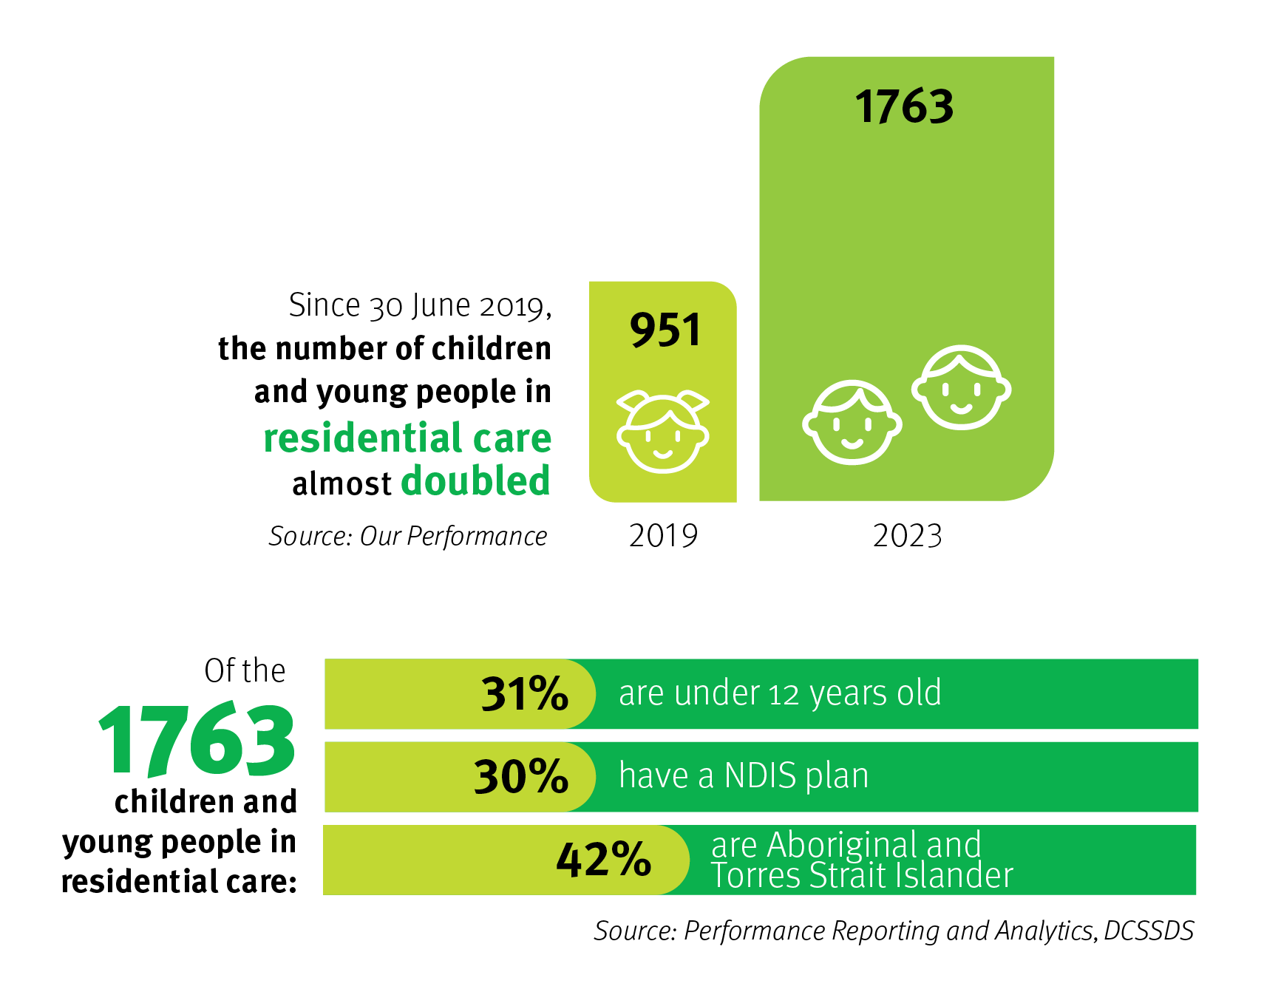

What we heard:
We need to adopt a flexible approach to residential care.
- Residential care is most effective when it can respond to the specific needs of each child.
- Children and young people with complex needs in residential care require specialist and therapeutic support in addition to placement support.
- Placement processes can be improved to better match the needs of children and young people in care.
- Each young person needs a trusted adult who is available to them.
- Commissioning models make it difficult for organisations to maintain stable care teams for children and young people.
We can improve service quality standards.
- Improving service quality standards will help to support the consistent provision of care for children and young people. We should review service standards to develop a revised quality approach centered around the safety and wellbeing of children and young people.
- Many children and young people are remaining in residential care when they were initially placed in residential care in an urgent situation. More frequent reviews can support more timely identification of appropriate models of care that best suit the needs and circumstances of children and young people.
- Young people said new standards and accountability were needed to ensure young people are treated as part of the home and included in planning and decision-making (including house rules, but also individual child case planning). Models of care need to remove institutional designs of ‘bed nights’ and replace these with ‘parenting approaches’, including:
  - support to access earning/learning opportunities
  - Organise holidays, activities, sleepovers, pets
  - being able to meet workers before moving in (placement matching)
  - graduated independence (planning for adulthood, also fostering independence in adolescence).
- There is confusion about who needs to make day-to-day decisions for young people in residential care, particularly in relation to ‘normal childhood activities’.
We should support children and young people using a multi-agency approach.
- The residential care sector does not sit in isolation of other care arrangements or departmental systems (e.g. early childhood, health, youth justice and education), community and family.
- We should adopt a multi-agency/entity approach. There is an opportunity to partner with other government departments to enable smoother transitions and planning for children and young people.
- Education is important particularly during key transitions and children want to remain with peer groups. We should ensure children remain engaged at school.
- Early health assessments for children and young people are important. We should focus on early intervention and assessment, including NDIS eligibility, for children and young people with disability, mental health and behavioural support needs.

What we do now:
- Invest in assertive outreach services to increase the safety, support and connection of young people disengaging from care.
- Test nontraditional models of residential care; a reunification house in Far North Queensland region, a family stay house in Sunshine Coast and Central region, a short-stay house in North Queensland region.
We will also:
- build our understanding of different models of care matched to need
- renegotiate the Memorandum of Understanding with Queensland Health for the delivery of Evolve Therapeutic Services.

Next, we will:
Establishing the right care models
Action | Commence
Trial new models of residential care and build an evidence base of what works to meet the needs of Queensland children and their families (e.g. sibling house, respite care, short-stay assessment centre, house parent, transition to independent living). | Year 1
Review our service delivery expectations to develop a contemporary approach to quality that is fit for purpose. | Year 1
Design a specialist services project to support a trial of intensive therapeutic care and support for young people with disability, mental health and behavioural support needs. | Year 1
Stand up multiagency panels to coordinate service provision and supports for children in residential care with intensive support needs. | Year 2
Develop a performance and outcomes framework to maximise investment in residential care. | Year 2

Keeping families together and connected

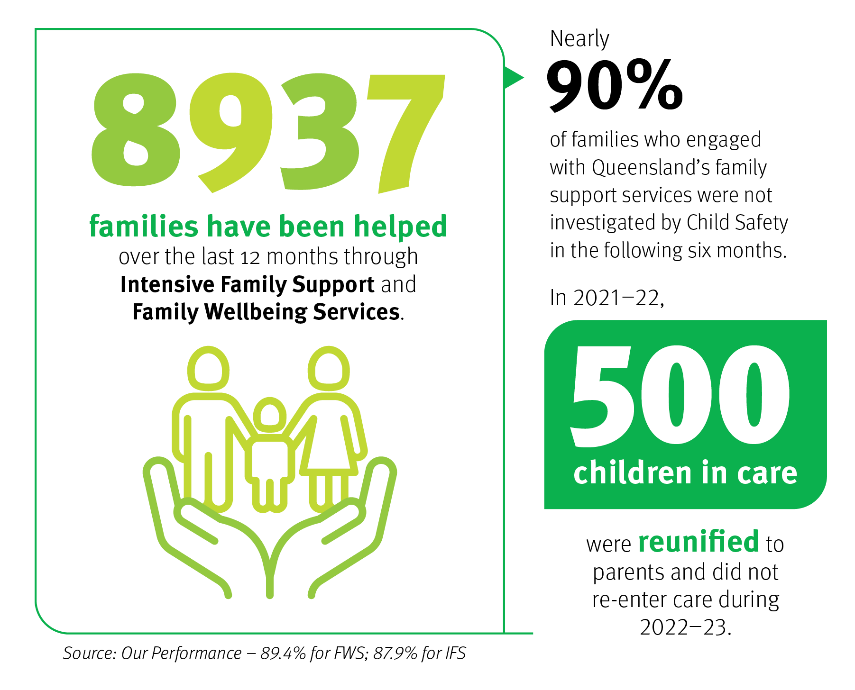

What we heard:
We should help families stay together.
- Some families want support to care for their child at home. They need access to support before things reach crisis point.
- We need to increase efforts to work with families to address the safety concerns for their children and young people.
- We need to conduct family mapping earlier to get a better understanding of the people in a young person’s life to help them stay connected to their identity, family and culture during and after their care experience.
We must help children and young people maintain connection to family and culture while in care.
- Children and young people will always want to know their parents and families.
- Children and young people want safe and supported contact with their families in a home-like environment. They want family involved in life events.
- Children and young people in care need help to understand and work through emotional difficulties they experience as a result of the harm they have suffered.
- People need help with the trauma of removal to help them heal and find ways back together.
- Residential homes and services can do more to enable family contact and communication.
We can work to improve reunification.
- We need to keep working to ensure a child or young person can be with their family.
- Residential care could be re-envisioned as a pathway back to family rather than a placement.
- Families need help addressing the underlying issues that might have contributed to a child’s risk of harm.
- Family finding is not always being undertaken thoroughly; we should see it as an ongoing process that continues in parallel to placement.

What we do now:
- Invest in community-based Family and Child Connect Services that provide information, advice, and referrals for families in need of support.
- Invest in Aboriginal and Torres Strait Islander Family Wellbeing Services, Family Participation Programs and Intensive Family Support services to engage with families and meet their needs earlier.
- Delegate child protection decision making for Aboriginal and Torres Strait Islander children and young people to Aboriginal and Torres Strait Islander organisations in appropriate circumstances.
We are also:
- trialling a Family Caring for Family initiative to increase the number of Aboriginal and Torres Strait Islander children and young people being connected to and living with kin
- partnering with the Queensland Parent Advisory Committee to introduce a survey of parents involved in the child protection system
- expanding the reach of Aboriginal and Torres Strait Islander Family Wellbeing Services
- increasing investment to support family contact for children and young people in care
- employing cultural practice advisors to help staff provide culturally responsive services to Aboriginal and Torres Strait Islander children and families and work better with Aboriginal and Torres Strait Islander organisations.

Next, we will:
Keeping families together and connected
Action | Commence
Partner with the Aboriginal and Torres Strait Islander organisations to design a new reunification service. | Year 1
Pilot a new early intervention assessment and safety response supporting families to stay safe and together where child protection risk is identified. | Year 1
Redesign the youth support program to deliver outreach services that strengthen connections to family and community-based supports. | Year 2
Work with residential care providers to improve family contact opportunities and incorporate family connection into quality standards and performance reporting. | Year 2
Review and recommission tertiary and targeted family support services to enhance in-home and placement supports. | Year 2
Develop and pilot a community-based mental health response including supports and treatment for young people at risk of entering or who have recently entered care. | Year 4

Culturally led responses for Aboriginal and Torres Strait Islander children and families
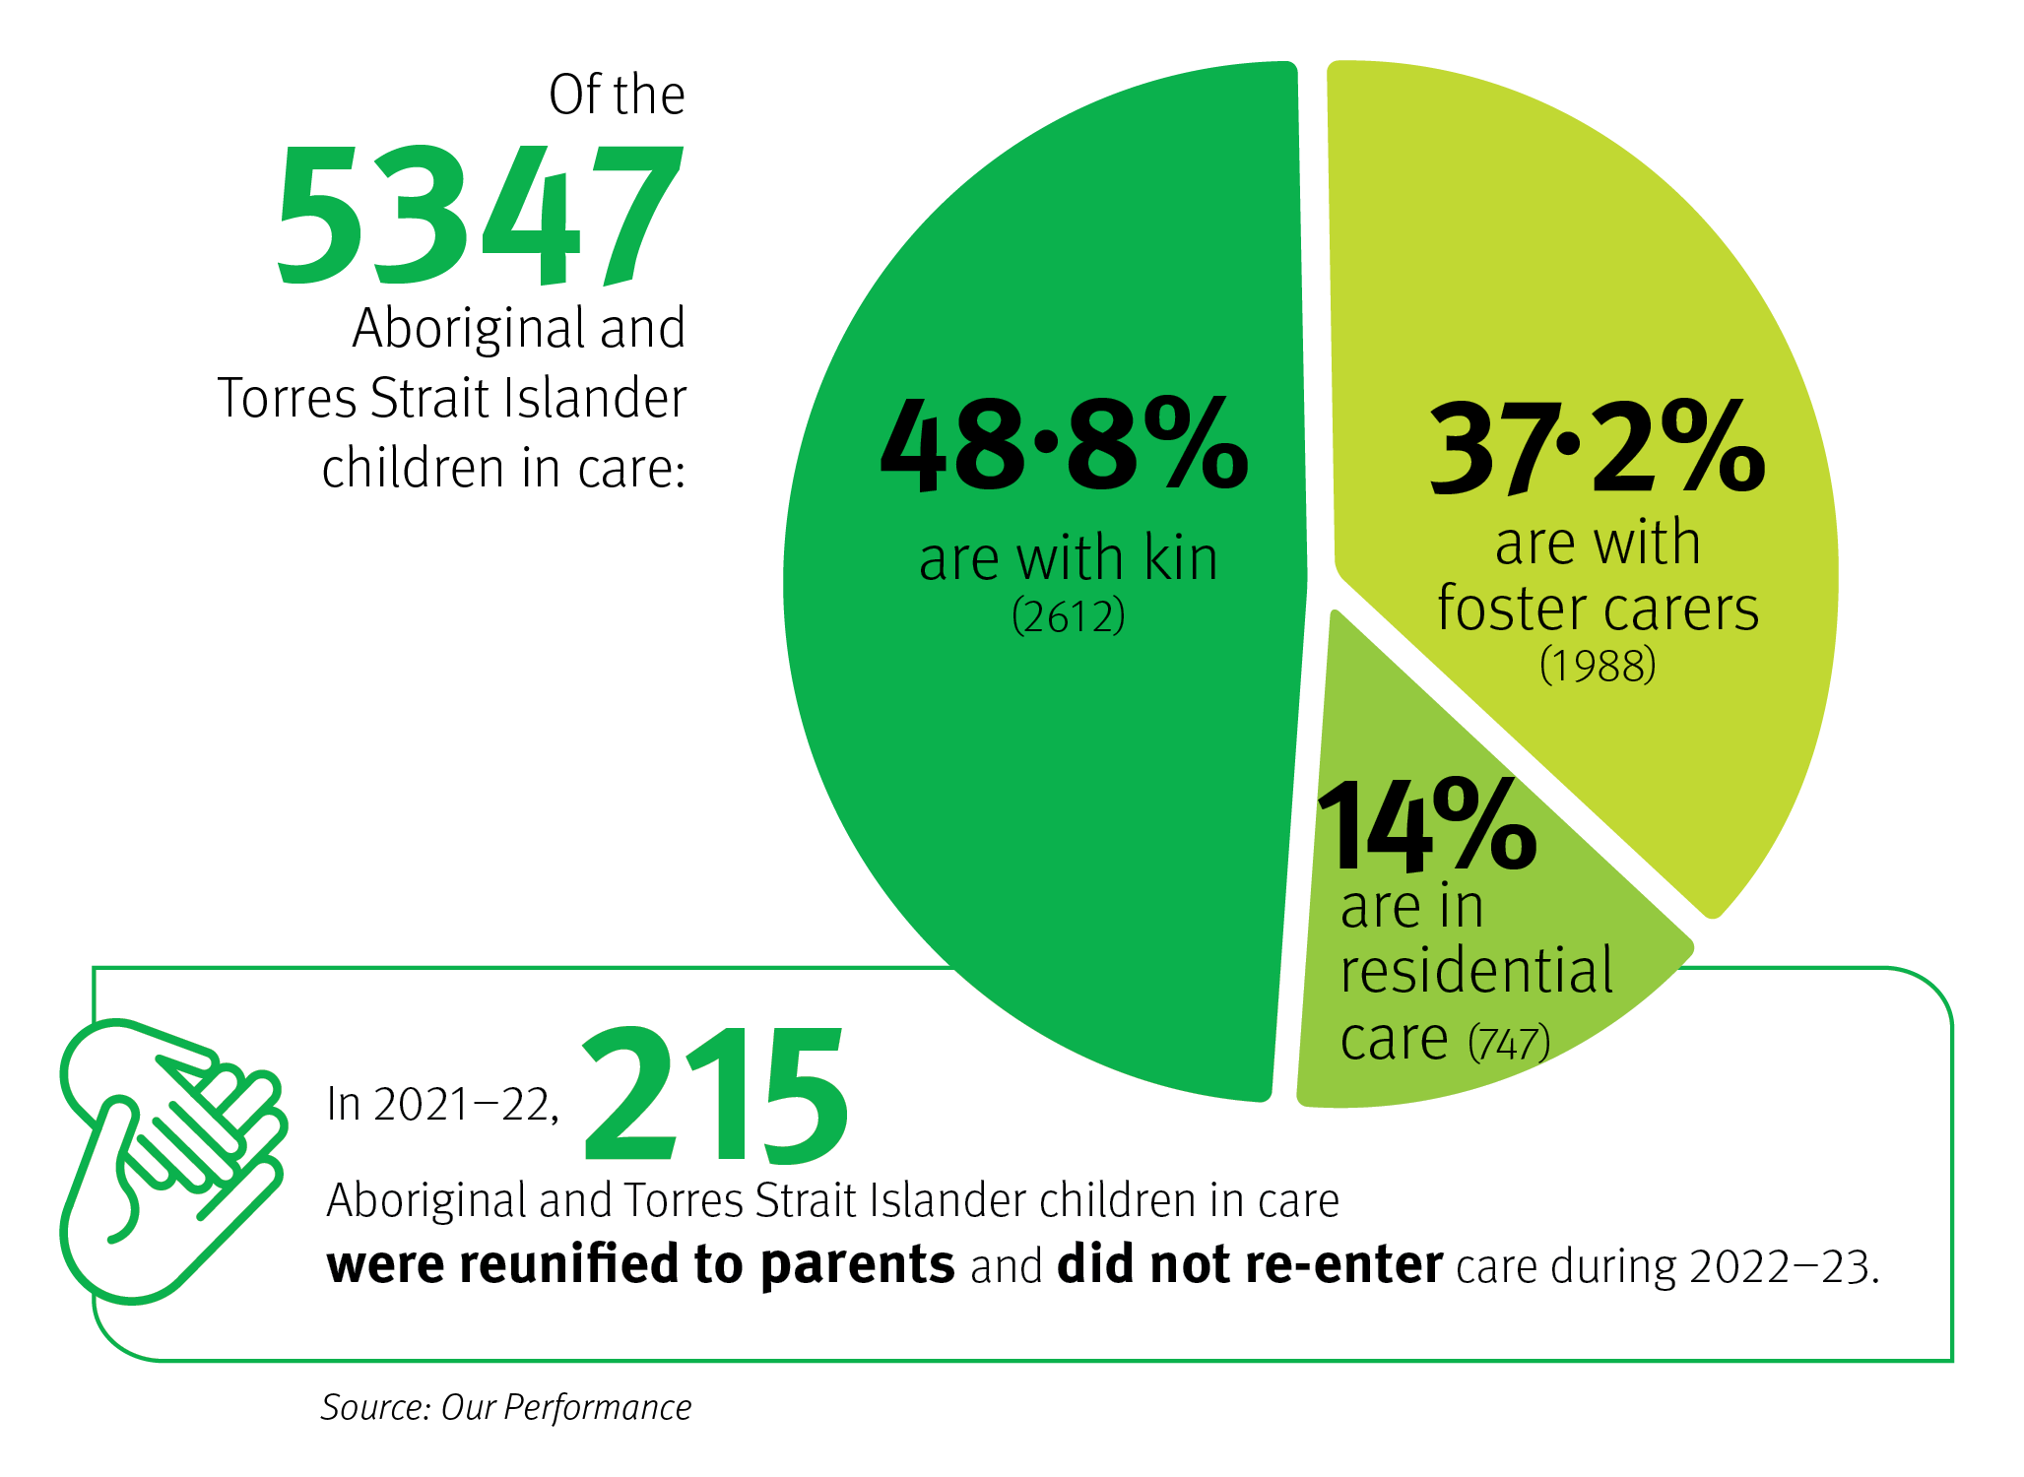

What we heard:
We can work harder to make active efforts to implement the ATSICPP.
- We need to review the care arrangements for every Aboriginal and Torres Strait Islander child and young person in residential care to make sure we have made active efforts to apply the ATSICPP.
- We need to ensure processes facilitate the application of the ATSICPP and there are processes to monitor compliance.
- Children and young people want Aboriginal and Torres Strait Islander carers to take them on excursions and cultural activities.
- Children and young people want service providers to be accountable for enabling access to family, community and Elders.
We need to focus on empowering Aboriginal and Torres Strait Islander parents, families, and communities.
- Aboriginal and Torres Strait Islander communities and ATSICCOs are best positioned and want to decide how to meet the needs of their children and young people. We need to ensure the contemporary system better reflects Aboriginal and Torres Strait Islander cultural knowledge and practice and keeps children and young people within their families and communities by embedding the principles of self-determination.
- Children and young people in residential care want to spend time and connect with their extended family or people important to them.
- We should partner with Aboriginal and Torres Strait Islander communities to design and deliver alternative models of support and care.
- Family members were available to care for Aboriginal and Torres Strait Islander children but could not successfully navigate the approval system.

What we do now:
- Continue to address the drivers of over-representation through our ongoing commitment to Our Way: A generational strategy for Aboriginal and Torres Strait Islander children and families 2017–2037 and delivery of Breaking Cycles: An action plan for Aboriginal and Torres Strait Islander children and young people and families 2023–2025.
- Invest $108 million over four years in delegated authority.
- Increasingly fund Aboriginal and Torres Strait Islander Family Wellbeing Services and Family Participation Programs.
- Continue our commitment to the ATSICPP, legislating active efforts and embedding in practice and service delivery.
- Engage openly with the Queensland First Children and Families Board to guide our strategic direction and approach to system reform.
We are also:
- developing a community-led and designed investment strategy to increase investment to ATSICCOs and Indigenous businesses by 2031
- working locally to develop strong relationships and partnerships with communities and ATSICCOs
- undertaking placed based engagement and regional planning to support non-government, non-Indigenous organisations prepare for the transition of existing investment to ATSICCOs.

Next, we will:
Culturally led responses for Aboriginal and Torres Strait Islander children and families
Action | Commence
Review every Aboriginal and Torres Strait Islander child in residential care to ensure their current placement meets their best interest and supports the development of effective transition plans. | Year 1
Increase Aboriginal and Torres Strait Islander self-determination through the expansion of Delegated Authority models. | Year 1
Redesign the Safe House model in discrete communities to reflect a community-led response to child and family safety. | Year 1
Develop a First Nations First Choice policy to increase investment in ATSICCOs and Indigenous businesses. | Year 1
Establish an innovation fund to support ATSICCOs to design and deliver culturally appropriate models of care. | Year 2

Improving support for kin and foster carers
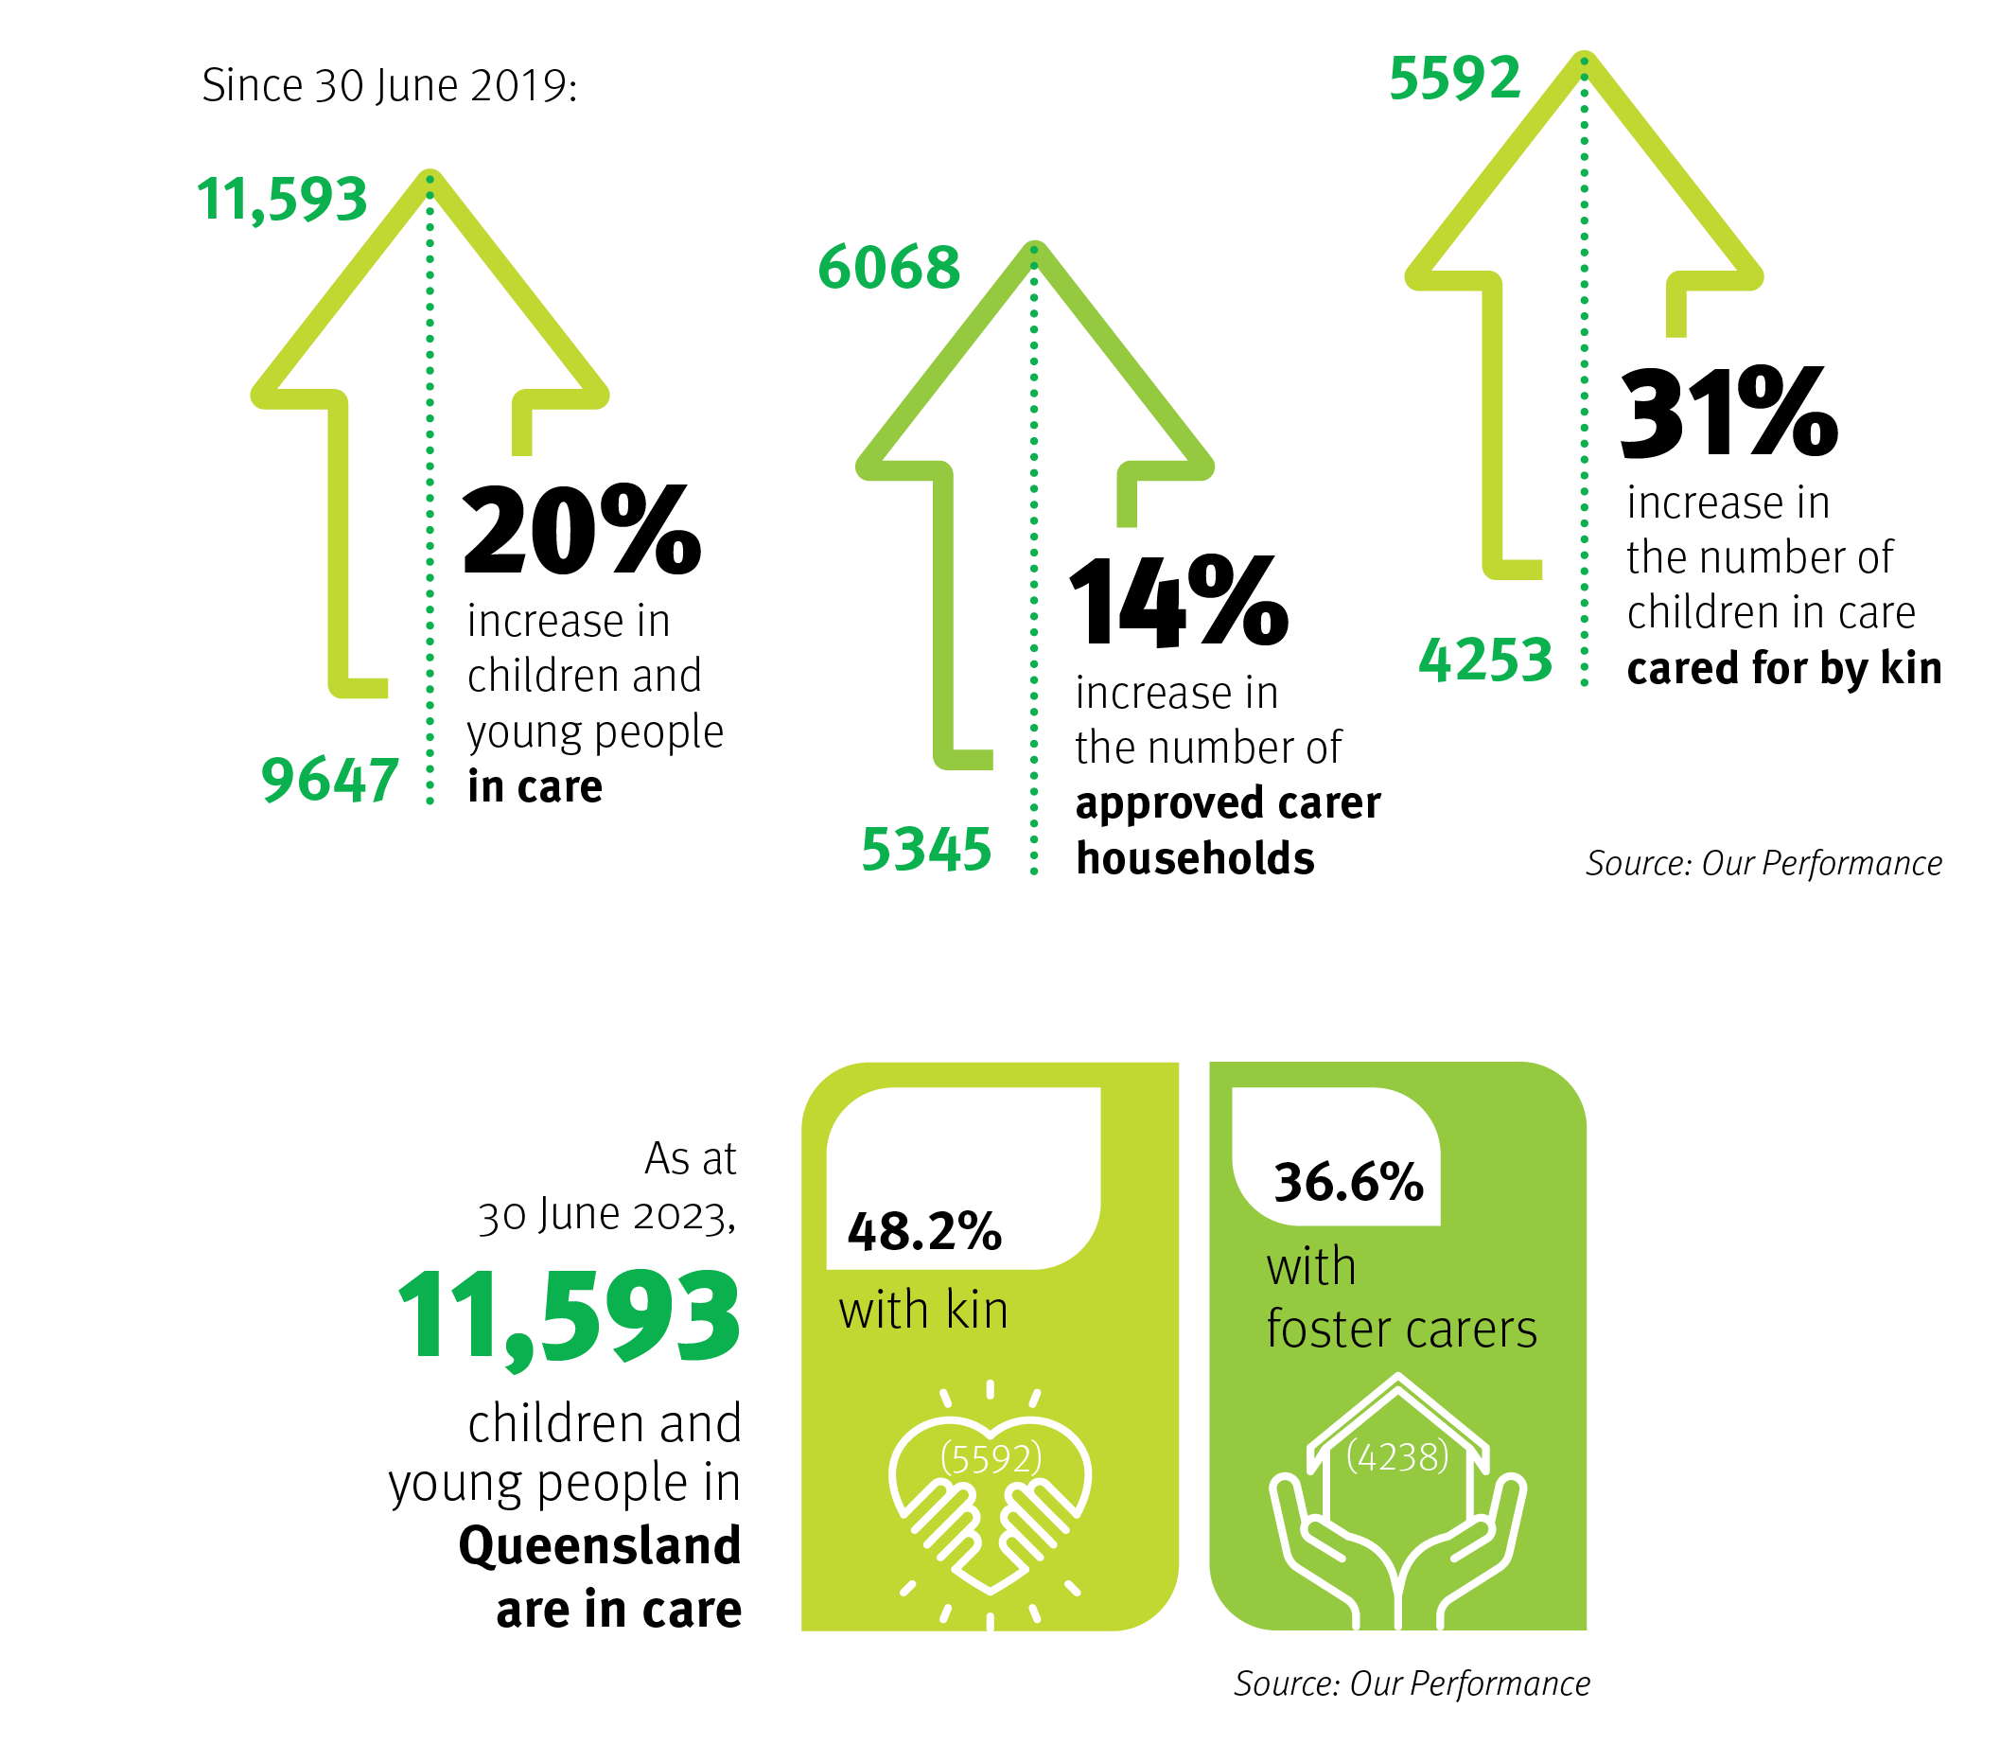

What we heard:
We can better support kinship carers.
- Kinship carers are family who have a significant connection with the child. We can do better to recognise them as family and help them take on the caring role for children.
- The rising cost of living and other factors can significantly affect kin and foster carers’ ability to provide adequately for the child in their care. These factors all place pressure on family-based care arrangements and can lead to placement breakdown and instability for the child.
- Kinship carers are available and want to care for family but urgency around placement decisions lead to children and young people entering residential care.
- There are key barriers for kinship carers, including lack of practical support, legal and blue card eligibility issues and financial constraints.
- The needs of foster carers and kinship carers are different, and therefore the supports should be tailored.
- Kinship carers need better support with timely, practical and financial aid, options for respite and improved communication with the department.
We can better support foster carers.
- The profile and needs of foster carers are changing and a different mindset and approach is required to support them.
- When family is unable to look after children and young people, foster carers can play an important role to ensure the child remains in family-based care.
- We should channel effort into supporting foster carers, such as providing training opportunities and timely access to practical and financial support. It is important to foster carers to have support in accessing specialists, and options for respite.

What we do now:
- Financially support carers to support young people to their 21st birthday.
- Recently announced an increase to care allowances of 5.2 per cent from 1 January 2024 to keep pace with the cost of living. This is in addition to the 7.9 per cent increase on 1 January 2023.
- Establishing regional dedicated kin teams to find, connect and assess kinship carers.
We are also:
- designing and piloting new family-based care services to better meet and flexibly respond to the needs of foster and kinship carer households
- piloting new models of carer recruitment and support
- considering the Queensland Family and Child Commission’s Thematic analysis of provisionally approved kinship carers who received a subsequent Blue Card negative notice report and recommendations.

Next, we will:
Improving support for foster and kinship carers
Action | Commence
Pilot a Ready Response to increase family-based care as the first placement in emergent situations. | Year 1
Pilot new and innovative models of foster and kinship care (e.g. recruitment services, respite care, shared care, specialist family-based care, professional care). | Year 1
Increase financial supports to kin and carers by streamlining care allowances and piloting flexible brokerage support packages. | Year 1
Expand access to counselling, intervention and support services to carers. | Year 2
Pilot a new behaviour management hotline for carers to access the specialist support they need at the times they need it. | Year 3

Our workforce

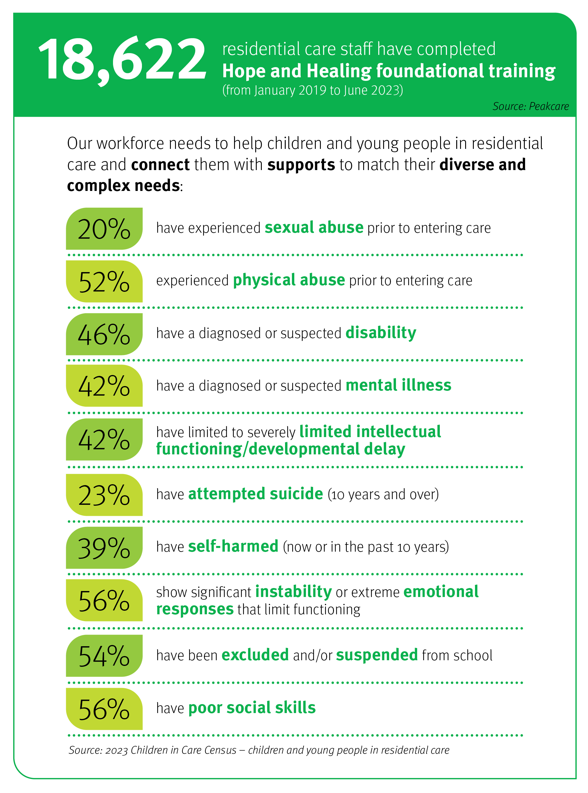

What we heard:
We can increase capabilities of the workforce.
- The people and workforce of the system are a key element to ensure service delivery can meet the complex needs of children and young people.
- We should ensure the workforce is better equipped with essential knowledge, skills and roles (i.e. therapists). This can improve access to health services and assessments (e.g. trauma-based behaviours) and address what children and young people require earlier.
- There is an opportunity to employ staff who are genuinely committed to the wellbeing of young people, understand their needs, and provide stable relationships.
We should support and invest in our people.
- We should improve the support mechanisms for staff including supervision and safety support. We should have smaller groups and more consistent staff rotations to support staff. We can do better at supporting collaboration amongst workers.
- We should focus on cultivating a diverse workforce that meets the needs of children and young people and recognise best practice across the sector.

What we do now:
- Build sector capability in readiness for the transition of funding to ATSICCOs.
- Strengthen the Human Services Quality Framework as the core cross-government quality system for outsourced human service delivery.
- Continue to partner with our peaks.
- Deliver a new Hope and Healing Master Class series on Positive Behaviour Support and Managing High Risk Behaviours.

Next, we will:
Our people
Action | Commence
Develop a residential care workforce strategy, led by PeakCare, to meet the current and future needs of the sector. | Year 1
Expand Queensland’s Hope and Healing Framework and related training to equip the workforce with a broader range of essential knowledge and skills. | Year 1
Develop new training to provide foster and kinship carers with foundational skills and ongoing learning opportunities to better equip them for their caring role. | Year 1
Establish a new sector-led forum to showcase and recognise best practice across the sector. | Year 2

Governance and accountability
Implementation of the roadmap and associated actions will build on work underway to deliver the strategic direction of the department to eliminate the over-representation of Aboriginal and Torres Strait Islander children in the child protection system and meet the needs of children and families within the child protection and family support systems.
The Principal Commissioner of the Queensland Family and Child Commission will provide expert advice on and oversight of the implementation of the roadmap and provide an independent report to the Honourable Craig Crawford MP, Minister for Child Safety and Minister for Seniors and Disability Services.
A monitoring framework will be developed to assess how well the existing and new actions are contributing to a non-family-based care (residential services) system that is meeting the needs of children and young people. The framework will be informed by the experience and outcomes for children and young people living in residential care.

Appendix 1:

Terms of Reference — Queensland Residential Care Review
Background
In Queensland, the Department of Child Safety, Seniors and Disability Services (the department) partners with non-government organisations to provide care arrangements for children and young people in out-of-home care.
Children and young people require different kinds of care arrangements depending on their individual needs. There are two broad types of care services – family-based and non-family-based care (known as residential care).
In July 2023, the Honourable Craig Crawford MP, Minister for Child Safety and Minister for Seniors and Disability Services announced a review of the Queensland residential care system. The review responds to concerns raised in the community about the growing number of children and young people in care living in residential care arrangements and whether these care arrangements are meeting the needs of these children and young people.
In 2022, the department commenced significant reform work addressing future care options for children and young people to:
- increase the proportion of children and young people cared for by kin to 70 per cent by 2026
- reduce the proportion of children and young people in residential care to 7 per cent by 2027
- transition investment to Aboriginal and Torres Strait Islander Community Controlled Organisations within 10 years.
This review focuses on whether the provision of non-family-based care (residential services) is meeting the needs of children and young people. The review will also consider what improvements could be made to improve residential care services and the experience and outcomes for children and young people living in residential services.
Scope
The purpose of the review is to examine the system and determine what is needed for the future.
The review is intended to:
- develop an understanding of the needs of different groups of children and young people in residential care, including children under 12, Aboriginal and Torres Strait Islander children and young people, sibling groups, young people with disability and mental health needs, and young people transitioning from care
- explore evidence-based models, supports and interventions
- describe the processes and structures needed to achieve positive outcomes for children and young people including changes to contracting and procurement
- confirm a theory of change of how outcomes for children and young people, and the quality-of-care services can be improved, and how outcomes will be measured and monitored
- understand financial sustainability and costs of service provision.
How the review will be conducted
The review will bring together sector partners and experts through a Ministerial Roundtable in September 2023, alongside a regional engagement and consultation process.
In recognition of the importance of honouring the voices of those with lived experience, the review will include a range of opportunities for stakeholders including people with lived experience of residential care to engage, inform and shape the review and its deliverables.
Deliverables
A report will be delivered for the Minister’s consideration in December 2023.
The report will:
- provide an overview of evidence and best practice,
- outline future directions for non-family-based care including identified issues and future opportunities; and
- propose an implementation plan.
The review will inform the development of a Roadmap for Contemporary Residential Care in Queensland (the roadmap).
Governance
A Project Executive will oversee the review and report to the Director-General (Child Safety, Seniors and Disability Services). The Project Executive will include representatives from:
- The Department of Child Safety, Seniors and Disability Services
- PeakCare Queensland
- Queensland Aboriginal and Torres Strait Islander Child Protection Peak.
The Principal Commissioner of the Queensland Family and Child Commission will provide expert advice and oversight of the review and provide an independent assessment of its findings to the Minister for Child Safety and Minster for Seniors and Disability Services.

