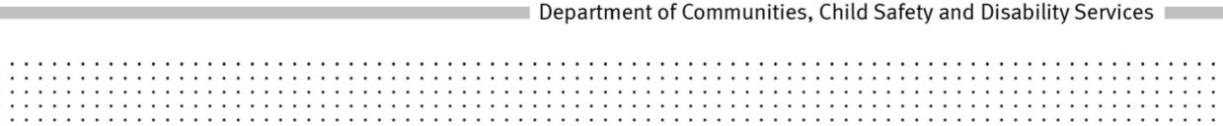
POLICY
Title: Closing the expression of interest register
Policy No: CPD619-2
Policy Statement:
The Department of Communities, Child Safety and Disability Services will close the expression of interest register, or part of the expression of interest register, if the number of persons listed in expression of interest register, or part of the expression of interest register, is significantly higher than the number needed to meet the anticipated future need for adoptive parents.
Principles:
- The wellbeing and best interests of an adopted child, both through childhood and the rest of his or her life, are paramount considerations in all adoption matters.
- The Adoption Act 2009 is to be administered in a way that supports efficient and accountable practice in the delivery of adoption services.
- The expression of interest register only contains the names of people in such numbers as to reasonably meet the anticipated future need of children requiring adoption.
Objectives:
The aim of this policy is to:
- ensure, whenever possible the expression of interest register is to generally remain open, unless the number of persons listed in the register is significantly higher than the number needed to meet the anticipated future need for adoptive parents
- ensure, as far as possible, couples seeking to be assessed for suitability to adopt a child have an opportunity to express their interest when they are ready, willing and able to actively proceed through the adoption process and
- avoid unnecessarily raising the expectations of some people of the prospect of adopting a child, when the numbers of persons already listed on the register are significantly higher than the number needed to meet the anticipated future need for adoptive parents.
Scope:
The expression of interest register can be closed as a whole or in part, relating to:
- local adoptions and/or
- intercountry adoption and/or
- intercountry adoption from a stated country and/or adoption of children with a stated characteristic

Roles and Responsibilities:
Adoption and Specialist Support Services will regularly review the number of people, and the profile of people, listed in the expression of interest register with regard to the number of children anticipated to need an adoptive placement and the anticipated needs of those children as required.
If there is an apparent need to close the expression of interest register, or a part of the register, Adoption and Specialist Support Services will provide relevant information to assist the Executive Director, Operations:
- decide whether the register needs to be closed as a whole or in part, and the specific part needing to be closed
- arrange, at least 30 days before closing the expression of interest register, or a part of the register, to publish in print media circulated throughout the State, a notice of the closure, including reasons for the closure and the last day expressions of interests may be accepted
- review the need for the closure at intervals of not more than 6 months and
- re-open the register if satisfied it would be appropriate to do so.
Authority:
Adoption Act 2009, sections 84, 85, 86 and 87.
Delegations:
Executive Director, Operations

Records File No.: CHS-16721
Date of approval: 04 March 2013
Date of operation: 12 March 2013
Date to be reviewed: 04 March 2016
Office: Communities, Child Safety and Disability Services
Help Contact: Child Protection Development
Links:
Adoption Practice Manual
Related Adoption policies:
The wellbeing and best interest of the child in adoption (626)
Determining the number of adoption assessments to be undertaken in a financial year (617)
Determining which persons on the adoption expression of interest register will be assessed (618)
Regular re-assessment of persons whose names are included in the suitable adoptive parents register (623)
Rescinded policies:
2.4 CHS-16721 Closing the expression of interest register
619-1 Closing the expression of interest register
Margaret Allison
Director-General

