Module four

Quality care - Working together

Activities

Brainstorm- slide 6 – Working in partnership

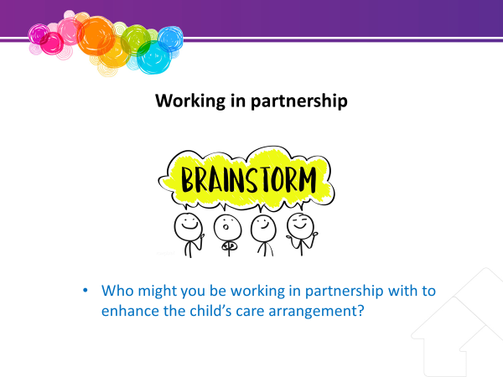

Brainstorm
Time – 10 mins
Resources - Whiteboard / Pens

Brainstorm some of the members of the team or people you might work with to enhance the child’s placement. Allow time for some brainstorming
The team members you might meet or hear about include:
- The Child and their family
- CSSC staff – such as the CSO, senior team leader, senior practitioner, manager, family group meeting convenor
- Cultural Practice Advisor
- Foster and Kinship care service
- Queensland Foster and Kinship Care
- FAST representative
- PeakCare
- Office of the Public Guardian (OPG)– including Community Visitors and Child Advocates
- Education, school and cultural services
- NDIS
- Counselling and therapeutic services

Activity 1 – Slide 12 – Standards of Care

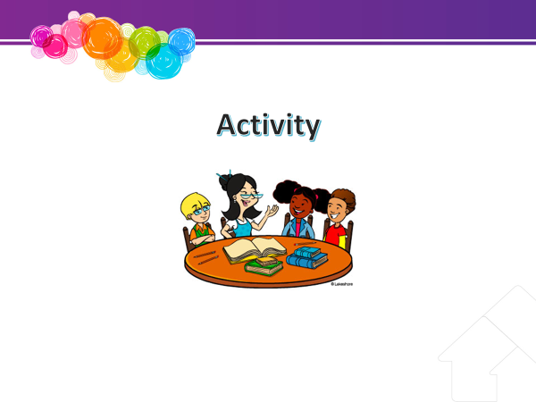

Time – 10 mins
Resources - Whiteboard / Pens

Question for the participants – what do you think should happen if there are allegations that a child in care is harmed by their carer?

This should lead into a discussion about the need to assess these concerns.

Activity 2 – Slide 18 – Carer Support

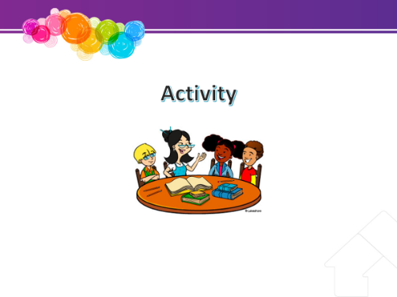
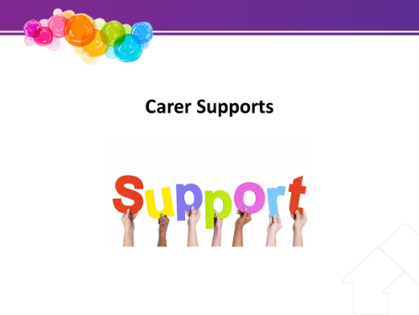

Time – 10 mins
Resources - Whiteboard / Pens / butchers paper

Exercise: Support mapping

Either on the whiteboard (for the whole group) or on butcher’s paper (as small groups), draw up a simple table:

Challenges | Sources of Support

Based on their learning so far and the knowledge they have about fostering and Child Safety, ask participants to list the challenges associated with the role.

Activity 3 – Slide 23 – Guest Panel and/or CREATE PowerPoint

Time – 45 mins
Resources – any resources required by the panel

This session explores some issues that may assist you as a care arrangement continues.
- Foster carers are part of the child’s safety and support network that has its focus on meeting the needs of a child or young person. A guest speaker who has been a child in care will attend to give their perspective on their experiences.
- Current foster carers will be invited to form a panel to answer questions that you may have about their daily experiences.
- Show some of the CREATE power points of quotes from children in care.

Guest speaker – young person who has been in care
Foster carers are part of a team that is constantly reassessing a child or young person’s changing needs. Children and young people and their families are part of that team, and care environments should respect the dignity and rights of children, young people and their families, and create an environment where their views and wishes are actively sought.
To illustrate the experiences of a child or young person, every attempt should be made to arrange for a child who has been in care to attend training. CREATE may be able to assist and may attend with the young person but may not be able to send a young person due to limited resources or geographic locations of training. Introduce the young person where relevant.
Alternatively, where this has been impossible to arrange, show the CREATE power point with quotes from children and young people.
It is important that participants should be asked to consider the needs of the child or young person and reflect this in appropriate questioning.
Questions should cover:
- Describe what it was like to arrive at a placement for the first time?
- What can a foster carer do to assist you feel welcome and respected?
- How did contact with your own family occur?
- How do you think your own family felt about you living with foster carers?

Activity 4 – Slide 31 – Saying goodbye

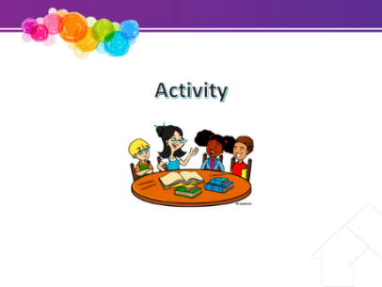

Time – 10 mins
Resources - Whiteboard / Pens / butchers paper

This session looks at the roles and tasks around helping children and young people move on. It is also the end of this course and we will look at how you “move on” from here.
- Saying goodbye often has a sense of loss about it – get participants to reflect on goodbyes that they may have experienced. What were some helpful factors in the process?
- List on the board the ways that people say goodbye
- What might be the impact of moving for a child or young person in care? Discuss impact of a number of moves, often with little notice, loss of belongings.
- What helpful factors might be put in place to make the move a positive one? List these on the whiteboard.

Optional or alternate Activity
Refer to Handouts Case Studies 1, 2 & 3 - Part 4
Divide into small groups and consider the following questions:

- How would the child or young person, their family and the foster carer and their family be feeling?
- What can the carer do to help the move for the child or young person and their family?
- How will this move impact on your family?
- What can you do to assist your own family to cope with the move?
Discuss this in the larger group - Experienced foster carer presenter to facilitate this session.
- Discuss feelings you might have if the care arrangement ends on a difficult note or you don’t agree with the decision.
- How can you ensure the child or young person still has a positive ending with your family?

