Module one
Context of foster care
Session Plan

3 Hours
Method of Delivery
Learning Outcomes
Assessment

The assessment necessary for each participant will be based on:
- Participation in discussions and training activities

- Completion of worksheets at the end of the session; and

- Completion of a self- assessment pro forma.

Lecture
Small / large groups
Brainstorm
Activities

At the end of this module participants will be able to:
- Explain why children can require care arrangements

- Demonstrate knowledge of how children come into care and who is involved in decision making.

- Identify the needs of children in care, and the roles and responsibilities of foster carers in meeting those needs.

- Name tags | - Power Point Slides | - Multiple copies of the Charter of Rights
- Copy of the Child Protection Act 1999 | - Multiple copies of the Child Placement Principle | - Multiple copies of Case Studies 1, 2 and 3
- Multiple copies of the Historical Overview handout | - Multiple copies of the Principles of the Act  - the Queensland Human Rights Act: an easy read guide | - Multiple copies of the Child Protection System – Flow Chart
- Name tags as per “roles” as described on PowerPoint slide “String Sculpture” and a long roll of string or red tape. | - Copy of the CSPM procedures:  - Support a child in care  - Provide and review care | - Multiple copies of:  - Learning opportunities for carers  - Independent Person  - Aboriginal and Torres Strait Islander Child Placement Principle

Resources
Resources can be obtained from CSSC staff or via a search of the Child Safety Internet or within the Child Safety Practice Manual

2 mins | Acknowledgement of Country  I would like to respectfully acknowledge the Traditional Owners of the land on which we are meeting today and acknowledge that Aboriginal and Torres Strait Islander peoples are the custodians of this country and recognise their connections to land, sea, water and sky. We pay our respects to Insert Local tribal/language group, their continued culture and to their Elders past, present as well as those emerging leaders of tomorrow.  Pause  Thank you
 | Distribute name tags and show Slide 1 | Slide 1  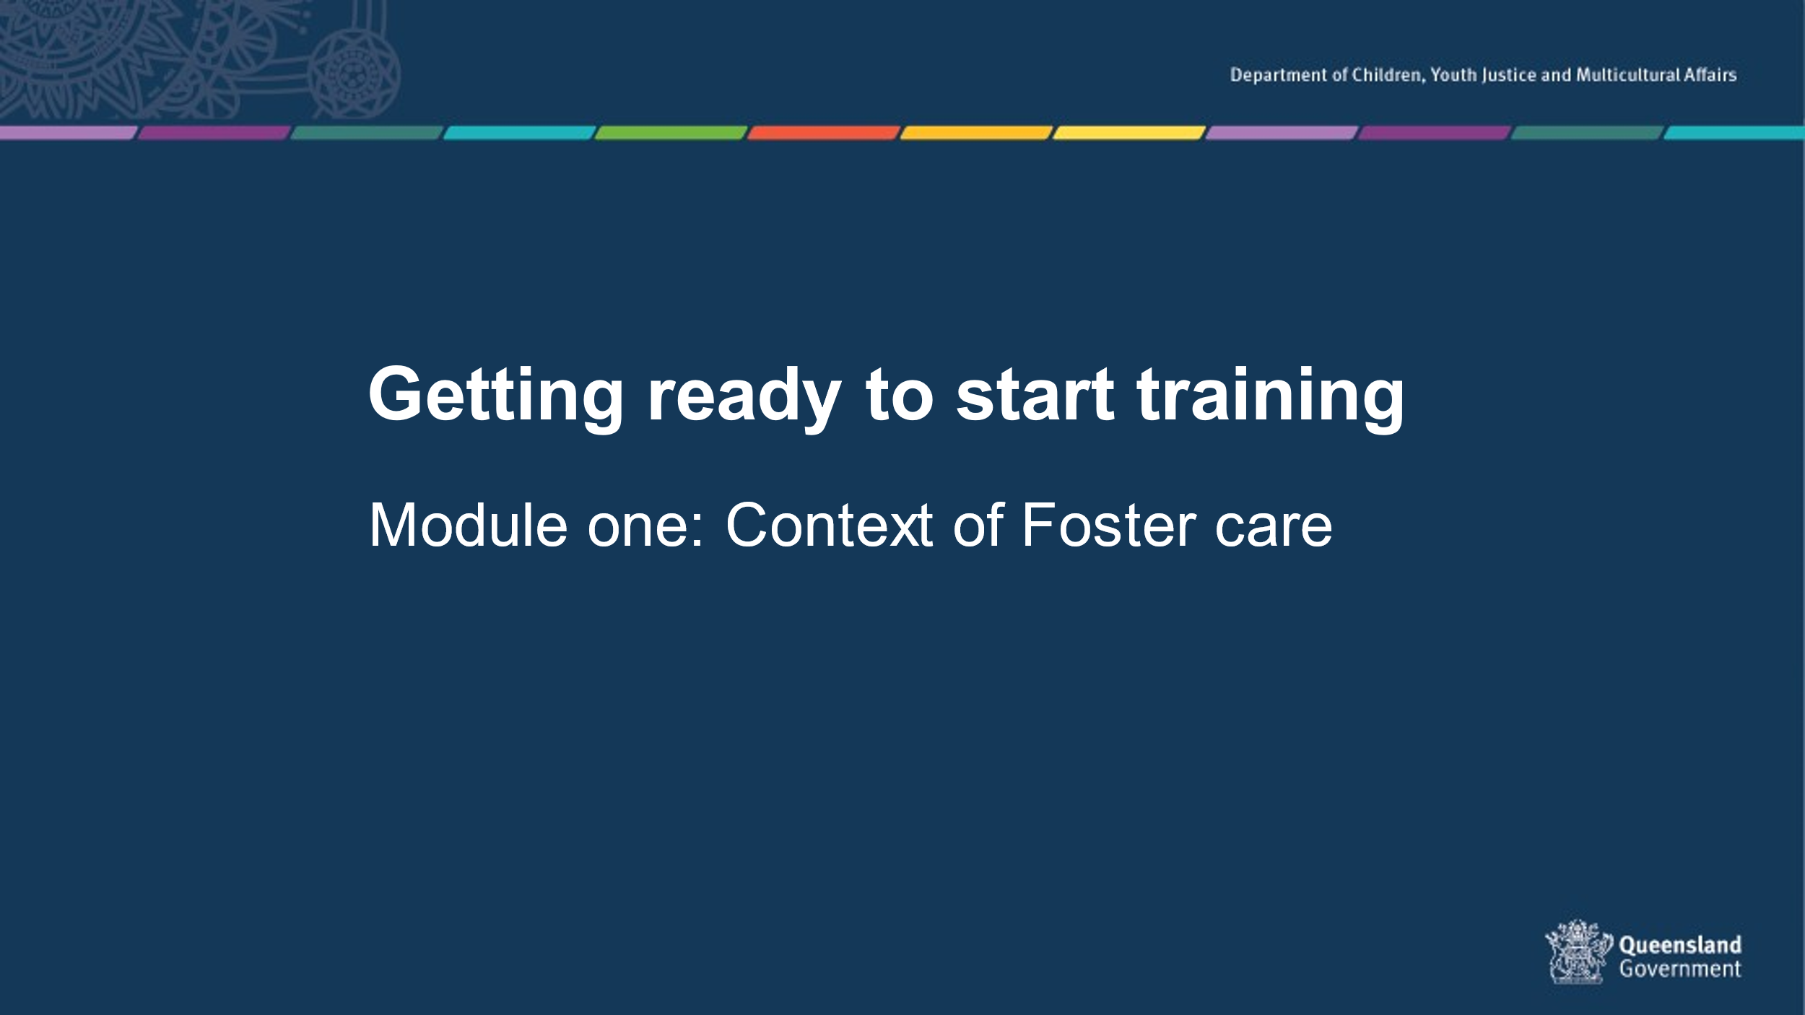
25 mins | Housekeeping, introductions and training assessment expectations  Housekeeping details – provide the location of exits and toilets, information on breaks and catering, arrangements for smokers and phone messages. Include fire, evacuation and emergency exit and meeting points as well as any other WH&S procedures required.  Introducing each other - Use your own icebreaker or the example below  Get participants to introduce themselves to the person sitting next to them and tell them one fun activity they have done with a child or young person. Report back to the group.

Group Rules

These should be sourced from the group - ask what people would need from the group in order to feel comfortable. Ensure that the following are covered:

- Confidentiality – any information that is shared in the group will be confidential to the group
– link to the need to respect confidences in a placement situation.

- Mutual respect and tolerance for a diversity of opinions, cultural backgrounds and experiences.

- Punctuality and respectful processes in discussion.

 | Show slide 2  - Thank you and introduction of the Statement of Commitment  - Statement of Commitment - foster and kinship carers of Queensland (www.qld.gov.au)  - Advise where to find this document on the internet or allow carers to scan the QR code. | Slide 2  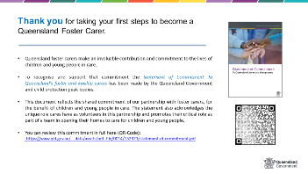

 | Show slide 3  Overall aim of Foster Carer training: Getting ready to start training.  Getting ready to start training is presented in 4 modules of 3 hours each.  - Context of Foster Care Module one- you are here.  - An understanding of the process of how children and young people come into care and the impact of this process, and why children and young people require a care arrangement.  - Understanding the past for a child or young person  - An understanding of trauma and related behaviours for a child or young person who is in care arrangement.  - Early days in a care arrangement  - Developing knowledge and skills required to meet the physical, emotional and social needs of children and young people in care and an understanding of the importance of participation by children and young people and their families in decision making.  - Quality Care - Working together  - Have an understanding of the importance of partnerships between children, their families, foster and kinship carers and workers, (both in the government and non-government sectors), and their roles and responsibilities when working together as a team. | Slide 3  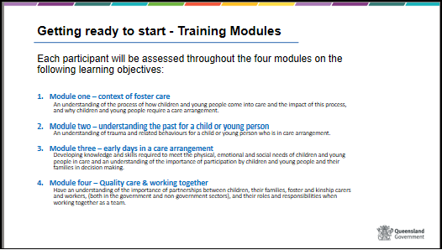
 | Show slide 4  Context of foster care – learning outcomes  This module will encourage you to reflect on how aspects of the child protection system and carer roles will impact on you and your family and assist you in making a decision about whether to become a foster carer or not.  At the completion of training you will be able to: as per slide | Slide 4  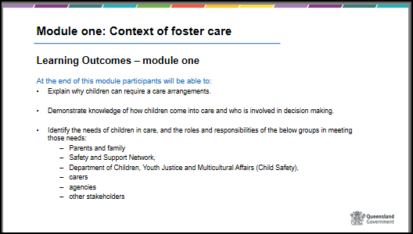

 | Show Slide 5  Overall assessment.  Give information on the processes for assessment. Explain that a comprehensive assessment will be necessary for each applicant which goes toward the assessment of their suitability to be approved as a carer.  The assessment will be based on:  1. Observations  2. Participation and responses in discussions and training activities  3. Satisfactory completion of Worksheets  4. Completion of Personal Reflections forms  Explain that consideration will be given to the needs of participants, and there is provision for some information to be obtained orally.  After completion of the training, the trainers will consider each of you and make a recommendation about whether you are competent or not yet competent in meeting the learning outcomes. Any concerns raised during the training will be discussed with you and you may be provided the opportunity to demonstrate your competency again.  The training assessment and outcome will inform the final assessment of your application to become a foster carer. This assessment also requires suitability checks and a series of interviews leading to a comprehensive written assessment. All information gathered is then forwarded onto a Child Safety Service Centre Manager for the final decision about whether to approve you to become a foster carer.  Most importantly you must be able to demonstrate you will be able to meet the needs and standards of care for children and young people in a care arrangement. These standards, otherwise called the statement of standards are written in law and will be addressed in further depth throughout the training.  Explain that this process can lead to approval as a foster carer for an initial 12 months. During the initial 12 months foster carers can start taking care of children or young people. | Slide 5  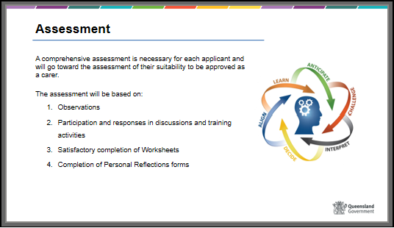
Handout - Carer fact sheet 2 Learning opportunities for carers

  - Multiple copies of: Learning opportunities for carers
  - Trainer refer to Child Safety Practice Manual (CSPM): Provide and review care

10 mins  35 mins  35 mins  40 mins  20 mins  20 mins  20 mins | Show Slide 6  Context of foster care - Content  Highlight time allocated for each session  - Why do you want to be a foster carer?  - When does Child Safety intervene?  - The Child Protection System - overview?  - Working together to meet the needs of children and young people, the roles and responsibilities of:  - Safety and Support Network which includes foster and kinship carers, families, an independent person plus others  - Child Safety  - Licensed Care Services  - Carer Allowances  - Foster and Kinship Carer Supports  Activity – String Sculpture or PDF | Slide 6  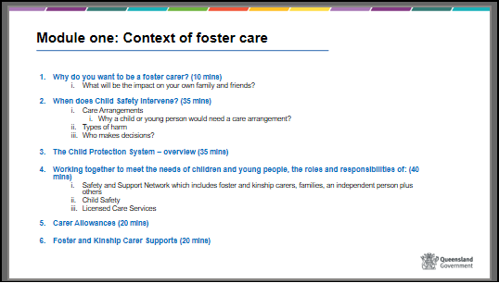
10 mins | Show Slide 7  Why do you want to be a carer?  Activity 1 – Why do you want to be a carer? | Slide 7  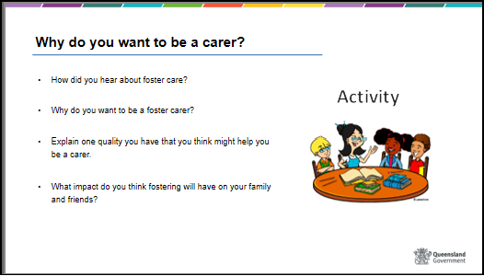

35 mins | Show Slide 8  When does Child Safety intervene?  Not all children who experience abuse or harm will need a care arrangement. The decision whether to place a child in care is determined by the interpretation of law, child rights, principles, and the use of a professional assessment.  By law Child Safety must intervene when it is suspected that the definition of a child in need of protection in the Child Protection Act 1999, section 10 has been met.  Child in need of protection  That a child has suffered significant harm, is suffering significant harm or is at unacceptable risk of suffering significant harm and does not have a parent able and willing to protect the child from harm.  Show Slide 9  Handout - Refer to Case Studies 1, 2 and 3 – “Part 1” in handouts. Introduce 3 case studies.  Participants to read the case studies noting the child’s background and current situation in each Case Studies 1, 2 and 3 – “Part 1”  Activity 2 – When does Child Safety Intervene – Case Studies 1, 2 & 3 Part 1  Show Slide 10  BRAINSTORM - thoughts on case studies | Slide 8  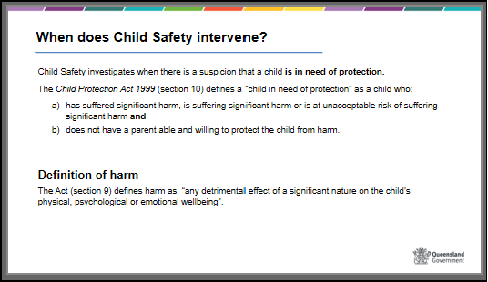  Slide 9  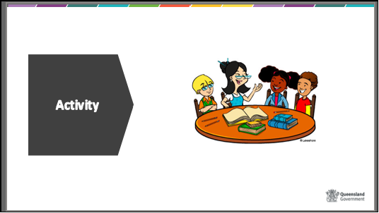  Slide 10  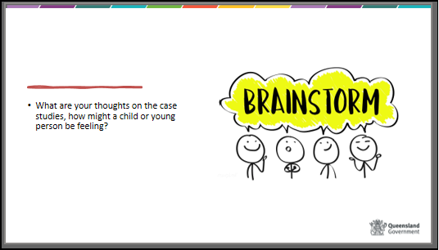
 | Show slide 11  Placing a child or young person in care: Care arrangements  Non-Government Organisations provide many functions to support Child Safety in caring for children and young people who can no longer remain safely at home. Providing care arrangements is just one of the many functions. Licensed Care Services are non-government organisations that are funded directly through Child Safety and work in partnership to meet the needs of children and young people in care.  Non-Government Organisation’s provide foster, kinship and specialist foster care services to children and young people.  In addition, non-government organisations provide a range of non-family care arrangement options including Residential Care, Therapeutic Care, Indigenous Safe Houses and Supported Independent Living, which will be discussed a little later.  Show Slide 12  Children and young people come into care because it has been assessed that it is no longer safe for them to stay at home because their parents are unable or unwilling to protect them from harm and risk of future harm.  The goal is for all children and young people to return home after support, intervention and assessment that identifies it is safe to do so. Foster and kinship carers are part of a team who work to provide the child or young person with a safe and supportive environment while they are unable to stay at home.  As we stated previously placing a child in care is a complex decision based on the combination of law, principles, children rights, research and a professional assessment of harm and future harm to the child.  In the first instance Child Safety works with families to identify possible family-based care options including extended family networks while listening to the views of the child or young person.  For Aboriginal and Torres Strait Islander children, family-based care also supports building and maintaining connections to kin, culture and country.  Show Slide 13  Run through the two main types of care i.e. primary vs short break (respite).  Show Slide 14  Run the types of care arrangements that can be provided for children and young people identifying that each arrangement type requires a different approach to ensure it meets the needs of the child or young person.  Highlight that family-based care leads to better outcomes for children and young people as it provides an opportunity to change the trajectory of the child or young person’s future and help them to reach better outcomes.  Residential Care  This type of care arrangement is for young people over the age of 12 and may take various forms including some of those listed below.  The Hope and Healing framework (2019) guides the provision of residential care services. It identifies a young person's fundamental needs for physical, emotional, and cultural safety, nurturance, development and healing from trauma.  Therapeutic residential care service – as per slide  Aboriginal and Torres Strait Islander Safe Houses – as per slide  Supported Independent Living (SIL) – as per slide  Other entities – as per slide  Show Slide 15  Emergency care arrangement – as per slide  An emergency care arrangement can also include a fee-for-service care arrangement as well as Commercial Accommodation which is when children and young people may need to reside in hotel accommodation with a youth worker. | Slide 11  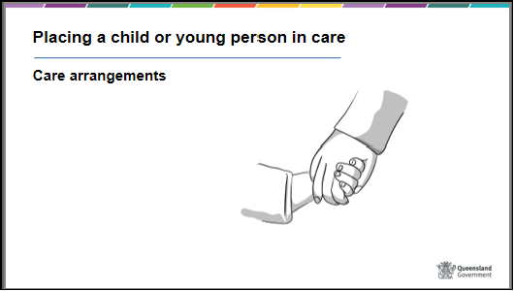  Slide 12  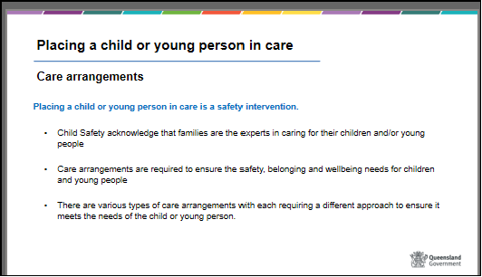  Slide 13  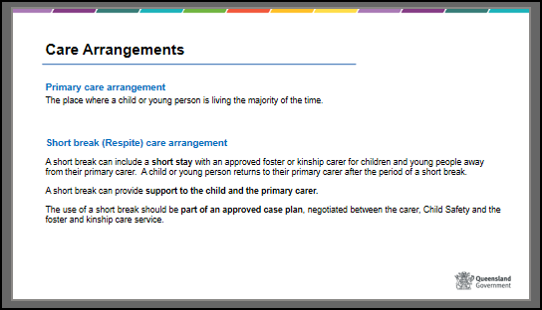  Slide 14  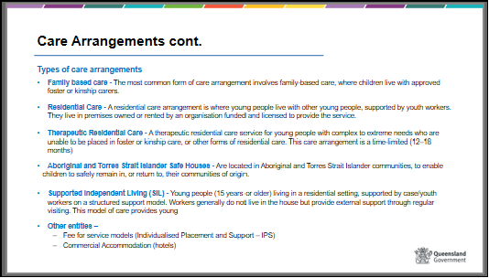  Slide 15  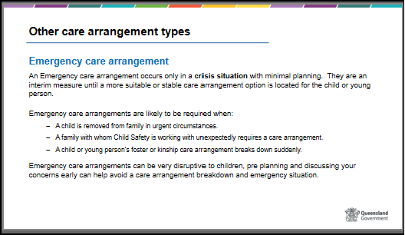
 | Show Slide 16  Types of abuse and resulting harm.  Children and young people in care have usually been subjected to abuse at home which can result in harm.  Provide an example of the differences between abuse (e.g. Actions - being hit, yelled at, sexual) and the resulting harm (e.g. The impact - physical, emotional).  Trainers can read the Practice Guide: the assessment of harm and risk of harm in the Child Safety Practice Manual for more detail if required.  Handout – Relationship between abuse and harm – excerpt of Child Protection Act 1999, see Section 9 (1) and Section 10.  While some parents are not able or willing to protect their child at a particular point in time, each of these parents will have strengths and positive social relationships and support that may reduce the likelihood that harm will occur to the child if they remain in their care. These are called protective factors.  Show Slide 17  BRAINSTORM – types of abuse and harm  OPTIONAL BRAINSTORM ACTIVITY | Slide 16  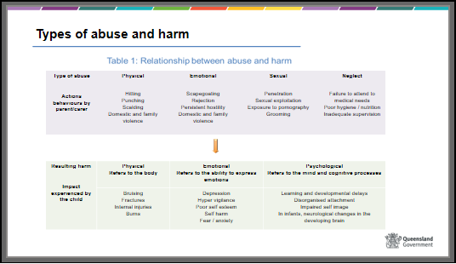  Slide 17  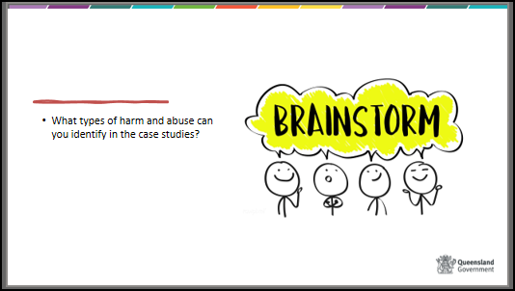

 | Show Slide 18  Who is involved in decision making?  Introduction to this section  There are many people involved in the decision to place a child in out-of-home care. For example, some people offer information about the child and their parents (school staff, police, GP, medical staff) to help make this decision while others, like foster carers offer support and care to the child or young person.  The child and their family are part of the decision-making process. The Charter of Rights for a Child in Care (which we will discuss a little later in more detail) establishes the right for a child or young person to be consulted about, and to take part in making, decisions affecting the child’s life (having regard to the child’s age or ability to understand), particularly decisions about where the child is living, contact with the child’s family and the child’s health and schooling.  Child Safety staff including the CSO along with the senior team leader, senior practitioner, court coordinator and manager will assess all the information gathered and decide the type, level and length of statutory intervention, where required.  In the case of Aboriginal and Torres Strait Islander children and families, decisions will be taken in conjunction with an independent person. Review or refer again briefly to the Child Placement Principle and the importance of maintaining family and cultural connections.  Where a child is in need of protection and the family does not agree with the ongoing intervention required, Child Safety may recommend a child protection order to the Director of Child Protection Litigation (DCPL). The DCPL will decide to either apply for a child protection order or refer the matter back to Child Safety.  Magistrate – Where DCPL apply to the Children’s Court, the magistrate of the court will decide the Child Protection Order based on the information provided by Child Safety and hearing from the child, parents and any legal representatives.  Foster and kinship care agency – as per slide information  Discuss the frustration that some carers have with contacting their CSO. Highlight this is a very busy and often urgent time and provide a brief explanation about the CSO’s complex role, the number of people involved and the demands when making this decision, which will become evident in the string sculpture. | Slide 18  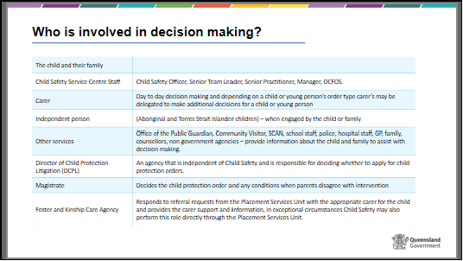
35 mins | Show Slide 19  Child Protection System – Overview | Slide 19  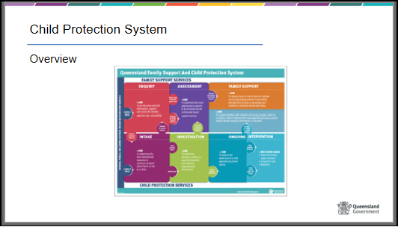
 | Show Slide 20  Overview of the Child Protection System  Briefly talk through with participants what the process is when a notification is received by Child Safety.  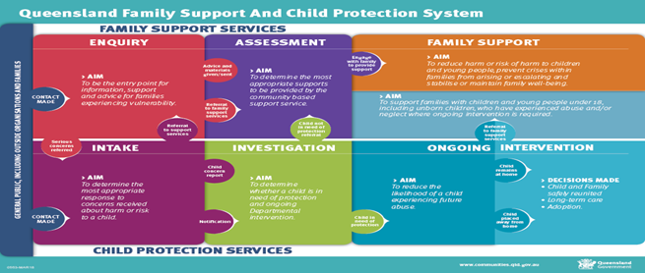  Handout - Provide the handout the flow chart below for more information to take home. Remind carers that CSSC staff can explain and clarify any questions.  Family support and child protection system framework  3 areas of intervention – as per slide  - Intake  - Investigation and Assessment  - Ongoing Intervention | Slide 20  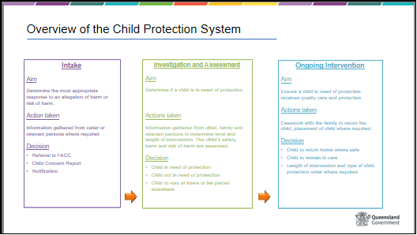

 | Show Slide 21  Types of Intervention and Child Protection Orders  The needs of the child/young person and their family directly influences how long an intervention, child protection order and care arrangement is required.  Highlight that there is a complex and often difficult process undertaken with the family prior to the care arrangement. Care arrangements can be negotiated with parental consent or through the application of a court order in the Children’s Court. This can be a very confusing, distressing, and emotional time for the family and the child.  The table shows the types of interventions and child protection orders that are most commonly used and where a child or young person can be placed, whilst subject to that intervention.  It is not crucial that you remember all the specific details about the types of interventions and orders at this early stage of foster care. You can ask the child’s CSO for details about the intervention when considering a care arrangement or when a child is placed with you.  What is important for a foster carer to ask about is;  - the length of the order or intervention or time the child is likely to be placed  - What, where, how and who is involved in family contact  - who by law can and cannot talk with or contact the child?  - are there any special considerations or requirements with the intervention?  - an explanation of the intervention and order if you want clarification.  Other orders include a Directive order and Supervision order, more information on these provided in the following slides. | Slide 21  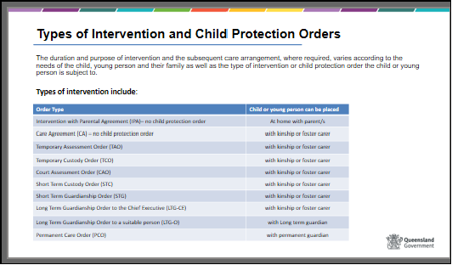

 | Show Slides 22 to 28  Intervention and Child Protection Orders  Expansion of information relative to the most common intervention and CPO’s:  Slide 22  - Intervention with Parental Agreement  Briefly describe this type of intervention and the impact for the carer.  Generally, with this type of intervention there is more involvement with the family or requests from Child Safety due to the agreement of the parents to work with Child Safety to address the concerns. This intervention is usually short term and intensive. The child generally stays in the home but could be placed in a care arrangement a Child Protection Care Agreement.  Slide 23  - Care Agreement – A voluntary agreement between the parent/s and Child Safety to enable Child Safety to place their child or young person in the care of someone other than themselves (parents).  There are 2 types of Care Agreements  - an assessment care agreement which can be no longer than 30 days – an assessment care agreement is applied for when Child Safety needs to assess whether a child is in need of protection.  - A child protection care agreement is generally sought for no more than 30 days but can be extended if required – a child protection care agreement is applied for when Child Safety have already determined that a child is in need of protection.  Slide 24  - Temporary Assessment Order (TAO)  - Temporary Custody Order (TCO)  Temporary assessment and custody orders are short term orders that are generally no longer than 3 days. The difference in the orders are determined by whether or not Child Safety believe that the child or young person is in need of protection (TCO) or if they need to do some more investigation and assessment to determine if the child or young person is in need of protection (TAO).  A child or young person may stay in a care arrangement for longer if another order is applied for. e.g. Court Assessment Order or Child Protection Order. Discuss short term nature of TAO and CAO often mean Child Safety may contact frequently, have many requests and at very short notice.  Slide 25  - Court Assessment Order (CAO)  A short-term order is where a child is placed initially for up to 28 days while an assessment of harm and risk of harm is being undertaken. The child may stay in the care arrangement for longer if the CAO is extended up to 28 days or another order is applied for. E.g., Child Protection Order.  Child Safety may contact you frequently and have short timelines of actions or requests.  Foster carer facilitator can provide some information or examples.  Slide 26  - Short-Term Custody Order (STC) can be made to the Chief Executive (Child Safety) or to a suitable family member  - Short-term Guardianship (STG)  Advise of the difference between custody and guardianship to help carers understand the difference between the two orders. Discuss differences between assessment and short-term orders. Discuss that Child Safety Officers will likely change because of the different focus teams in the Child Safety Service Centre (CSSC) have.  The focus of work/contact with a carer and for a child will be different than assessment orders. Expectations of carers will be different, for example carers may have more involvement in decision making, attending meetings and be asked to provide feedback on the child’s care and needs for case planning. Provide examples or foster carer can provide some.  Slide 27  - Long-Term Guardianship to Chief Executive (STG – CE)  - Long-Term Guardianship to Other (STG-O)  Discuss the differences and the impacts for carers who care for children who are subject to long term orders. Foster carers can provide some information or examples, including guardianship and custody differences but this will be explained later.  Slide 28  - Permanent Care Order (PCO)  Discuss the differences and the impacts for carers who care for children who are subject to permanent care orders.  Foster carer can provide some information or examples.  Only if time permits the trainer can mention the following orders. Ensure there is time for some questions or ask the group what challenges they may have as a carer after hearing some training information so far. Where you don’t mention the orders in this detail then provide a brief statement that there are other orders that you might here about where children usually remain at home.  Slide 29  - Other Child Protection Orders  As a carer you may not hear about the following orders very often as the child usually remains at home.  There are two types of Directive Orders:  - An order directing a parent of a child or young person to do, or refrain from doing, something directly related to the child or young person’s protection (Section 61 (a) of the Child Protection Act 1999) or  - An order directing a parent not to have contact, direct or indirect, either  - With the child or young person  - With the child or young person, other than when a stated person or a person of a stated category is present (Section 61 (b) of the Child Protection Act 1999)  - A Directive Order must not be more than one year (Section 62 (2) of the Child Protection Act 1999)  A supervision order requires the Chief Executive to supervise the child or young person’s protection, with respect to the matters stated in the order.  A supervision order may be applied for in conjunction with a directive order.  - The child or young person’s case plan needs to clearly specify how the supervision order will be implemented and monitored.  - A supervision order must not be for more than one year.  Trainers can discuss “Pre-adoptive Care” if this issue is raised within the group.  A small number of foster carers in Queensland may be approached to provide pre-adoptive foster care to a child whose parents are considering adoption. Very few of these care arrangements occur each year. Pre-adoptive carers do not require any additional training to provide pre- adoptive care; however they are asked to take on some additional responsibilities and must be able to abide by strict confidentiality requirements of the Adoption Act 2009 regarding the children who are being adopted.  Some of the additional responsibilities of pre-adoptive carers include:  - Preparation of the infant or child for future living arrangement with parent/s, extended family or adoptive parents.  - Provision of accurate and comprehensive progress records and photographs  - Introduction (transition) of a child to their prospective adoptive parents.  - matters stated in the order. | Slides 22  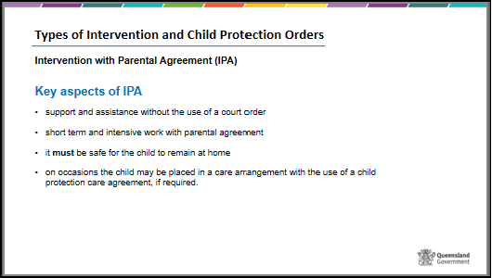  Slide 23  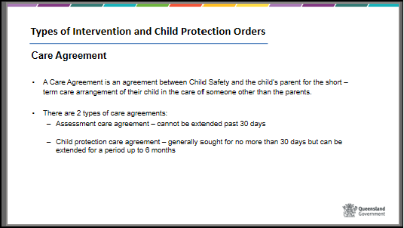  Slide 24  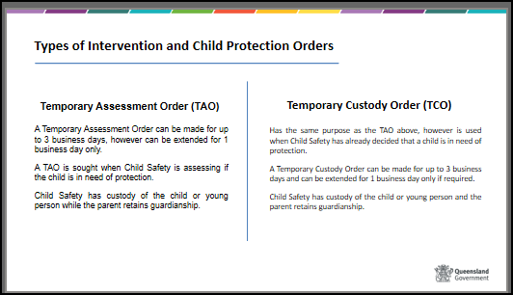  Slide 25  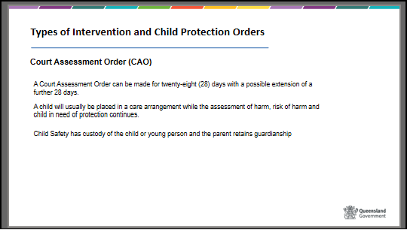  Slide 26  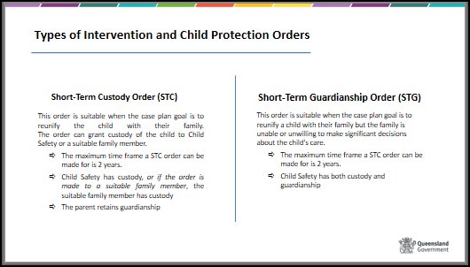  Slide 27  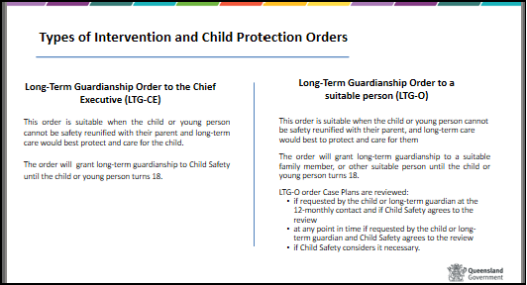  Slide 28  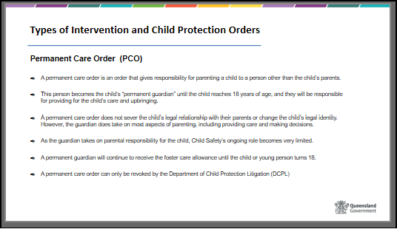  Slide 29  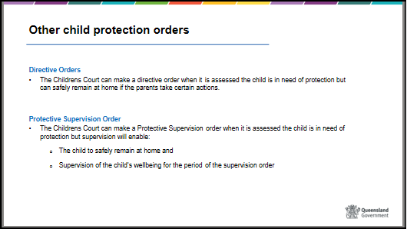
20 mins | Show Slide 30  This activity is suitable for a large training group, if you do not have a large group (i.e. enough participants to complete all roles associated with the activity) please skip this activity and slide.  An alternative activity has been provided for single participants or small training groups further along on the PowerPoint.  Activity 3  String Sculpture PowerPoint – Alice’s story | Slide 30  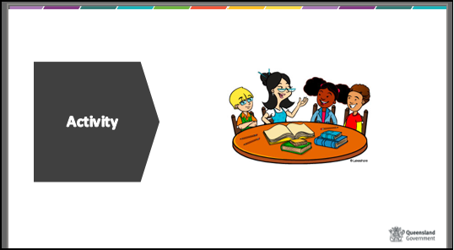

50 mins | Show Slides 31 and 32  Working together to meet the rights and needs of children and young people.  We all work as a team and have a shared responsibility to ensure that children in care have their rights and needs met and that they are provided with opportunities to have better outcomes. | Slide 31  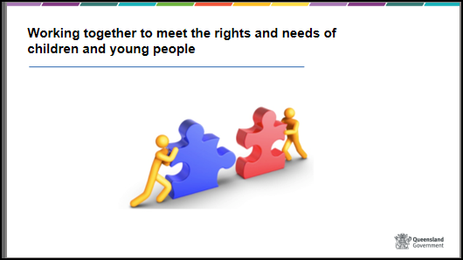  Slide 32  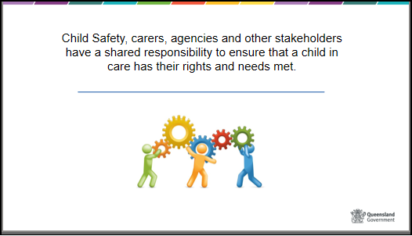
 | Show Slide 33  Rights and needs of children and young people  The legislation requires that the rights and needs of a child and standards of care are met. Child Safety staff carry a primary responsibility to ensure these requirements are met, but responsibility is also shared by all members of the child’s safety and support network – including carers and their Foster and Kinship Care agency.  Explain that some of these concepts will be discussed here and in more detail in later modules but that it is important to remember that what Child Safety and Foster and Kinship Carers do, and are required to undertake, is usually determined by law. | Slide 33  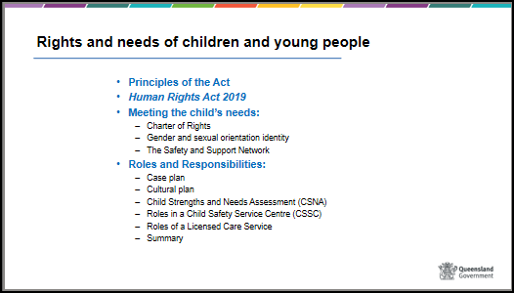

 | Show Slide 34  Principles of the Child Protection Act 1999  Handout – Principles of the Act, Charter of Rights  The principles of the act outline the general requirements needed to ensure the safety, wellbeing and best interests of a child or young person.  The preferred way to work with children and young people is with the support of their families and what is in the best interest of the child. As discussed earlier, Child Safety is by law required to seek family or kinship appropriate care arrangements when placing a child in a care arrangement (principle 5B (h)).  Wherever possible the aim is to safely return the child to their family. Link this with previous discussion about protective factors and supports to families.  Where children and young people need longer term stable care, every effort is made to preserve meaningful family and social connections for them including cultural, religious and ethnic relationships and connections (principle (l). Discuss that part of the carer’s role is to support and assist with maintaining these family connections and provide examples how.  Optional - Trainers can post the principles onto a wall and refer to them regularly during the training.  Slide 35  The needs, goals, outcomes, and actions just described meet the responsibilities and rights outlined in the Charter of Rights in the Child Protection Act 1999.  It is important to know that there is a legal obligation to ensure rights of children and young people are upheld. | Slide 34  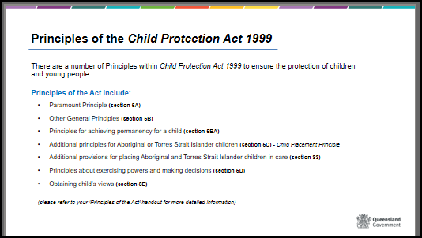  Slide 35  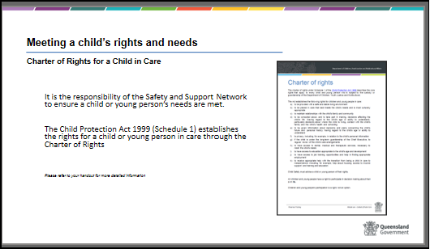

 | Show Slide 36  Activity 4 – Principles of the Act | Slide 36  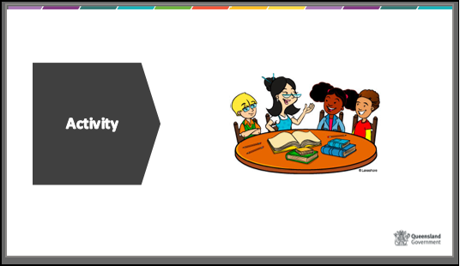
 | Show Slide 37 & 40  Principles of the Child Protection Act 1999  Special provisions for Aboriginal and Torres Strait Islander children.  Note to participants that this is a content heavy section.  Trainers are encouraged to contact local Aboriginal and Torres Strait Islander organisations for local information and resources to assist with these sections or questions by participants.  It is important for all foster carers to be aware of the issues that face Aboriginal and Torres Strait Islander people because if they are caring for an Aboriginal and/or Torres Strait Islander child they will be required to assist in enhancing the child’s Aboriginal and Torres Strait Islander identity, connection to their culture. This includes involvement with maintaining contact between the child and their family and/or community group.  Handouts  - Refer to ‘Principles of the Act’ handout – section 5(c) Aboriginal and Torres Strait Islander Child Placement Principle  - Additional provisions for placing Aboriginal and Torres Strait Islander children in care  - Child Placement Principle poster  - Independent person – information for Aboriginal and Torres Strait Islander children and young people (note that this resource has been written for children and young people, however carers should familiarise themselves with the content so they are aware of children and young peoples rights regarding an Independent person)  Show slide 37  The Child Protection Act 1999 states that the preferred way for an Aboriginal and Torres Strait Islander child to be cared for is within their family or community.  Section 5(c) of the Child Protection Act 1999 provides the guiding principles when making decisions about Aboriginal and Torres Strait Islander children.  The 5 Child Placement Principles as can be found on the Principles of the Act handout, page 2, go through these principles with participants as per the slide information.  Show slide 38  Refer to the Additional provisions for placing Aboriginal and Torres Strait Islander children in care handout.  Go through each slide and provide an overview of the provisions and discuss with participants their understanding of the importance of these additional provisions.  The following slides provide excerpts of the Child Protection Act 1999 (s83) section 83 regarding the additional provisions for placing Aboriginal and Torres Strait Islander children in care.  Section 83 s(2) and (3) - provisions that are required to be undertaken by Child Safety regarding an independent person to facilitate the participation of the child and the child’s family when needing to make a decision on where or with who the child or young person will live.  For further understanding of an independent person refer participants to the Independent Person handout.  Show slide 39 & 40  Section 83 s(4) through (7) - the provisions around ensuring that an Aboriginal or Torres Strait Islander child should be placed with a member of the child’s family group.  Where this isn’t possible, section (5) advises that if it is not practicable to place the child with a member of the child’s family group, the child should be placed in order of priority to:  - a member of the child’s community or language group; or  - an Aboriginal or Torres Strait Islander person who is compatible with the child’s community or language group; or  - another Aboriginal or Torres Strait Islander person; or  - a person who—  - lives near the child’s family, community or language group; and  - has a demonstrated capacity for ensuring the child’s continuity of connection to kin, country and culture.  If a care arrangement cannot be made with or near a member of the child’s family or community or language group or another Aboriginal person or Torres Strait Islander within or near to the child’s community or language group, the child may be placed with a non-Aboriginal person or Torres Strait Islander.  Provide the below handouts for participants, give them time to read through the information so they gain some understanding as to why these principles have been incorporated and the importance of understanding the significance of the lived trauma for Aboriginal and Torres Strait Islander people.  Handout - “Historical Overview of why Aboriginal and Torres Strait Islander children come into care”  Refer to Handout  Outline the historical background – include:  - removal of children until the 1960’s  - compounded by poverty  - unemployment, and  - health factors  - Over representation in the child protection system.  In view of past history many Aboriginal and Torres Strait Islander people have a fear and distrust of government organisations. | Slide 37  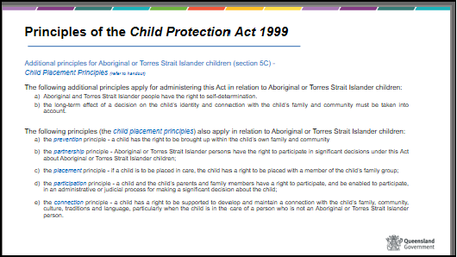  Slide 38  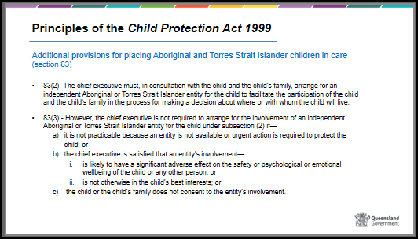  Slide 39  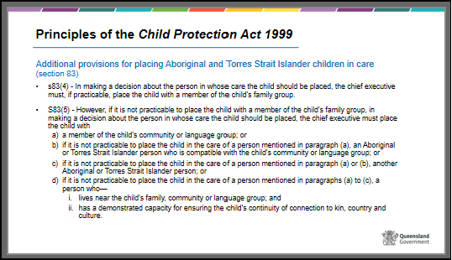  Slide 40  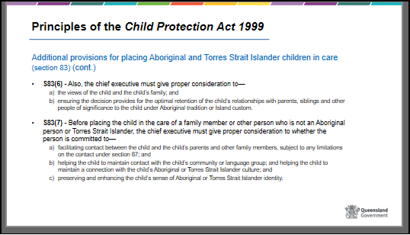
Useful resources for trainers

- Resources in the Child Safety Practice Manual including
- Practice Kit: Child Placement Principle (https://cspm.csyw.qld.gov.au/practice-kits/care-arrangements/overview/child-placement-principle)
- Practice Kit: Independent person (https://cspm.csyw.qld.gov.au/practice-kits/safe-care-and-connection/participation-in-planning-and-decision-making/seeing-and-understanding/independent-person)
- Bringing them home DVD – this is available via the Australian Human Rights Commission website at: http://www.humanrights.gov.au/social_justice/bth_report/index.html
- Secretariat of National Aboriginal and Islander Child Care (SNAICC) website at www.snaicc.org.au
- Queensland Aboriginal and Torres Strait Islander Child Protection Peak at http://www.qatsicpp.com.au/

 | Show Slide 41  Handout - the Queensland Human Rights Act 2019: an easy read guide  Queensland’s Human Rights Act was passed by State Parliament in February 2019.  Queensland’s Human Rights Act 2019 protects 23 human rights in law. The Human Rights Act 2019 protects the rights of everyone in Queensland and requires the Queensland public sector to act and make decisions which are compatible with these rights.  Child Safety is considered a ‘public entity’ under The Human Rights Act 2019 which requires them to consider human rights in all decision-making and actions, and only limit human rights in certain circumstances and after careful consideration.  When delivering services and interacting with the community, public entities must:  - act compatibly with human rights when making decisions or taking actions  - give proper consideration to human rights when making decisions or taking actions.  These obligations apply to Child Safety staff, as employees of a public entity under the Human Rights Act 2019 and apply to all aspects of decision making that is undertaken by Child Safety staff, who have a responsibility to respect, protect and promote the human rights of individuals.  Carers are also considered under this ‘public entity’ and have a responsibility to ensure that the decisions made for children and young people in their care are also in line with the Human Rights Act. | Slide 41  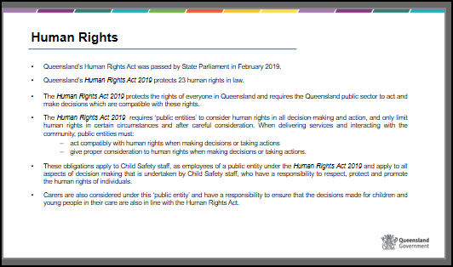

 | Show Slide 42  The 23 human rights are not absolute - that is, they are allowed to be limited, but only in a way that is necessary, justifiable and proportionate.  The 23 human rights are:  - Your right to recognition and equality before the law  - Your right to life  - Your right to protection from torture and cruel, inhuman or degrading treatment  - Your right to freedom from forced work  - Your right to freedom of movement  - Your right to freedom of thought, conscience, religion and belief  - Your right to freedom of expression  - Your right to peaceful assembly and freedom of association  - Your right to taking part in public life  - Property rights  - Your right to privacy and reputation  - Your right to protection of families and children  - Cultural rights – generally  - Cultural rights – Aboriginal peoples and Torres Strait Islander peoples  - Your right to liberty and security of person  - Your right to humane treatment when deprived of liberty  - Your right to a fair hearing  - Rights in criminal proceedings  - Rights of children in the criminal process  - Right not to be tried or punished more than once  - Retrospective criminal laws  - Right to education  - Right to health services | Slide 42  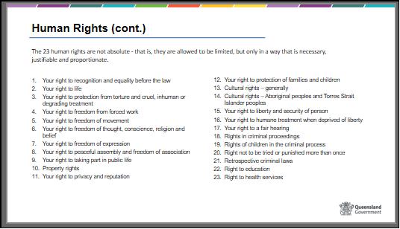

 | Show Slide 43  Meeting the child’s rights and needs – gender and sexual orientation diversity  Depending on the group, the amount information that is provided below may vary.  Discuss with participants the need to be sensitive and non-judgmental around the topic of gender and sexual orientation diversity.  It’s important to remember a person’s sexual orientation is theirs, and the way they want to describe it and who they share that with is completely up to them. We should never force a person to share information with us that they are not comfortable sharing.  Just as a child or adult’s culture forms an important part of their identity, so does their sexual orientation, gender identity and gender expression. These concepts all relate to one another in various ways; however, they have distinctly unique meanings and must be recognised as such.  It is important that we all understand the basic concepts that relate to sexual and gender diversity so we can be respectful when working with families and caring for children and young people.  Handout – Basic concepts for sexual and gender diversity  Discuss the concepts on the handout  - Sexual orientation refers to who a person is emotionally, physically and/or romantically attracted to. There are many sexual orientations including, but not limited to, gay, lesbian, bisexual, asexual, heterosexual, demisexual, pansexual and many more.  - Gender identity is about how a person feels inside, regardless of their sex assigned at birth. It is an inner concept of the way one’s self is viewed, ranging from male, female, to neither or both. Gender can be considered on a spectrum, ranging between male and female. Some people may not identify exclusively as being either male or female and identify somewhere in between.  - Gender expression is the way someone expresses aspects of their gender identity or role, which is usually visible to other people. Gender expression can include what someone wears, the way they talk, walk and behave, and the way they present themselves such as their hair style or use of make-up. A person’s gender identity or sexual orientation cannot be determined based on their gender expression. Gender expression can also be considered on a spectrum ranging from masculine to feminine. Some people may slide along the scale and express themselves as more masculine or feminine at different times. Some people may express themselves as being neither overtly feminine or masculine, and some people may choose to express themselves in both a feminine and masculine way at the same time.  It is important that you understand these and other terms in order to support and affirm the children and young people in your care. Also, language helps shape our perceptions of other people and has great power to affirm or harm the identity of the people we work with.  Show Slide 44  Some other terms that you may need to understand are, LGBTIQ+, Cisgender, gender binary, assigned sex / sex assigned at birth, non-binary and genderqueer.  Discuss the terms on the slide with participants  Show Slide 45  As a carer, you need to be aware of your own beliefs, values, and prejudices when it comes to sexual orientation, gender identity, and gender expression. A good place to start is to reflect on your own sexual orientation and gender identity.  There is a big difference between being unfamiliar with terminology or not knowing how to best support a child with gender or sexual orientation diversity and rejecting or condemning a child’s sexual orientation and gender identity.  A lack of acceptance or denial of a child’s sexual orientation or gender identity greatly increases the risk that a child or young person will experience anxiety and depression, will engage in self-harm, and/or attempt or complete suicide.  As a carer, if you do not affirm a child’s sexual orientation or gender diversity, this will further compound the trauma the child or young person is likely to have experienced prior to and while in care. | Slide 43  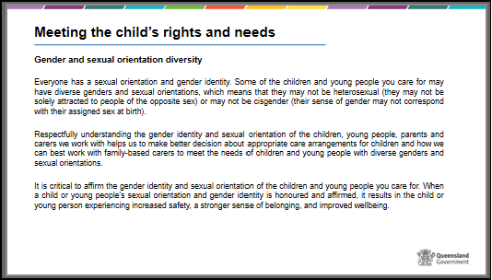  Slide 44  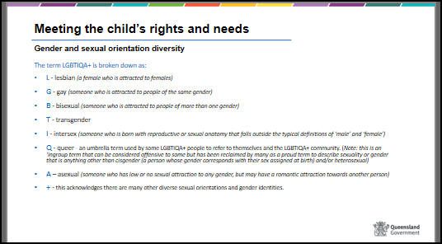  Slide 45  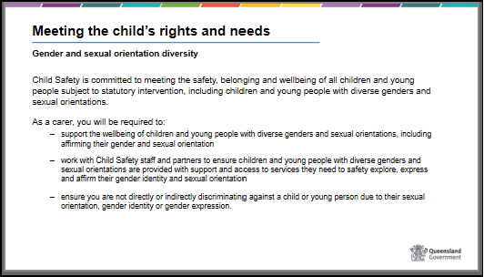

 | Show Slide 46  Meeting a child’s rights and needs - The Safety and Support Network  What is a safety and support network?  Discuss with participants the importance of the Safety and Support Network and the role they will play in advocating for the children and young people in their care.  Over time the safety and support network is to build a strong network around the child or young person, their parents, family, friends, community members, carers and professionals to ensure the best outcomes for that child or young person.  Show Slide 47  Each child and young person’s safety and support network will look different as different children and young people will require a unique safety and support network depending on the harms they have already suffered and any risk of harm or current worries for that child or young person. | Slide 46  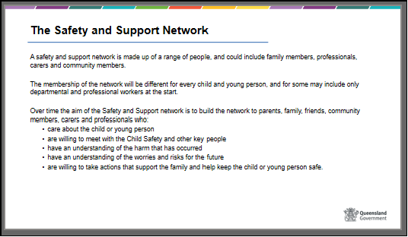  Slide 47  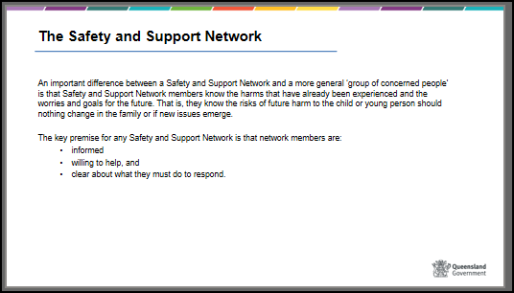

 | Meeting a child’s rights and needs – Roles and Responsibilities  Child Safety and Foster and Kinship care services will assist carers with their roles and responsibilities.  Carers will engage with a range of people and organisations whilst caring for a child and at times this can become confusing. This section is an overview of the roles and responsibilities of Child Safety and Foster and Kinship Care Services and some of the people you are likely to meet.  Later in Module 4 we will be examining other organisations involved in the care of children in Queensland.  Where you are unsure about who does what then remember to ask either your Foster and Kinship Care worker or the child’s CSO.  Show Slide 48  Roles within a Child Safety Service Centre (CSSC)  The role of Child Safety is the provision of care and protection to children who have or are at risk of harm and do not have a parent willing and able to protect them.  Discuss briefly the roles and responsibilities of each category below and discuss who that are likely to talk to day to day.  - CSSC Manager - Oversees that the child protection services provided comply with relevant legislation, delegations, policies, quality standards and the Child Safety Practice Manual.  - Senior Practitioner - Supports, monitors and mentors Child Safety Officers, Child Safety Support Officers and Senior Team Leaders in development of practice skills.  - Senior Team Leader - Provides leadership and supervision to CSSC staff who deliver child protection services to children, young people and their families.  - Child Safety Officer (CSO) - is an authorised officer under the Child Protection Act 1999 and is responsible for delivering statutory child protection services.  - Child Safety Support Officer (CSSO) - Supports CSO’s in the provision of child protection services to children, young people and their families and works collaboratively with foster and kinship carers, the community, government and non-government service providers.  - Cultural Practice Advisor (CPA) –is based in the CSSC and is an Aboriginal and Torres Strait Islander (identified) position that provides individualised and culturally appropriate casework support to children and families, and cultural leadership in the CSSC, to support culturally appropriate work with children and families.  - OCFOS Lawyer (Legal Officer) – is an in-house legal unit providing early and independent information and legal advice to Child Safety Service Centres in relation to the commencement of child protection applications in Queensland.  - Family Group Meeting Convenor - The convenor plans, facilitates and records the child or young person’s case plan that is developed at the Family Group Meeting.  - Administration Staff - Provides administrative support to staff in the CSSC.  - Business Officer (BO) - Provides financial, human resources and business support to Child Safety staff within the CSSC. | Slide 48  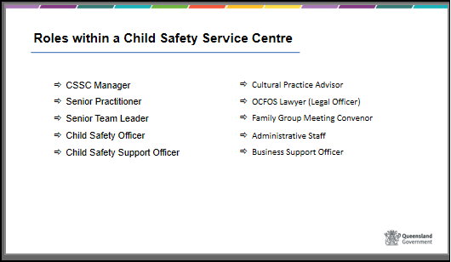
 | Show Slide 49  Roles within a licensed care service  Foster and Kinship care services recruit, train, assess and support foster and kinship carers. Carers then provide role modelling and a safe, secure, supportive care environment to children and young people in care.  Foster and Kinship care services provide assistance and advice to carers about the legal, policy and practice processes of Child Safety and the associated standards of quality care expected for children and young people in care.  Carers are also supported and assisted with any concerns raised about a child in care or where a carer requests a review of a decision Child Safety has made in the Queensland Civil and Administrative tribunal.  Carers can face very challenging times when caring for a child with moderate to high behavioural, emotional, medical, social, and physiological support needs. Foster and Kinship Care services are funded by Child Safety to help counsel, provide advice, guidance, and support to carers when times get challenging. Child Safety and Foster and Kinship can also provide access to respite when required.  Support will be discussed further in module 4. | Slide 49  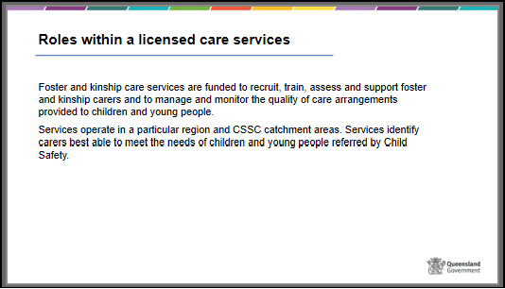

 | Slide 50  Roles of Child Safety  Discuss with the participants the importance of the Case Plan and that is it contains all the goals and outcomes that Child Safety is currently working on with the child, young person, their family and any other significant people which may include themselves in the carer role.  A case plan will be reviewed every 6 months or when there are significant changes for a child or young person.  Cultural Support Plans are significant for children and young people who are Aboriginal or Torres Strait Islander and who have been placed in care. The cultural support plan is developed to ensure they remain connected with their culture, families and communities regardless of where they are living.  A Child Strengths and Needs Assessment – or CSNA – is completed for each child and young person in care and provides an assessment of any strengths and needs for that child or young person. The CSNA will be incorporated into a child or young person’s case plan to identify the tasks, actions and goals that need to be met as part of the assessment. | Slide 50  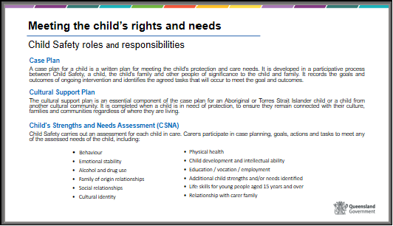
 | Show slide 51  Critical incident reporting  As a child’s carer, you may be the first person to be aware of a critical or major incident involving or impacting on a child in care. Your immediate response, and the ongoing guidance and advice from others in the child’s safety and support network, will help in providing a supportive, responsive and safe care environment for the child, and reduce the risk of recurrence.  Child Safety requires carers to, respond to and report events which negatively impact, or have the potential to negatively impact on the safety, well-being and best interests of a child or young person in care.  Go through slide information and advise participants that more information can be found on the Departments website under Information for existing carers or get them to scan the QR code to be taken directly to the page. | Slide 51  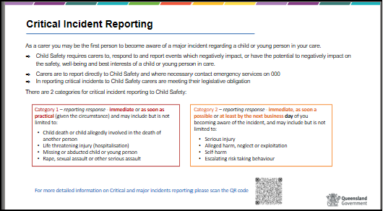

 | Slide 52  Meeting a child’s rights and needs – Summary  To pull this together, the Safety and Support network as a whole are responsible for meeting the needs and rights of children and young people in care. The needs are outlined by Child Safety in the child’s case plan and the Safety and Support network help action the goals and outcomes in the case plan. These needs are linked to the legal responsibility to ensure that the Charter of Rights is met for all children in care. | Slide 52  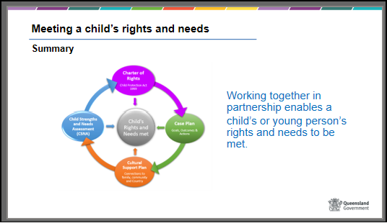
 | Show slide 53  There are 2 activities below, you can either complete both or just one of these activities.  It is recommended that if you have previously completed Activity 3 – Alice’s Story you do not need to complete Activity 5 Jaxon’s situation here.  Activity 5 – Needs of children  and/or  Activity 6 – Jaxon’s situation | Slide 53  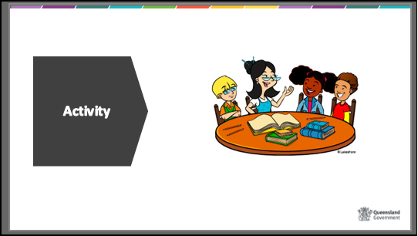

 | Slide 54– 57  Carer Allowances  HANDOUT – Carer Allowances  When caring for a child or young person Child Safety provide a variety of carer allowances to financially support carers. Not all carers will receive all allowances however depending on the needs of the children and young people you care for additional financial support may be provided for periods of time.  Go through the slides and the various types of allowances with participants, participants can refer back to the handout or scan the QR code if they require more information.  The Fortnightly caring allowances is provided to all carers and is to help meet the day to day costs of caring for a child or young person but may not cover all associated costs.  The fortnightly caring allowance takes into consideration the following:  - day-to-day reasonable clothing and footwear, including one school outfitting per year  - personal care items  - general schooling and education expenses, including lunches and travel  - costs for consulting with a GP (excluding Child Health Passport assessments)  - all prescribed and non-prescribed pharmaceuticals  - general travel costs, including fuel costs up to 250km per week (excluding for approved family contact)  - leisure and recreational activities, toys, pocket money, entertainment, hobbies and holiday expenses  - safety equipment such as car seats, bike helmets  - energy and utility costs (pro rata)  - household goods for the child.  The allowances provided by Child Safety are not considered to be income when providing care which means, carers are not required to declare this money when completing you tax returns and it cannot be declared as ‘income’ when applying for loans.  Carer allowances do not affect any Commonwealth benefits received by carers. | Slide 54  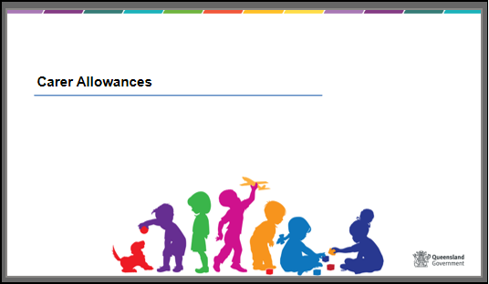  Slide 55  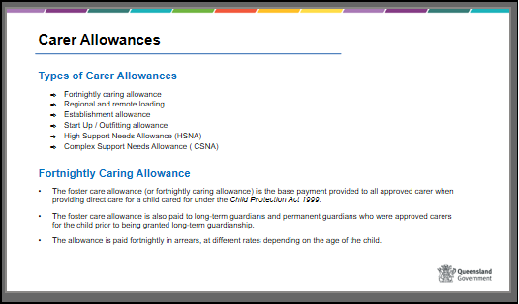  Slide 56  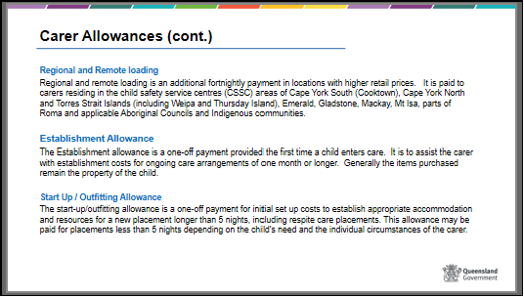  Slide 57  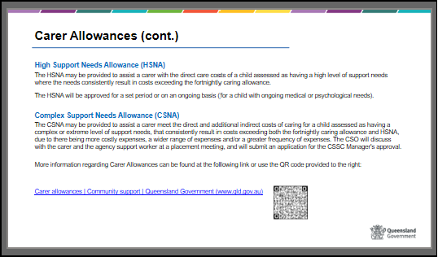
 | Slide 58  Australian government financial support  Foster and kinship carers may be eligible to receive family and parenting payments from the Australian Government.  Go through the slide information and advise participants that the can find more information on the departments website, under the Information for existing carers webpage, or scan the QR codes on the slide. | Slide 58  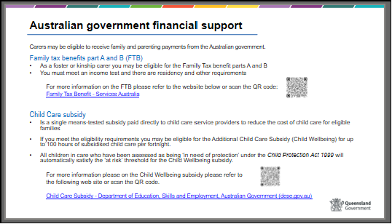
 | Show Slide 59  Foster and Kinship Care Supports  Show Slide 60  Carer Connect  Carer Connect is a web and digital app that that has been developed to provide carers by providing secure access to information and support, when needed.  Information available through the app includes:  - Placement agreement and Authority to Care  - medical information, e.g. serious health condition alert, health passport and immunisations  - Child Safety contact information, including after-hours phone number  - type of child protection order and expiry date  - cultural information  - current education information.  The app can be downloaded through either the Apple store or google play.  Show video in slide, if not working the video can be found at the following link:  https://youtu.be/11JJBAv2UNw | Slide 59  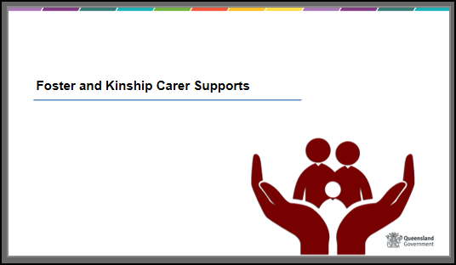  Slide 60  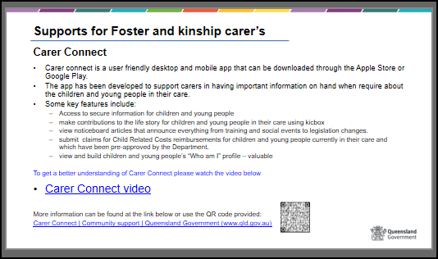
 | Show Slide 61  Support for carers  While all these responsibilities and roles may seem daunting remember there is support provided to approved foster and kinship carers by either Child Safety staff or the staff of a foster and kinship care service.  If you are a foster or kinship carer that is supported by a Non-Government Organisation, you will be assigned a case worker who will conduct regular home visits, be available for telephone support, respond to emails, attend case planning meetings, provide support through matters of concern and in addition, access to an after-hours telephone support is available. Throughout the training we will be providing further information about support. | Slide 61  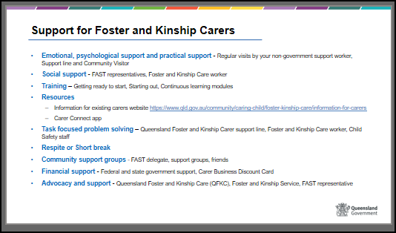
 | Show slide 62  Play CREATE Foundation video ‘Snap the Stigma’ using the link on the slide.  The video is to help participants understand that children in foster care are often perceived differently to children who are not in care and how this perception negatively affects each child or young person. This will be something that they can take with them at the end of the session to reflect on.  CREATE want to change the pre-conceived views that people may have about young people with a care experience. CREATE want to share stories of children and young people in care who are doing great things to help change these views It all starts with believing that children and young people are more than just their care experience. | Slide 62  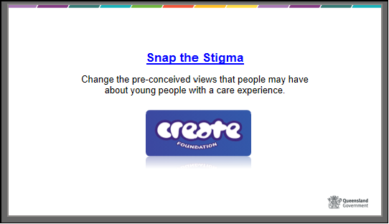

 | Show Slide 63 and 64  Conclusion Show  Summarise the module and focus on the key aspects of why a child comes into care, who makes the decisions, roles and responsibilities and needs.  Provide the “Learning outcomes” and summarise the main points discussed in each outcome. Ask participants to complete the Worksheet and return it at the next session. Offer participants the opportunity to raise any questions with the trainers.  Emphasise the needs of children in care, refer to the need’s domains, and that children in care have high behavioural, emotional, social, health, educational support needs, which can be challenging but there is support. Review that it is the role and responsibility of carers and Child Safety staff to address these needs in accordance within the principles of the Act, Charter of Rights, and the statement of standards. Remind carers that support is offered by both Child Safety and non-government agencies when times get challenging. | Slide 63  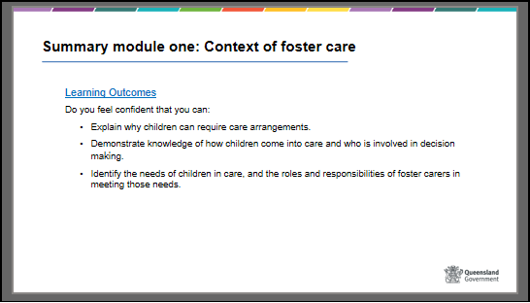  Slide 64

