Module four
Quality care - Working together
Session Plan

3 Hours

Assessment
Learning Outcomes
Method of Delivery

The assessment necessary for each participant will be based on:
- Participation in discussions and training activities
- Completion of worksheets at the end of the session
At the end of this module participants will be able to:
- Demonstrate how all key players can work together – including when things go wrong
- Demonstrate an understanding of carer support options
- Demonstrate an understanding of Transition

- Demonstrate an understanding of the complexities of ending a placement

Lecture
Small / large groups
Brainstorm
Activities

Handouts – multiple copies of:
- Statement of Commitment | - TILA fact sheet – CREATE
- Change in carer circumstances form | - Next Steps Plus Fact Sheet
- Case Studies – 1, 2 & 3 | - Standing on your own two feet
- Conclusion of placement form | - Go your own way – Information kit
- Qld Health Fact - Depression | - Qld Health Fact Sheet - Anxiety
- Qld Health Fact Sheet - PTSD

- Power Point slides
- Whiteboard/pens
- CREATE Resource
- CSPM:
- Procedure – Support a child in care
Resources can be obtained from CSSC staff or via a search of the Child Safety internet, Infonet or within the CSPM.

Resources

Resources can be obtained from CSSC staff or via a search of the Child Safety Internet or within the Child Safety Practice Manual

2 mins | Acknowledgement of Country  I would like to respectfully acknowledge the Traditional Owners of the land on which we are meeting today and acknowledge that Aboriginal and Torres Strait Islander peoples are the custodians of this country and recognise their connections to land, sea, water and sky. We pay our respects to Insert Local tribal/language group, their continued culture and to their Elders past, present as well as those emerging leaders of tomorrow.  Pause  Thank you
 | Show slide 1  Distribute name tags | Slide 1  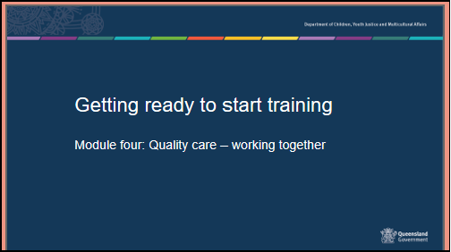
25 mins | Housekeeping, introductions, and training assessment expectations  Housekeeping details – provide the location of exits and toilets, information on breaks and catering, arrangements for smokers and phone messages. Include fire, evacuation and emergency exit and meeting points as well as any other WH&S procedures required.  Introducing each other - Use your own icebreaker or the example below  Get participants to introduce themselves to the person sitting next to them and tell them one fun activity they have done with a child or young person. Report back to the group.

Group Rules

These should be sourced from the group - ask what people would need from the group in order to feel comfortable. Ensure that the following are covered:

- Confidentiality – any information that is shared in the group will be confidential to the group – however, link to the need to respect confidences in a placement situation.
- Mutual respect and tolerance for a diversity of opinions, cultural backgrounds, and experiences.
- Punctuality and respectful processes in discussion

 | Show slide 2  Overall aim of Getting ready to start training.  Getting ready to start training is presented in 4 modules of 3 hours each.  - Context of Foster Care Module one-.  - An understanding of the process of how children and young people come into care and the impact of this process, and why children and young people require a care arrangement.  - Understanding the past for a child or young person  - An understanding of trauma and related behaviours for a child or young person who is in care arrangement.  - Early days in a care arrangement  - Developing knowledge and skills required to meet the physical, emotional and social needs of children and young people in care and an understanding of the importance of participation by children and young people and their families in decision making.  - Working together- you are here  - Have an understanding of the importance of partnerships between children, their families, foster and kinship carers and workers, (both in the government and non-government sectors), and their roles and responsibilities when working together as a team. | Slide 2  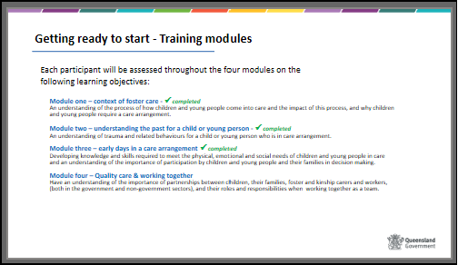
 | Show slide 3  Learning outcomes – module 4  This module outlines some of the knowledge and skills you will need as a placement continues.  At the end of this module you will be able to: as per slide | Slide 3  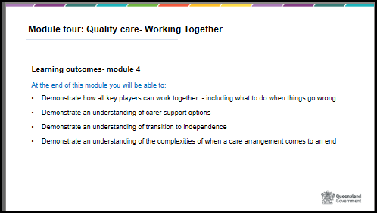
15 mins  30 mins  30 mins  45 mins  15 mins  20 mins  10 mins | Show slide 4  Early days in a care arrangement – Content and timeframes  This module of the training will cover some of the things you need to know before you accept a care arrangement for a child or young person.  - Working in partnership – Statement of Commitment  - Standards of Care (SOC)  - What is a Standard of Care?  - What is a harm report?  - Carer Supports  - General support  - Financial support  - Changes in carer circumstances  - Guest panel  - Transition to Adulthood  - What is T2A  - How can you support T2A as a carer?  - Resources  - Saying Goodbye  - When a child or young person moves on.  - Conclusion & Evaluation | Slide 4  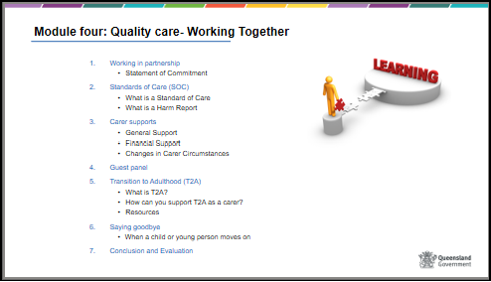
15 mins | Show slide 5  Working in partnership – Statement of Commitment  A Statement of Commitment has been developed by Child Safety and peak bodies, Queensland Foster and Kinship Care (QFKC) PeakCare and the Queensland Aboriginal and Torres Strait Islander Child Protection Peak (QATSICPP) to reflect the shared commitment of partnership with carers for the benefit of children and young people in care.  The commitment acknowledges the unique role of carers as volunteers in the partnership and promotes the critical role carers will play as part of a team when you open your homes for children and young people in care.  The objective of the team approach is to work together effectively to promote and ensure the safety and wellbeing and belonging of children and young people in care. |  | Slide 5  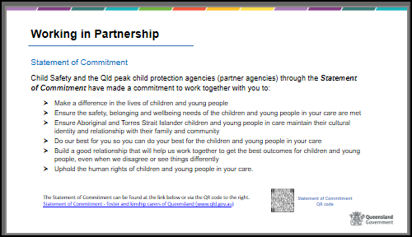
 | Show slide 6  Refer to separate activities resource for instructions on activity  BRAINSTORM – Who might you be working in partnership with to enhance the child or young person’s care arrangement? |  | Slide 6  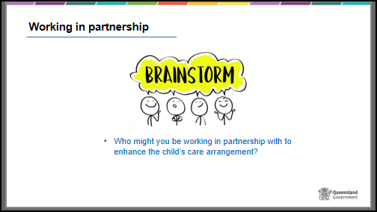

 | Show slide 7  Statement of Commitment cont.  HANDOUT – Statement of Commitment and explain that the power point roles and responsibilities are not an exhaustive list.  Each party of the Statement of Commitment have a role to play with Child Safety, foster and kinship care services and carers have common responsibilities, however the way in which these responsibilities are used will vary according to the respective roles.  Child Safety, being the lead child protection agency in Queensland works with carers and foster and kinship care services to ensure the safety, belonging and wellbeing of children and young people in care.  The next 2 slides will focus on some of the key roles of carers and Child Safety.  Show slide 8  Carer roles focus on providing stable care arrangements for children and young people that are consistent with the Statement of Standards and the Charter of Rights.  Given the over representation of Aboriginal and Torres Strait Islander children and young people in the child protection system, a strong focus on ensuring that Aboriginal and Torres Strait Islander children and young people are connected to family, community and culture is a vital role that requires ongoing commitment from the whole Safety and Support network including you as a carer.  As a carer you will be participating in decisions for children and young people in your care that may have a profound effect of their lives.  Other roles that you may not have thought of as part of your role as a carer my also include the development of and amending of current Child Safety policies that may impact carer practice as well as participate in and support carer training.  Show slide 9  Similarly, Child Safety have specific roles and functions that they must follow to ensure they meet the needs of children and young people.  Give participants time to read through Child Safety’s roles on the slide and answer any queries raised.  Advice participants to refer to the Statement of Commitment document for more detailed information.  Child Safety also provides funding to foster and kinship care services and works closely with Queensland Foster and Kinship Care, PeakCare, Create, OPG and QATSICPP to promote the safety, wellbeing and best interest of children and young people in care.  Together the key role and responsibility of Child Safety, carers and other services is to work in close partnership to ensure that:  • The child’s day to day and special needs (education, health) are met  • The child maintains contact with family, significant others, siblings, and places  • The child’s cultural identity, practices and religious beliefs are supported  • Children are supported to participate in decision making about their life. | Slide 7  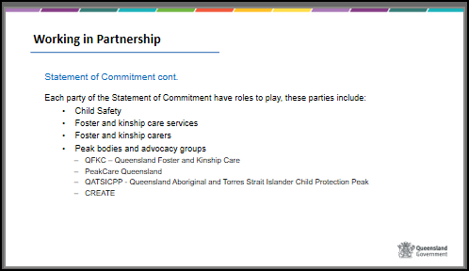  Slide 8  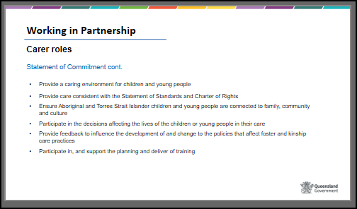  Slide 9
30 mins | Show slide 10  Standards of Care (SOC)  You are here today because you want to play a part in caring for, nurturing, and protecting children who are unable to safely live at home.  Although carers dedicate their lives to children in care and want the best for them, sometimes concerns can arise about the standards of care provided to children and young people by their carers.  Unfortunately, it is true that some children have been harmed while in care and this has led to significant changes to the child protection system. | Slide 10  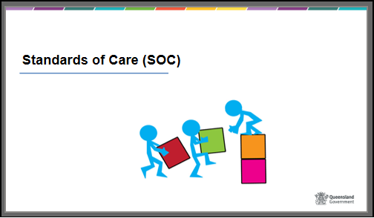

 | Show slide 11  Refer to separate activities resource for instructions on activity  Activity – Standards of Care | Slide 11  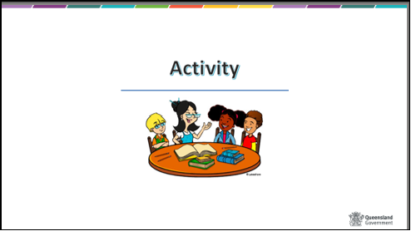
 | Show slide 12  Standards of Care  Child Safety has a responsibility to ensure that children in care are provided with care that meets their needs and is consistent with the legislated Statement of Standards.  If Child Safety becomes aware of information that a child’s care may not be meeting the standards of care, Child Safety will respond to find out if there is a problem and how everyone can work together to fix it. This includes how the carer can be supported to meet the child’s needs.  The process of responding to and assessing concerns about the standards of care is to be conducted in a manner that is consistent with the Statement of Commitment we have just discussed. This means that carers should feel valued and supported throughout the process.  When Child Safety receives information about possible concerns or worries regarding the care of a child or young person, a decision will be made about the most appropriate way to respond to these concerns or worries that fits with the seriousness of the concerns.  Not all concerns are the same, so the response will depend on the nature of the concerns, the possible impact on the child, and what needs to be done to address the concerns.  Carers also have the option to access a support person during a standard of care process.  There are three different response options from Child Safety that depend on the nature of the concern or worry:  - Continue to monitor  - Standards of care review  - Investigation and assessment of harm  Child Safety is responsible for working collaboratively with the child’s care team to ensure that the child is safe from harm, and that appropriate actions are taken to resolve the identified concerns. | Slide 12  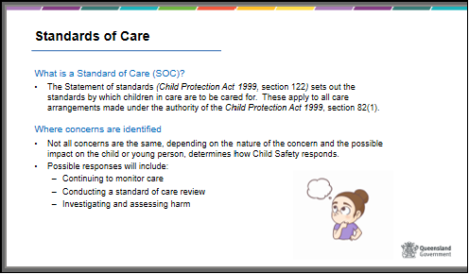
 | Show slide 13  Continue to monitor  This response may occur when Child Safety has some concerns about the care a child or young person is receiving, the CSO and/or your foster and kinship care support working will discuss these concerns with you to see if there is any additional assistance or supports that could be provided to you to help.  Generally, most concerns can be addressed through the regular supports provided by your agency and Child Safety. | Slide 13  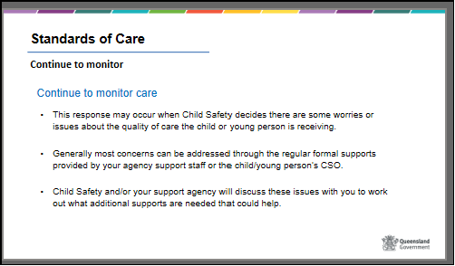
 | Show slide 14  Standard of Care Review (SOCR)  This response will be followed if Child Safety has some concerns that the quality of care a child or young person is receiving may not be meeting the legislated standards of care and therefore a more direct assessment is required, which is a Standard of Care Review.  As per the slide information Child Safety will engage with you and your foster and kinship care support worker to work through any concerns and gather an understanding of any challenges, achievements or supports you are receiving or if there are any areas of unmet needs that could be contributing to any concerns.  Child Safety will also speak to the child or young person to provide them with an opportunity to talk about their current care environment, as well and take into consideration any roles and responsibilities of the other members of the safety and support network including Child Safety themselves and the foster and kinship care service.  If its determined that the needs of the child or young person have not been met, then Child Safety will ensure there is a review of the carer’s placement agreement prior to finalising the standards of care review. | Slide 14  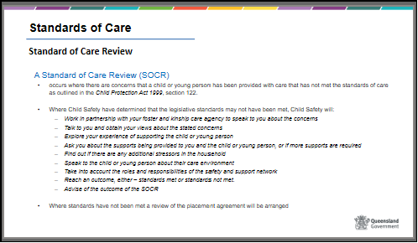
 | Show slide 15  Harm Report  Where there are concerns that a child or young person may have been harmed as a result of the actions or inactions of a carer, Child Safety, in consultation with the foster and kinship care support agency will record a harm report.  A harm report is a more serious response and requires Child Safety to complete an investigation and assessment which, depending on the concerns received, may or may not include Qld Police.  Child Safety will work with the carer’s support agency to discuss the concerns and seek their contribution on how to best respond to the allegations.  Go through the remaining points as displayed in point 3 and that should Child Safety determine that there is a high risk to a child or young person in the care arrangement, they may make the decision to remove that child or young person from the care arrangement. | Slide 15  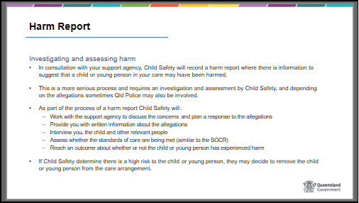
 | Show slide 16  Harm report outcomes  The possible outcomes for a Harm report include:  1. Substantiated harm – standards not met  2. Substantiated harm – standards met  3. Unsubstantiated – standards not met  4. Unsubstantiated harm – standards met, and  5. No outcome.  The outcome of Substantiated harm – standards not met  - means that the child has experienced harm or is likely to experience future harm AND the actions or inactions of the carer contributed to the harm.  - For example, the child experienced physical harm, such as bruising, and emotional harm, by being hit by the carer.  Whereas the outcome of Substantiated harm – standards met  - means that the child has experienced harm or is likely to experience future harm BUT there is no indication that the carer has not met the standards of care.  - An example of this scenario could be where another adult or child who resides in the carer’s household has harmed the child however the carer’s actions or inactions did not contribute to the harm. In such cases, the carer would be protective of the child and have continued to meet the standards of care for the child.  Where the outcome is either (1) Substantiated harm or (3) Unsubstantiated but the standards have not been met – an action plan is developed with the carer to identify actions to address any concerns.  Handout Complaints brochure  Review processes are available to you for certain actions – either within Child Safety or through the Queensland Civil and Administration Tribunal (QCAT). Child Safety will advise you of your rights | Slide 16  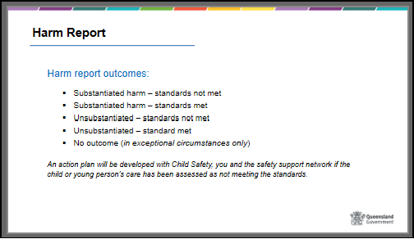
30 mins | Show slide 17  Carer Supports  It is important that you recognise the pressures and stresses that are intrinsic in this work, and plan ways to access support.  In this session we will look at support options including practical and emotional support. Support and self-care is covered in more depth in a module that you will complete in the first 12 months after this training. | Slide 17  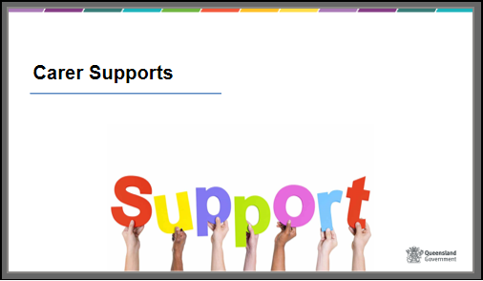
 | Show slide 18  Refer to separate activities resource for instructions on activity  Activity – Carer Support | Slide 18  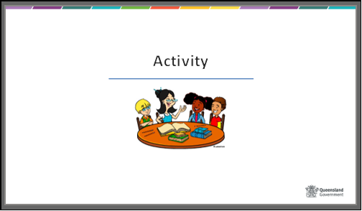
 | Show slide 19  Carer Supports  As per slide information  Email and contact links to each agency has also been provided (where available)  There are also a wide range of internet sites and telephone supports that can be located with a simple search on the web, in libraries, councils or telephone books.  Provide some advice about each of the services e.g. – QFKC is the Peak body for foster carers and provide a range of activities to improve carer related systems and policies. QFKC also deliver the FAST program.  Include other local services as well. | Slide 19  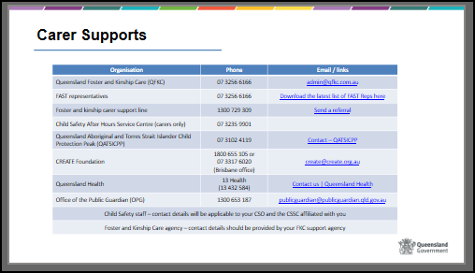
 | Show slide 20  FAST representatives  Handout – Fact Sheet 3: Support for carers and discuss.  FAST Program is provided by QFKC and is a team of trained specialist local foster and kinship carers who volunteer to provide advice, support and advocate on behalf of other foster and kinship carers.  Discuss the elements of support include ongoing casework support, advocacy and referral, practical support, access to training, informal support networks and peer support.  An optional resource for distribution is the Helplines and telephone counselling services for children, young people and parents available through ‘Child Family Community Australia’ (CFCA). This resource includes the contact details for each State and Territory or through the Australian Institute of Family Studies | Slide 20  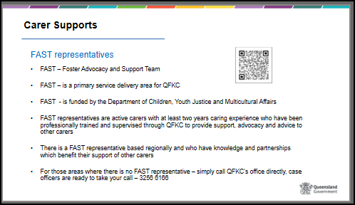

 | Show slide 21  Different types of supports to be aware of  Discuss the power point and some of the key supports available to carers including both financial and other supports. Consider handouts of other local services – parent line, lifeline etc. Highlight again the key agencies that provide support and other supports available including Aboriginal and Torres Strait Islander Health services and community elders. | Slide 21  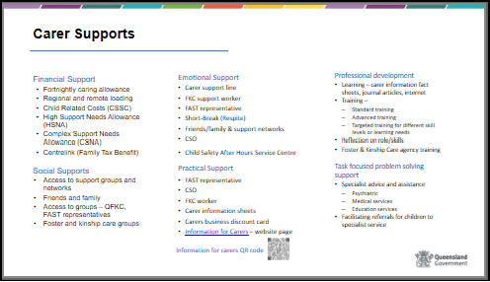
 | Show slide 22  Change in carer circumstances  Handout: Change in carer circumstances – Form 39 CCC  It is a legal requirement to tell Child Safety if there are any changes to your circumstances while you are a carer.  Including changes to:  - Household membership - a person intends on residing or leaving the household  - Traffic history, criminal history or domestic violence incidents  - Involvement with any child protection agency in the country  - Personal circumstances – health issues, employment demands  - Spousal arrangements – divorce, separation or death of a partner  - Change of address  The above also applies to any household members who live with you. If in any doubt please ask a CSSC staff member. A review of the Foster Carer Agreement may occur when there is a change in circumstance, depending on the change. | Slide 22  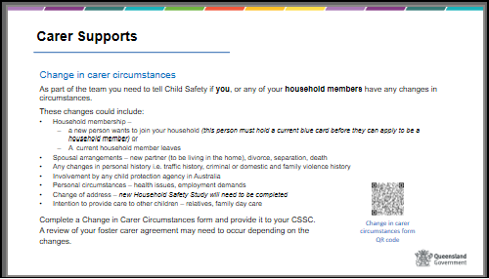

45 mins | Show slide 23  Refer to separate activities resource for instructions on activity  Activity - Guest Panel and/or CREATE PowerPoint | Slide 23
15 mins | Show slide 24  Transition to Adulthood | Slide 24  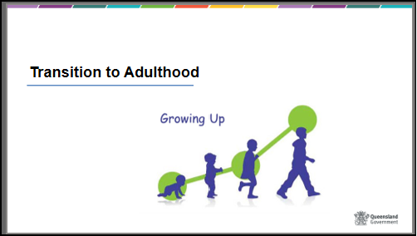
 | Show slide 25  Transition to Adulthood  All young people who are or have been subject to a child protection order granting custody or guardianship to the chief executive have the right to receive appropriate assistance and support with their transition to adulthood, in order to maximise their life opportunities and choices.  Planning for a young person’s transition to adulthood occurs as part of the case plan and formally starts in the calendar year that the young person turns 15 years and intensifies as the young person approaches 18yrs.  As a carer, you can provide the encouragement for young people to be an active participant in their transition to adulthood planning to ensure their planning is in line with what they will need once they turn 18 and moving forward.  Show slide 26  Young people leaving care and transitioning to adulthood are often confronted by issues such as reconnecting with their families and communities, coming to terms with the reasons why they came into care or finding themselves alone without the security of a family or community to fall back on. A well-planned, gradual, and flexible process for transitioning young people from care is therefore critical, including the potential provision of post care support, if necessary.  Young people who are transitioning to adulthood have the same developmental needs as those who are not in care, but they also face a range of unique issues and circumstances that highlight their particular need for support during this time.  One key difference between young people who have left care and other young adults is that most young people who have not been in care have families that they live at home with until their early twenties, and their movement towards adulthood usually involves a long transitional period during which they may leave and return home multiple times.  It is essential that we establish a robust safety and support network for these young people and form partnerships with those that are in the network and those who will also be there once the young person transitions to adulthood.  Show slide 27  Child Safety will work with the young person to meet their identified T2A goals, which may include:  - getting financial assistance for further studies, apprenticeship/traineeship etc.  - obtaining a driver’s licence  - developing life skills – e.g. cooking or budgeting  - moving into semi-supported accommodation  - assisting in applying for TILA (Transition to Independent Living) payments of up to $1500.00. | Slide 25  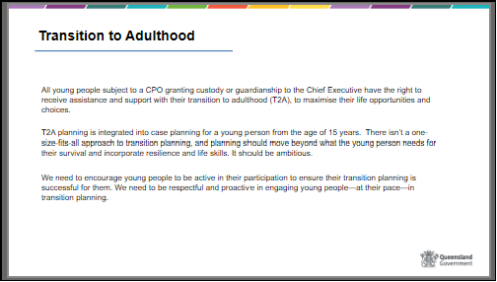  Slide 26  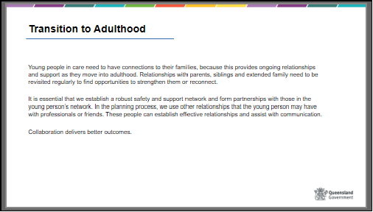  Slide 27  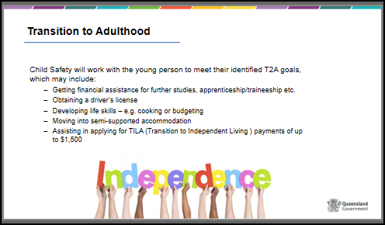

 | Show slide 28  What carers can do  Carers who continue to support a young person who has been in their home at age 17 and remains in the home once they have turned 18 are eligible to receive the fortnightly caring allowance up until that young person 19th birthday. This provides the opportunity for the young person to have a more stable and stress free transition to adulthood and removes the pressure of not knowing where they will go, and as you recall from the slide 26 this is provides the same opportunity for young people who have not been in care.  Transition to adulthood is for a young person is the responsibility of everyone in the safety and support network however there are keyways in which carers can contribute to a young person’s transition, these include:  - Referrals – assist the young people to access services that can help them in the short term and long term.  - Assist with T2A planning – with assistance from the CSO help the young person plan their independence.  - Individual Advocacy – advocate on behalf of the young person to ensure they receive the supports they need.  - Support – provide emotional and practical support the young person will need for their journey to adulthood and beyond  Discuss that while not an obligation it is in the best interest of the young person to continue to support and care for them even after they turn 18years. | Slide 28  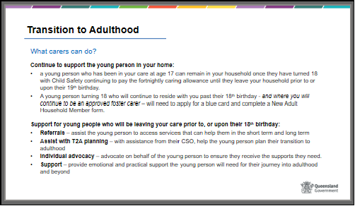

 | Show slide 29  Transition to Adulthood – Resources  CREATE resources  Resources have been developed by CREATE Foundation and Child Safety to help the young person, the carer and their CSO plan for their transition to adulthood. These are accessible from the CREATE (Queensland) website.  Show slide 30  Transition to Adulthood – Resources cont.  HANDOUT – Qld Health fact sheets  TILA – previously mentioned a few slides ago, is a one-off payment for eligible young people who have been in care to assist them in their transition to adulthood. Young people from age 18 to 25 who have left care may be eligible for the TILA allowance as well as those young people who remain with carers post their 18th birthday.  Next Step After Care services help young people who have been in care with support to build their independent lives. Services are voluntary and target young people who have left care, up to the age of 25 years. These services are flexible enough to provide young people with quick access to practical support with things like finding somewhere to stay; managing money; understanding their financial entitlements as well as responding to their support needs arising from relationships, legal advice and jobs.  A couple of additional fact sheets from Qld Health have also been provided for you to read through when you have time, or you can scan the QR codes on the slide and bookmark these pages. | Slide 29  Slide 30  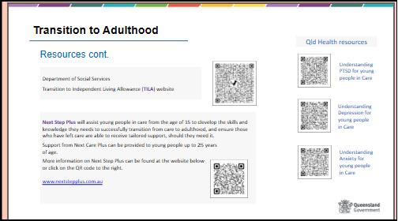

 | Show slide 31  Refer to separate activities resource for instructions on activity  Activity – Saying goodbye | Slide 31  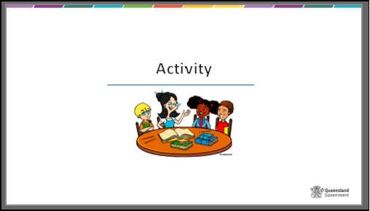
20 mins | Show slide 32  Saying goodbye  This session looks at the roles and tasks around helping children and young people move on.  It is also the end of this course and we will look at how you ‘move on’ from here. | Slide 32
 | Show slide 33  Saying goodbye  At some point there will be a time with a care arrangement may end, this can be a challenging and emotional time for both children and young people, the carer/s and their family. Care arrangements can come to an end for various reasons but generally care arrangements will either be planned or unplanned.  Planned moves are always best and will involve meetings with the carer, carer family (if appropriate) CSO, the care agency support worker. Things covered in these meetings may include but aren’t limited to any achievements the child or young person has made whilst in your care, anything that they still may need help and support with practical arrangements i.e. transport to school, any routine appointments and when the move will occur.  Unplanned moves are more challenging and can occur for a number of reasons, breakdowns may occur between you or a family member and a child or young person and if things cannot be mended, a new care arrangement may be the only option. A breakdown is not pleasant and can be best managed by not parting in anger when saying goodbye.  It’s important for carers to ensure that all of the child or young person’s belonging go with them, including anything you may have purchased for them while they have been in your care, such as any presents, bedding, clothing, technical equipment, toys, bikes, personal hygiene belongings, photos. Generally anything you have purchased for them with the carer allowance will remain their property.  Lastly, its also very important for carers to touch base with their own families to make sure everyone is feeling ok, it’s to have emotions when a child or young person leaves your care and these feelings should be acknowledged and spoken about within your own family network. | Slide 33  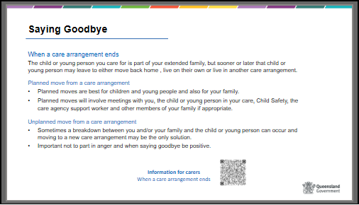
 | Show slide 34  Saying goodbye  Handout – Conclusion of placement form  This form is completed by carers when the child has left the care arrangement (of more than a few days duration). The form is then provided to the next carer of the child or young person and provides information about them that will assist that carer to support the child or young person in their new care arrangement.  It covers a range of information that the carer has first-hand knowledge about:  • Significant friendships or significant others in the child’s life  • Their relationship with the carers family and their reaction to the placement ending  • The child’s swimming ability and the level of ‘active’ supervision required  • Hobbies, interests or social activities or sports  • Medical and dental information  • Scheduled appointments  • The personal records that were returned (and to whom)  • The key belongings that are going with the child (e.g. computer, bicycle etc.) | Slide 34  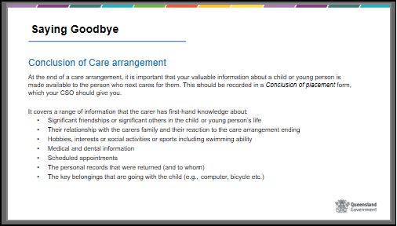
10 mins | Show slide 35  Evaluation  Display Slide 30 “Learning outcomes” and summarise the main points discussed in each outcome  Please complete the Worksheet and Personal Reflections and return to the trainers within 1 week. Should there be any discussion arising from your responses, there will be an opportunity to meet with the trainers. | Slide 35  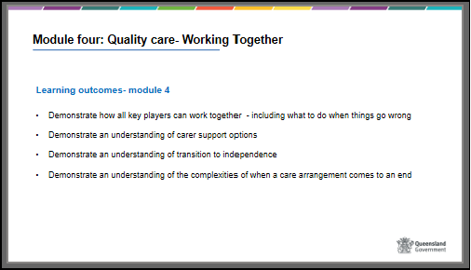
 | Show slide 36  Reflection  Trainer can use a closing exercise for the participants e.g., reflection on aspects of training and learning, sharing positive acknowledgement of others in the group, farewell exercises or use the following.  Inform participants that there will now be some small group discussion about their reaction to the course. Ask them to consider:  - Did anything change from when you first started to now?  - Do you have any concerns as a result of the information you now know?  Facilitate a larger group discussion  Point out that some people will decide not to proceed any further. Others may have some doubts while others may be keen to get started. | Slide 36  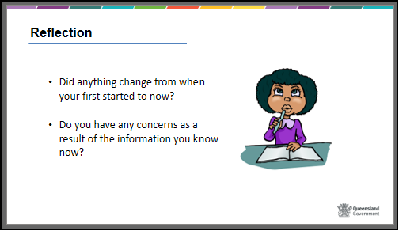

 | Show slide 37  Where to from here for you?  A formal assessment report will be prepared and discussed with you. Upon completion of your assessment the assessor will make a recommendation to Child Safety to approve or refuse the application.  During the first year you are approved as a carer you will be expected to complete a further 3 modules of training and you will be assessed as you put knowledge into practice  There will be a learning journal to assist you and your support person to reflect on learning as it takes place.  As an approved carer and after your initial 1st year approval, you will be required to renew your carer approval every 2 years. | Slide 37  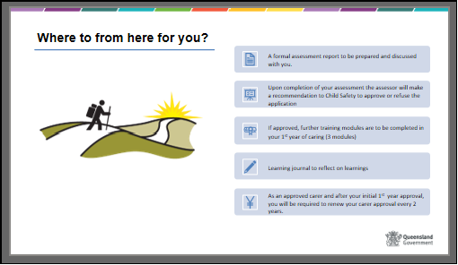
 | Show side 38  Thank you  Thank participants for their input and work during the course and for their concern for children and young people.  Participant Evaluation forms should be handed out and collected at the end of the session | Slide 38

