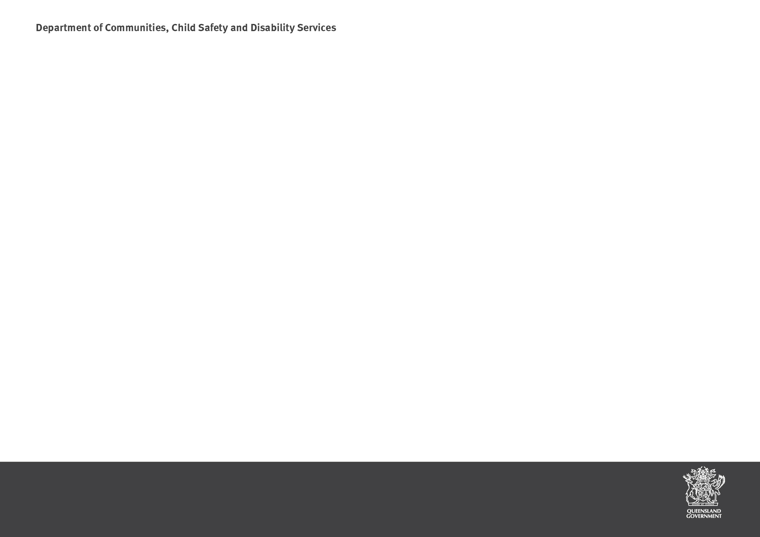

5

Module 5: Promoting Positive Behaviours Session plan

Module 5: Promoting positive behaviours has been written to be presented as a four (4) hour workshop.
Time | Resources | Method of delivery | Learning outcomes | Assessment
4 hours | Name Tags PowerPoint slides Data Projector Computer Whiteboard/pens  Activity paper for groups  Drawings for small group activity for #3.2 | Lecture; large group; brainstorm; activities  Prior to the presentation, photocopy the pages of drawings (on to card, or laminate). Have 2 or 3 copies of each depending on the size of your group. | At the end of this module participants will be able to:  - Understand that there may be a range of reasons that contribute to various behaviours.  - Understand that a caring approach includes a range of strategies to promote positive behaviours.  - Accept the importance of carers managing stress for themselves, their families, and the child or young person. | The assessment necessary for each participant will be based on completed worksheets, participation in discussions and training activities.
 | Access to YouTube clips* or access to the internet | *If there is not access to the internet (or access to YouTube), trainers will have to save all of the YouTube clips on to the computer for easy access prior to the presentation.  Slide 8: Teenage Song http://www.youtube.com/watch?v=gKaUL2mtAqA  Slide 12 (Topic: Attachment) suggests a number of clips: Each of the clips show different aspects of how attachment can be interpreted:  Upload Mother Cat/Kitten: http://www.youtube.com/watch?v=0SS44uBpTkY (1 minute)  Upload John Bowlby Attachment Theory: http://www.youtube.com/watch?v=kwxjfuPlArY (8 minutes)  Upload Harry Harlow’s Monkey Experiment clip: http://www.youtube.com/watch?v=KlfOecrr6kI (2 minutes)  Upload Grey’s Anatomy: http://www.youtube.com/watch?v=O9Swo1anaCE (1 minute)  Slide 15: Upload Trauma, Brain and Relationship: Helping Children Heal http://www.youtube.com/watch?v=vak-iDwZJY8

 |  | Slide 22: Upload Warthog Pig fighting Lion: http://www.youtube.com/watch?v=cupx84dLP8I
 | Multiple copies of Fact Sheet 15: Promoting positive behaviour | This resource is located on the Carer Information and Fact Sheets internet page.
 | Multiple copies of Practice resource: Guide to supporting positive behaviour | This resource is located in the Child Safety Practice Manual under the Resources tab.  The Practice resource: Guide to supporting positive behaviour can be used as a tip sheet/reference during the presentation. Give the participants this resource at the beginning of the presentation.
 | Multiple copies of Handouts | Module 5: Promoting positive behaviours Handout for participants
 | Multiple copies of Positive Behaviour Support policy 604 | This resource is located on the Foster care Resources and publications internet page under Policies and procedures.

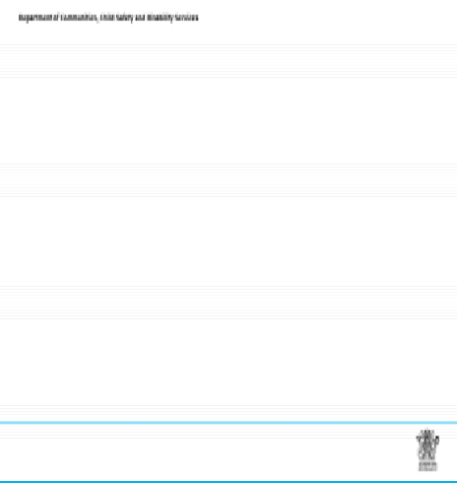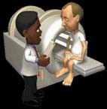
Time | Content | Resources
5 minutes  Slide 1 | Distribute name tags.  Introductions and welcome activities (including welcome to country) Show slide 1 on screen  Introduction for trainer/s and participants  Housekeeping details – location of exits and toilets, breaks and catering, arrangements for smokers, phone messages. Include fire, evacuation and emergency exit and meeting points as well as any other WH&S procedures required.  Include fire, evacuation and emergency exit and meeting points as well as any other WH&S procedures required.  Group Rules – These should be sourced from the group - ask what people would need from the group in order to feel comfortable. Ensure that the following are covered:  - Confidentiality – any information that is shared in the group will be confidential to the group – link to need to respect confidences in a placement situation.  - Mutual respect and tolerance for a diversity of opinions and experiences.  - Punctuality and respectful processes in discussion.  Explain expectations for assessments (competency in training goes toward their assessment for renewal of approval as a carer). | Slide 1  Standard Training  Module 5: Promoting positive behaviours
10 minutes  Slides 2 - 8 | Show slide 2  “This session we are going to talk about promoting positive behaviour. As you may know, supporting behaviour change can sometimes be challenging. Even doctors recognise, sometimes behaviour change can be quite a challenge (even with adults, and even if it is good for our health..).” | Slide 2  I don’t have time to do all this…  Which fits your busy schedule better - exercising one hour a day or being dead 24 hours a day?  Acknowledgement Dr Laura Riffel, 2011  Slide Number: 2

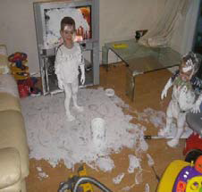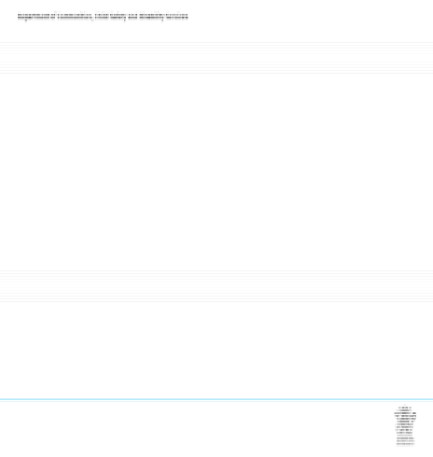
 | Show Slides 3 – 7  “As we look at the next few slides, what would be some of the things that you would be thinking and doing if you came upon this at home or in your care setting?”  Participants may suggest things to help promote positive behaviour: the environment or setting (e.g. making sure things are safely put away); learning experiences (e.g. having things to play with); fair and reasonable rules (e.g. safe play); clear, calm instructions; logical consequences/strategies. Participants may also discuss feelings that may come up if these situations occur. Many of these concepts will be discussed during the presentation. | Slides 3 - 7  What would you do about this?  Slide Number: 3
 | Show Slide 8: Access to YouTube: www.youtube.com/watch?v=gKaUL2mtAqA  An example of teenage behaviour – ask for any comments following the viewing of the YouTube video. | Slide 8 (2.12 minutes)  And this?  Upload The Teenage Song:  www.youtube.com/watch?v=gKaUL2mtAqA  2.12 minutes  Slide Number: 8
25 Minutes  Slides 9 - 18 | Show Slides 9 - 10  “This module will cover 3 different areas, all of which influence children and young peoples’ development. These are the trauma and attachment body of knowledge, developmental stages, and the area around how behaviour impacts on the quality of life for children and young people.” | Slide 9  This session will cover the following to assist in understanding challenging behaviours and how best to establish positive behaviours and relationships:  Trauma and Attachment  Developmental  Behaviour Stages  Slide Number: 9

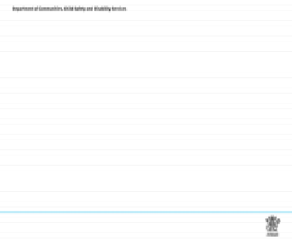
 | “The learning outcomes covered in this module will include a range of strategies to promote positive behaviours, and will also discuss the importance of taking care of yourselves as carers or care workers.” | Slide 10  Module 5: Promoting positive behaviours  Learning Outcomes  At the end of this module participants will be able to:  - Understand that there may be a range of reasons that contribute to various behaviours, e.g.  - Trauma and attachment issues  - Developmental issues (including social, emotional and learning)  - Behavioural reasons  - Understand that a caring approach includes a range of strategies to promote positive behaviours.  - Accept the importance of carers managing stress for themselves, their families, and the child or young person.  Slide Number: 10
 | Show Slide 11  “For today’s session, the working definition of trauma and attachment is up on this slide. We have some short clips to illustrate attachment and how that influences connection with others.”  One of the clips shows historical research around how the theory of attachment was established. | Slide11  Trauma and Attachment  - To be securely attached is to be safe.  “Every child needs at least one person who is irrationally crazy about him or her” Bronfenbrenner, 1979  “Pick me, choose me, love me”  Meredith Grey (Grey’s Anatomy)  - A lack of physical and emotional safety is the defining experience of children who have experienced relational trauma.  Slide Number: 11
 | Show Slide 12 (Access to YouTube required)  Mother Cat/Kitten YouTube: shows a mother cat instinctively comforting her kitten while sleeping.  John Bowlby Attachment Theory YouTube: John Bowlby (1958), psychologist pioneered "attachment theory," the idea that the early bond between parent and child is critical to a child's emotional development.  Harry Harlow’s Monkey Experiment YouTube: Harry Harlow (1957 – 1963), psychologist best known for his maternal-separation and social isolation experiments on rhesus monkeys, which demonstrated the importance of care-giving and companionship in social and cognitive development. Harlow’s experiments were controversial, including rearing infant monkeys in isolation chambers for up to 24 months, from which they emerged severely disturbed.  Grey’s Anatomy YouTube: A scene from Grey’s Anatomy where Meredith asks Derek to choose her over another” Pick me, choose, me, love me can be described as the ‘human condition’, where humans are always looking for connection with another.  Discuss the Youtube’s. The discussion may lead to definitions of connection, the ‘human condition’, and how children and young people learn about feeling safe. | Slide 12  Short attachment clip selection:  Upload Mother Cat/Kitten: http://www.youtube.com/watch?v=Vw4KVoEVcr0 1 minute  Upload John Bowlby Attachment Theory: http://www.youtube.com/watch?v=kwxjfuPlArY  8 minutes  Upload Harry Harlow’s Monkey Experiment clip: http://www.youtube.com/watch?v=KlfOecrr6kI  2 minutes  Upload Grey’s Anatomy: http://www.youtube.com/watch?v=O9Swo1anaCE 1 minute  Slide Number: 12

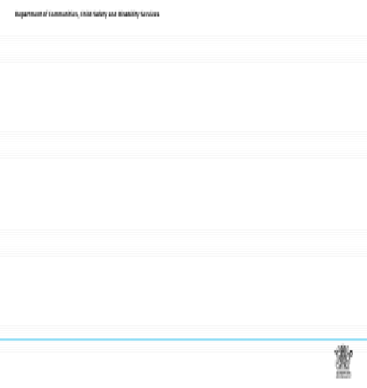
 | Show Slides 13 through to 18  Some discussion points around trauma:  - Explore the links between feelings and behaviours.  - Ask participants to think of an occasion when they could clearly link the way they were feeling, with how they behaved in a certain situation. If they are comfortable to do so, ask them to share this with the larger group.  - Discuss the fact that adults can usually put their feelings into words eg “ I am feeling sad today because- - - -“  - Remind participants that children coming into placement may have had experiences of abuse. Acknowledge that there is also trauma associated with witnessing acts of violence, domestic violence and other traumatic events.  - Discuss possible systems abuse resulting from the system within which care is provided eg abuse in care, drifting in care, unnecessary dislocation from family.  “Ziegler (2005) reports that behaviour cannot always be taken at face value with children who experience violent rages. In fact, these children can often act counter-intuitively:  They can push you away when they want closeness  - They can strike at you when they are beginning to care about you  - They can act in ways to receive reassuring touch by becoming aggressive and violent to self and others  - It is often the trusted adult that young children become violent with, because they know they are safe and they will get the reassurance they need  - If they do not find the physical reassurance they need and seek, they will often raise the level of acting out until they get it.”  Slide 15  Introduce the clip which shows the relationships between trauma and brain development:  www.youtube.com/watch?v=vak-iDwZJY8 | Slide 13  Trauma  “Traumatised children reset their normal level of arousal. Even when no external threat exists, they are in a persistent state of alarm”  Perry and Pollard, 1998  Slide Number: 13  Slide 14  Assumptions:  Trauma impacts upon all aspects of a child or young person’s development.  Trauma can undermine their ability to learn, form relationships, function appropriately, and to take another person’s perspective.  Slide Number: 14  Slide 15  Upload Trauma, Brain and Relationship:  Helping Children Heal  (Section Three: The Many Faces of Trauma):  http://www.youtube.com/watch?v=vak-iDwZJY8  Bruce D. Perry, M.D., Ph.D is a clinician and researcher in children's mental health and neuroscience, and is an internationally recognised authority on trauma and  attachment theory.  Slide Number: 15

 | Slide 16  “This slide summarises information shared in the clip – showing that the amygdala seems to modulate all of our reactions to events very important to our survival. Events that warn us of imminent danger are therefore very important stimuli for the amygdala. That is why the amygdala has so many connections with several structures in the brain. Children have less control over their emotions, because the axons that send information to the cortex to the limbic system are not fully developed. In addition, the neurons of the cortex that provide much of our rational control over our emotions do not mature until adulthood. In contrast, the amygdala is mature at birth and thus exerts a heavy influence in children.”  Slide 17 and 18  These slides are final points to the trauma and attachment section.  Ask the participants what the adult is doing when the young person is showing a particular emotion around a specific task.  Discuss the fact that children cannot often verbalise their feelings, so they act out what their underlying needs are. We may have to guess what their needs are.  Activity  Ask participants for examples of situations where children’s behaviour indicates an underlying need. Write these on the white board.  Ask the group to identify feelings that the child or young person may experience. Ensure the following is covered – loss/grief and abandonment, guilt, anger, fear, anxiety, insecurity, embarrassment.  Consider two questions:  - “Why could a child or young person be feeling this way?”  - “What impact might this have on behaviour when they come to live with you?”  - The more healthy relationships a child or young person has, the more likely s/he will be to recover from trauma and thrive. Relationships are the agents of change.  - Things that build connection include mutual, fun activities, and where success with safe emotional and physiological arousal can be experienced.  The next section will be covering developmental stages and how that may influence behaviour. | Slide 16  Mapping the brain  The brain develops in an ‘experience dependent’ manner.  The brain develops from back to front. Neurons that fire together, wire together. Use it or lose it.  The Amygdala are essential to your ability to feel emotions and to perceive them in other people.  “fight, flight or freeze”  Slide Number: 16  Slide 17  So what makes it different?  - Secure children learn a complex vocabulary to describe their emotions, such as love, hate, pleasure, disgust and anger. This allows them to communicate how they feel and to formulate efficient response strategies.  - Traumatised children rarely discuss their fears and traumas spontaneously…  Van der Kolk, 2005  Slide Number: 17  Slide 18  2006 Michael Bernard, PhD  Slide Number: 18

20 Minutes  Slides 19 - 25 | Show Slides 19 through to 25  Developmental Stages of Erik Erikson: Show each of the slides and discuss.  “Evidence of damage during specific developmental stages cuts across a range of behavioural and emotional domains of development, including problems of intrapersonal thoughts, feelings and behaviours (eg. depression, low self-esteem, suicidal ideation); emotional problems; social competency problems and anti-social functioning; learning problems, and physical health problems (Perry & Pollard, 1998)”.  Other discussion information may include:  - Stressful events affect each child in different and unique ways.  - Certain situations trigger more intense stress reactions and consequences than others.  - Nonetheless, even traumatic events like abuse, neglect, and family violence do not affect each child in a predictable, characteristic fashion.  - There impact depends on the child’s makeup and available supports. | Slide 19  Developmental Stages  (including social, emotional and learning)  The Developmental Stages of Erik Erikson (1959)  1. Infancy: Birth to 18 Months  - Ego Development: Trust vs. Mistrust  - Basic strength: Drive and Hope  2. Early Childhood: 18 Months to 3 Years  - Ego Development: Autonomy vs. Shame  - Basic strength: Self-control, Courage, and Will  Slide Number: 19  Slide 20  The Developmental Stages of Erik Erikson (cont)  3. Play Age: 3 to 5 Years  - Ego Development: Initiative vs. Guilt  - Basic Strength: Purpose  4. School Age: 6 to 12 Years  - Ego Development: Industry vs. Inferiority  - Basic Strengths: Method and Competence  Slide Number: 20  Slide 21  The Developmental Stages of Erik Erikson (cont)  5. Adolescence: 12 to 18 Years  - Ego Development: Identity vs. Role Confusion  - Basic Strengths: Devotion and Fidelity  6. Young adulthood: 18 to 35  - Ego Development: Intimacy and Solidarity vs. Isolation  - Basic Strengths: Affiliation and Love  Slide Number: 21

Slide 22 Slide 22
Have participants view the YouTube video Warthog Pig fighting Lion:
www.youtube.com/watch?v=cupx84dLP8I as another example of teenage behaviour (around Upload Warthog Pig fighting Lion:
‘checking boundaries’) – ask for any comments following the viewing. http://www.youtube.com/watch?v=cupx84dLP8I

D1FB1E07_YouTub e - Pig Fights ...

43 seconds

Slide Number: 22

Slide 23 has been included as information for participants to reflect on their own developmental stages Slide 23
(assuming that they are of that age).

The Developmental Stages of Erik Erikson (cont)

7. Middle Adulthood: 35 to 55 or 65
- Ego Development: Generativity vs. Self absorption or Stagnation Basic Strengths: Production and Care

8. Late Adulthood: 55 or 65 to Death
- Ego Development: Integrity vs. Despair
- Basic Strengths: Wisdom

Slide Number: 23

Slide 24 “This slide summarises how important it is for children and young people to learn social-
emotional development throughout the earlier developmental stages to ensure they become capable in Slide 24
self-awareness, social awareness, self-management, relationship skills, and decision-making.”
Social- emotional competence

- The development of social-emotional competence is an important foundation for children and young people’s later success and well-being:

  - Self-awareness
  - Social awareness
  - Self-management
  - Relationship skills
  - Responsible decision-making

2006 Michael Bernard, PhD

Slide Number: 24
15 minutes MORNIN  BREAK | G TEA BREAK

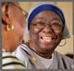

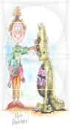

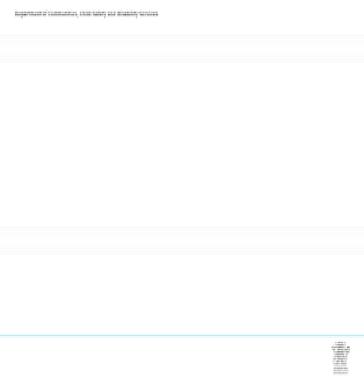
30 minutes  Slides 25 - 36 | Show Slides 25 through to 36  “The next few slides concentrate on behaviour, and how children and young people may behave the way they do because they have learned that behaviour, or don’t have an alternate behaviour to use.”  We will also be going through a range of strategies and techniques designed to promote positive behaviour, promote self control (social-emotional competence as discussed earlier) and responding to challenging behaviour. “  “The primary goal of Positive Behaviour Support (PBS) is improve the quality of life for children and young people by increasing their appropriate behaviours, and reducing the impact of challenging behaviours.”  “When caring for a child or young person who may have been abused it is important to be aware of your own values and beliefs, as these may influence the way you respond to particular behaviours. “  “The reasons why some behaviours may be upsetting include:  Behaviours may clash with your own beliefs. E.g. taking care of property, “borrowing” things without asking.  - Behaviours may mean more work for you, be costly, or may disrupt your plans.  - You may be alarmed that the young person may be out of control.  - You may feel inadequate or embarrassed, especially if the behaviour is observed by others.  - It may trigger something that happened in the past for you.” | Slide 25  Behaviour  ` Children may behave the way they do because they have learned that behaviour, or because they have not learned alternative, more positive ways to act.  The primary goal of Positive Behaviour Support (PBS) is to improve the quality of life for children and young people by increasing:  - their appropriate behaviours, and  - reducing the impact of challenging behaviours.  Slide Number: 25
 | Slide 26  “From the research on behaviour, there are some assumptions that we can consider.”  Read the four assumptions, and discuss whether any of these assumptions may help modify some of their strategies they use with children and young people already.  “Sometimes feelings are too overwhelming for children and young people. They may be too young to understand what is going on and mostly they will be unable to talk about it. Children and young people will often act out what they cannot verbalise. They may exhibit what we call a range of “behaviour problems” which are symptoms of underlying needs.” | Slide 26  Assumptions  - Behaviour is learned and serves a specific purpose.  - Behaviour is related to the context within which it occurs.  - For every year that a behaviour has been in place, we should expect to spend one month of consistent appropriate intervention for us to see a behaviour change.  - We can improve behaviour by 80%, just by pointing out what someone is doing correctly.  Slide Number: 26

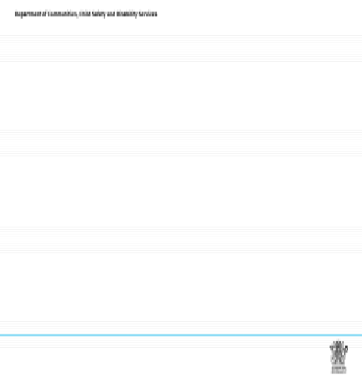
Positive Reinforcement | Negative Reinforcement
TO GET MORE OF | TO GET OUT OF OR ESCAPE FROM
Social attention | Activities
Access to materials | People
Sensory stimulation | Sensory pain

 | Slide 27  “This slide is the start of looking at behaviour differently – turning your sensors on to look at good behaviour and challenging behaviour with different lenses.”  Activity  Explain the slide to participants by giving examples of the types of experiences that children and young people would want TO GET MORE OF, and experiences that they would want TO GET OUT OF OR ESCAPE FROM.  Ask the participants for other examples for the positive and negative, some examples might include:  Social attention: spending time with people, enjoying company Access to materials: getting things for doing something Sensory stimulation: visual, touch, taste, hearing  Activities: doing something to get out of something (e.g. lesson at school, chores at home)  People: getting away from someone/not wanting to be around that person  Sensory pain: visual, touch, taste, hearing (noise) | Slide 27  Possible Functions of Behaviour:  Slide Number: 27
 | Slide 28  “The first step in promoting positive behaviour is to understand what motivates certain behaviours – what need is the child or young person expressing through their behaviour. “  “It is also very important to gather good information regarding the behaviour, whether you want to know more about when the good behaviour is happening, or when the challenging behaviour is happening.  For example. when, where, what is happening – what does it look like? “  “It also is important to name and acknowledge our own values and feelings about a range of behaviours, so we are more informed about the way we may respond.”  Ask the participants to give examples of good and challenging behaviours they have seen that may be meeting a need (WHAT DO THEY GET? WHAT DO THEY AVOID?)  Broader issues to consider – recent medication change, a change in physical environment that has influenced the behaviour, language or cultural considerations etc. | Slide 28  Target Behaviours and the Triggers (or becoming the Detective)  - Under what circumstances (or triggers) is the target behaviour most/least likely?  - WHEN?  - WHERE?  - WHAT?  - WHO?  - WHY?  - What consequences or results predictably follow the target behaviour?  - WHAT DO THEY GET?  - WHAT DO THEY AVOID?  - What broader issues are important influences on their behaviour?  Slide Number: 28

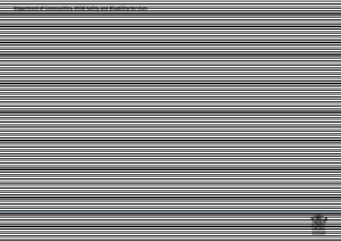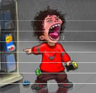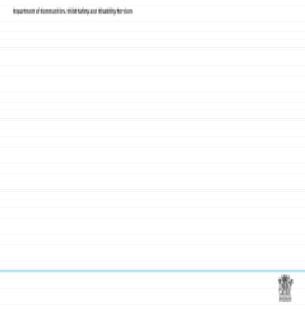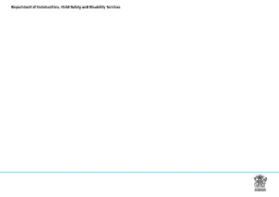
EXAMPLES | NON EXAMPLES
•high-pitched screams  •kicking over chairs  •completing tasks | •poor impulse control  •resentful, angry, hostile  •paying attention

 | Slide 29  This slide is presented as a scenario for the participants to hypothesise what is happening for Baby Bling. Ask the participants:  What are the triggers (A)?  - What are the behaviours (B)? Make sure they are clear to describe the behaviour – what does it look like..  - What are the consequences/reactions that follow this behaviour (C)? E.g. Baby Bling gets the car because Dad gives in… | Slide 29  …becoming the Detective  What are the triggers (A)? WHEN?  WHERE? WHAT? WHO?  WHY?  What are the behaviours (B)?  What consequences (reactions) follows the behaviour (C)?  WHAT DO THEY GET? WHAT DO THEY AVOID?  What broader issues are important influences on their behaviour?  Slide Number: 29
 | Slide 30 – an example designed for residential care workers to consider  An example/scenario for residential care workers to be talked through and discussed. Participants may have reflections from their own experiences or work context that they can share. | Slide 30  For example… Maree  12 year old female  - Triggers for the target behaviour most/least likely?  - WHEN? Prior to any major transitions or social events  - WHERE? At the residential home or in public spaces  - WHAT? Screams/swears, and hits out (as opposed to ‘random outbursts’ or ‘loses it’).  - WHO? Always with new staff  - WHY? Hold off on the WHY…  - What consequences or results predictably follow the target behaviour?  - WHAT DO THEY GET? More time with the new staff member  - WHAT DO THEY AVOID? Changing to the next activity  - What broader issues are important influences on their behaviour? Medication? Sleep (lack of?) Eating routine? Staffing patterns?  Slide Number: 30
 | Slide 31 – Defining the target behaviours.  “This slide provides an example of how to describe the target behaviours clearly (rather than in general terms). Once the target behaviour has been identified, then everybody knows what they are observing, gathering data about, and working together to change or modify.”  Introduce the concept of the Summary Statement:  When this occurs…(describe circumstances/antecedents)  - the child or young person does…(describe the target behaviour)  - to get/to avoid….(describe consequences)  Example statements:  - When all the young peoples’ attention is on the worker, Terry interrupts with comments, and everyone laughs at Terry’s comments.  - When Kim finishes her work before everybody else, she scribbles on the desk, which results in the teacher giving Kim some work to do. | Slide 31  Defining the target behaviours  Summary Statement  When the worker’s attention is withdrawn or focused on another young person, Maree will use high-pitched screams and kick over chairs to get attention back.

X | Screaming/swearing
O | Hits out

TIME OF DAY – THIRTY MINUTES INTERVALS | Time | Mon | Tues | Wed | Thurs | Friday | Sat | Sun
 | 6:00
 | 7:00
 | 8:00 |  | X |  |  | XO
 |  | X | XO |  | X | X |  | XO
 | 9:00 | X O | X |  | XO |  |  | XO
 | 10:00
 | 11:00 etc | X | X |  | XO |  |  | XO

 | Slide 32 – an example designed for residential care workers to consider  “When we start gathering data about a behaviour (whether good or challenging behaviour), we need to be clear about what we are gathering.”  “This slide asks what are the A (antecedents/triggers) for her behaviour (can suggest an antecedent/trigger), the B (behaviours – describe them clearly e.g. screaming and swearing), and the C (consequential reaction – what is Maree getting or avoiding with the behaviour).” | Slide 32  We want to know the following about Maree’s behaviour…  - A (antecedents / trigger phase) This lets us know when to put the NEW interventions in place.  - B (behaviours) This ensures that we are all measuring the SAME thing when collecting data.  - C*(consequential reaction*) This is the real key to why the behaviour is maintaining (getting or avoiding).  Slide Number: 32
 | Slide 33  “There are a number of ways to gather data:  Contextual Assessment Inventory (CAI) which is a highly structured tool that summarises the problem behaviour (can be used in more clinical contexts)  - ABC Notecards (direct observation and interview notes)  - Scatterplot data gathering (as presented on this slide as a scatter plot grid)”.  The slide shows an example of a scatter plot around some of Maree’s behaviour. The behaviour that data was collected over a week was specifically around when Maree screamed and swore, and when she hits out at others.”  “It is best to collect data for 2 weeks to establish any patterns.”  Activity  Ask the participants what they could hypothesis or assume from this data e.g.  - What makes Wednesday and Saturday so different to the other days?  - What are some of the challenging times for carers or staff from this data?  - What would this data mean for planning/staffing etc?  “There is an example of a scatter plot grid in your booklet that you may wish to use for future data gathering.” | Slide 33  Using a Scatter Plot Grid to gather data  Name: Maree No challenging behaviour  Slide Number: 33

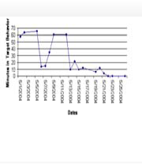
 | Slide 34  “Once we have collected good data, we can actually record it to track when the target behaviour is occurring (and decreasing). This example is one which shows a target behaviour being mapped across 13 days. From this, where has the implementation happened? What’s the extra ‘bump’ after all about?”  Participants can suggest the bump (sometimes called the extinction burst) can happen when things change.  “An extinction burst will often occur when the intervention has just begun. This often consists of a sudden and temporary increase in the frequency of the behaviour (meaning it may get worse before it gets better), followed by the eventual decline and ‘extinction’ of the target behaviour.” | Slide 34  This is what we are striving to achieve with data collection  Where has the implementation happened?  Slide Number: 34
 | Slide 35  “The biggest problem with data gathering includes some of the following issues, shown on the slide.”  Offer the participants an opportunity to reflect on any of these issues, and how perhaps they would challenge some of these problems mentioned. | Slide 35  Biggest Challenges  - Carers and workers don’t know what data to collect  - Not enough time perceived to collect data  - Admiring of problem instead of proactive planning  - Not carrying out the plan once it’s implemented  - Reverting back to “status quo”  Riffel, 2011  Slide Number: 35
 | Slide 36  “In conclusion, this cartoon summarises how challenging behaviour can be difficult to change even when it may be good for our health…” | Slide 36  Slide Number: 36

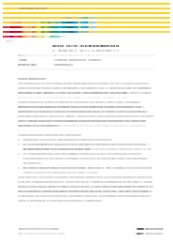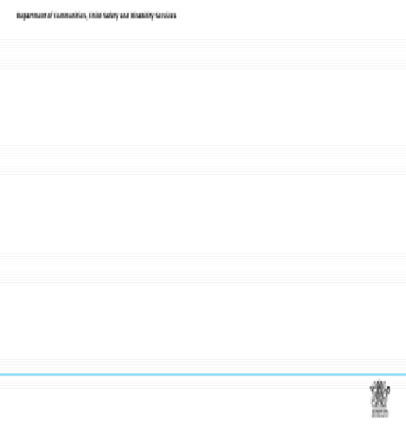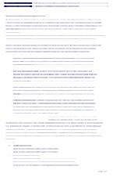
5 minutes  Slides 37 - 39 | Show Slide 37 – 39  “So what have we covered, and where to from here?”  Use this slide to summarise the information that has been covered across the 3 areas of knowledge – trauma and attachment; developmental stages; and behaviour. Participants may wish to share any reflections. | Slide 37  So…we have covered….now what?  Trauma  and Attachment  Behaviour Developmental Stages  Slide Number: 37
 | Slide 38 and 39 introduce the participants to the Positive Behaviour Support Policy 604 and the Practice Resource: Guide to supporting positive behaviour. The participants would have received their copy of the Practice Resource at the beginning of the presentation.  These resources are located on the Child Safety internet:  Policy- Positive Behaviour Support – on the Foster care Resources and publications webpage (under Children in Care)  Practice resource: Guide to supporting positive behaviour – in the Child Safety Practice Manual Resources webpage under Child Safety resources. | Slide 38  Positive Behaviour Support Policy  Slide Number: 38  Slide 39  Slide Number: 39

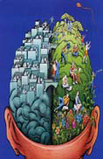
40 minutes  Slides 40 - 45  (allow 10 minutes after the activity for group discussion) | Slides 40 – 45  “For the remainder of the session we are going to discuss how to support positive behaviours. There are 4 components which promote positive behaviours:  Safe and interesting learning experiences and environments  - Fair and consistent rules  - Clear, calm instructions  - Logical consequences (strategies*)”  Discussion for this slide may include:  - Safe and interesting learning experiences and environments:  - Children and young people need to be safe from danger and have things to keep them busy and involved  - Young people’s emotional and behavioural difficulties may be caused or made worse by inconsistent, unpredictable, inflexible and chaotic environments.  - Positive organisational cultures promote positive outcomes for children and young people. In fact, it may be impossible to have good outcomes without a positive culture and climate (Glisson et al, 2006).  This approach helps a child or young person develop self esteem and self control. The following strategies could be used:  - Provide a role model.  - Listen to children and young people and ask questions.  - Positive reinforcement.  - Be specific with praise – “It is great that you picked up all your toys after you finished that game” rather than “You are a good girl today”. | Slide 40  Supporting positive behaviours  1. Safe and interesting learning experiences and environments  Slide Number: 40  Handout  Module 5: Promoting positive behaviours, Handout for participants

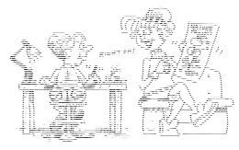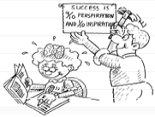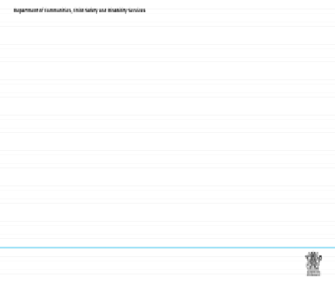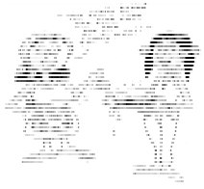
 | Slides 41 – 44 “These slides are examples where there is a positive learning environment and positive behaviours have been encouraged through clear specific praise. “  Activity  “Do we focus on strengths enough?”  Ask participants to individually write down some points about a child or young person that they work with or look after.  Write down a list of the good points about this child or young person. E.g. strengths, talents, nice aspects of their personality.  - Think how these good points could be used to help promote positive behaviour and make a note of each one.  - Consider how you could have helped a child or young person in the past by focusing more on their strengths.  Share these thoughts in the larger group.  “Another form of positive reinforcement is providing encouragement for effort or improvement. The value of this is that it can be used even if the child or young person has not totally achieved their goal. When you use encouragement consider the following:  - Focus on the child or young person’s responsibility for what has happened eg “You must be very proud of yourself” not “I’m very proud of you”.  - Focus on appreciation for what they have done – not value judgements about it. Eg “I appreciate the help you gave me” not “You are a good boy”.  - Focus on improvement – not the achievement. Eg “You have made lots of progress” not “You won!” | Slide 41  Paying attention to their good behaviour during these times encourages them to learn acceptable behaviour.  2006 Michael Bernard, PhD  Slide Number: 41  Slide 42  When children and young people are engaged in interesting and challenging activities, they have opportunities to learn, develop relationships, build a sense of belonging to a group, be creative, and problem solve.  Holden, 2007  Slide Number: 42  Slide 43  All activities should have a purpose and take into account the abilities and needs of the child or young person, helping them develop pro-social skills, behaviours, and attitudes.  Slide Number: 43

Slide 44

Research indicates that you can improve behaviour by 80% just by:

“Hey, great helping your sister…”

Pointing out what someone is doing correctly

“Thanks for being ready to go…”

Slide Number: 44
Rewarding good behaviour
“Most of us respond well if we know what rewards we can expect in return. How have reward systems worked for you?”
Think of something you have tried to change for yourself by promising yourself a reward eg quit smoking, dieting, exercising.
Think back to any reward systems you have offered children or young people and consider how effective they have been.
Write down an unacceptable behaviour you were trying to prevent. What was the reward, why do you think the reward system was successful in preventing behaviour?
Discuss the concept that reward systems should only deal with one behaviour at a time and once that behaviour has improved, the reward system should be stopped.
Earning privileges
“This is similar to rewards. It usually involves doing something that you would rather avoid in order to do something you would like. Example: “Let’s eat all this up so we can watch the Simpsons”. Best framed in a positive, firm way, rather than “If you don’t eat this you can’t watch the Simpsons.”
Planned ignoring
“Ignoring behaviour is simply pretending that the behaviour is not occurring – this means that you don’t look at, talk to, or respond to a child or young person until the inappropriate behaviour ends.”
Ask participants what the advantages of planned ignoring might be. Make sure the following is covered:

Ignoring the behaviour allows the child or young person some time to think and avoids confrontation.

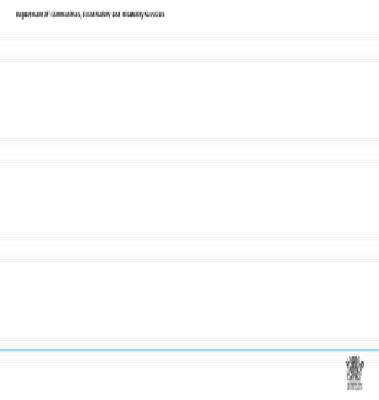
2006 Michael Bernard, PhD
Environment
Culture/Culture
Activities
Relationships

It places the responsibility for dealing with the situation on the child or young person.
Ask participants to think of the disadvantages of using planned ignoring. Ensure the following is covered.
- Some behaviours are not appropriate to be ignored – give examples.
 | “If the behaviour escalates (this is probable as behaviour may be happening to get attention) will you be able to continue to ignore it? If you are inconsistent it teaches a child that escalation of behaviour achieves the desired result.”
 | Slide 45 Activity # 1 (10 minutes), Report back to large group (10 minutes)  Break the participants into groups 3 - 4 to discuss the following question:  “What sorts of things support children and young people in their development and learning?  *Culture/culture (depending on the participants) can be interpreted as the cultural organisation of a setting and/or the cultural background of the children/young people/carers/home. “  “Each group are to record their answer on butcher’s paper/booklet. Once the activity has been completed, each group will get an opportunity to report back to the large group about what they have discussed.” | Slide 45  Activity 1  Group discussion: What sorts of things support children and young people in their development and learning?  Slide Number: 45
30 minutes  Slides 46 - 49  (allow 10 minutes for small group activity prior to lunch) | Slides 46 – 49 (including 10 minutes for Activity #2)  “The following slides show how important fair and consistent rules for children and young people are for them to learn social-emotional well-being.” | Slide 46  2. Fair and consistent rules  Children and young people learn to be responsible and develop self-control with fair and reasonable rules. Carers should have rules that are easy to follow and few in number.  Slide Number: 46

Slides 47– 48 Slide 47
“These are cartoons revealing how to and how not to use rules.”
If you have time for an activity: Each participant selects one of Mrs. Mutner’s rules and rephrases it to
identify the behavior they wish to see. It helps
Tell them that some are poorly worded rules for specific situations (e.g., no sweating). Ask for everybody when rules are
rephrasing of these negative rules that state the behavior we wish to see. displayed.
Slide 49 Activity #2: Approximately 10 minutes for participants to work up four or five rules that would help home or care setting.
Example rules can be recorded on the board (remembering the following): Slide Number: 47
- Rules are small in number Slide 48
- Rules are fair
- Rules are easy to follow
- Rules should be followed up with consequences
- Rules say what to do rather than what not to do
Ensure that the participants recognise that ‘Don’t rules don’t work’ – e.g. “Don’t hit your sister” becomes “Keep your hands to yourself.”

Slide Number: 48

Slide 49

Activity 2
Exercise: Deciding on clear ground rules.
Work up four or five rules that would help your home or care setting.

  - Rules are small in number
  - Rules are fair
  - Rules are easy to follow
  - Rules should be followed up with consequences
  - Rules say what to do rather than what not to do

Don’t rules don’t work – e.g. “Don’t hit your sister” becomes “Keep your hands to yourself”.

Slide Number: 49
30 minutes LUNCH BREAK
BREAK

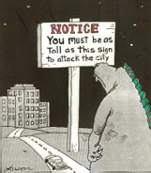

20 minutes  Slides 50 - 53  (allow 10 minutes for small group activity) | Show Slides 50 – 51  These slides are examples of what clear, calm instructions look like and sound like.  Slide 51 goes through step by step what to do. As the presenter, you may wish to use these as examples to illustrate what clear, calm instructions are:  - Get close and gain the child or young person’s attention – Stop what you are doing, move closer to the child or young person (within arm’s reach). Bend down to their eye level and use their name to gain their attention.  - Tell the child or young person what to do – Use a calm voice and say exactly what you want them to do: “Maree, it’s time for dinner. Come to the table, thanks”.  - If you want them to stop doing something, be sure to tell them what to do instead – “Aaron, stop hitting your brother. Keep your hands to yourself”.  - Give them time to cooperate (this is called take-up time).  - Praise cooperation – “Thanks for coming to the table, Maree”. | Slide 50  3. Clear, calm instructions  No child or young person can be good all of the time, and they all learn differently.  2006 Michael Bernard, PhD  Carers giving instructions that are clear, calm, well timed and not confusing can influence how children and young people do as they are told.  Slide Number: 50  Slide 51  Giving clear, calm instructions  - Get close and gain the child or young person’s attention – Stop what you are doing, move closer to the child or young person (within arm’s reach). Bend down to their eye level and use their name to gain their attention.  - Tell the child or young person what to do – Use a calm voice and say exactly what you want them to do: “Maree, it’s time for dinner. Come to the table, thanks”.  - If you want them to stop doing something, be sure to tell them what to do instead – “Aaron, stop hitting your brother. Keep your hands to yourself”.  - Give them time to cooperate (this is called take-up time).  - Praise cooperation – “Thanks for coming to the table, Maree”.  Slide Number: 51
 | Slide 52 – Whole Group Activity #3.1 (2 minutes)  Read the examples to the group and ask the group to provide clear, calm instructions which would be appropriate to use.  The relationship between clear calm instructions and praise can also be discussed: Instruction: Take your shoes outside thanks.  Praise: Great for taking your shoes outside.  “Every instruction is an opportunity for a child or young person to be praised on their behaviour.” | Slide 52  Whole Group Activity 3.1  Give examples of clear, calm instructions for the following situations:  Can try…5 words (including a VERB, and finishing with Thanks..)  - It is time for the child or young person’s dinner.  - They are jumping up and down on the lounge chair.  - They have left all their clothes thrown all over the floor of their room.  - It is time to get ready for their access visit.  Slide Number: 52

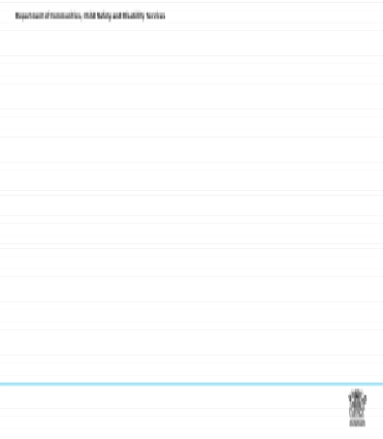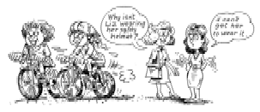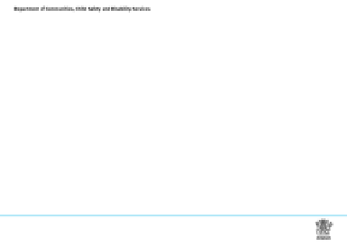
 | Slide 53 – Small Group Activity #3.2 (10 minutes)  Materials: Drawings for small group activity #3, sheets of paper, pencils/pens for participant B.  Prior to the presentation, photocopy the pages of drawings (on to card, or laminate). Have 2 or 3 copies of each depending on the size of your group.  This activity allows the participants to practice clear, calm instructions. Break the group into pairs of 2 and each pair will decide who the A is, and who is the B.  Each pair can then move into a quiet space in or outside of the training room, and sit back to back. B’s must take a sheet of paper and pen/pencil with them. The presenter then provides the A of each pair with a picture (not allowing the B to see the picture).  The A’s then have to provide clear calm instructions to the B’s (still sitting back to back) to draw the picture they have in front of them.  Once the instructions from A are finished, they may show B the original picture and compare. Each pair returns to the whole group to compare. | Slide 53  Small Group Activity 3.2  - Group breaks into pairs (A and B)  - Each pair sits back to back  - A will be instructor, B will draw A’s instructions on paper  - Hand out one picture to each of the A instructors  - A will then explain step-by-step what they want B to draw on their paper (A must not show B the picture until the end)  - Once the drawing has been completed by B, they can compare final drawing and the previous instructions provided.  Slide Number: 53
20 minutes  Slides 54 – 60 | Slides 54 – 60  “As discussed earlier, there are a range of strategies and techniques designed to promote positive behaviours. We have discussed promoting positive behaviours, and promoting self control. These slides relate to when you may have to respond when children and young people may experience a lack of control. “  “So far we have talked about how to use positive strategies that promote self esteem and encourage a child to control behaviour themselves. However there may still be occasions when a child or young person’s behaviour crosses the agreed boundaries. How do you manage difficult situations when they occur?”  Taking a calm and reasoned approach  Ask participants to reflect on how hard it is to manage their own emotions – especially acknowledging that we all get angry. “How would you react to this situation?”  “Jenny, age 10, is often destructive and one day is very angry and breaks some things that are kept by the carer/worker in a special display cupboard.”  Discuss 2 possible responses.  - In the heat of the moment the carer/worker says “Don’t ever do that to my things again. You are so destructive and it makes me very angry.”  - The carer/worker explains to Jenny that she is disappointed and upset because those things were | Slide 54  4. Logical consequences (strategies*)  Logical consequences (strategies*) are best for mild problem behaviours that don’t occur too often.  Consequences (strategies*) work best when they are brief and immediate.  2006 Michael Bernard, PhD  Slide Number: 54  Slide 55  Logical Consequences (strategies*)  - Children and young people learn self-control when carers use consequences (strategies*) for misbehaviour consistently and immediately.  - If the child or young person does not follow a rule or a clear instruction, then choose a consequences (strategy*) that suits the situation.  - Consequences (strategies*) work best if they are brief – 5 to 30 minutes is usually long enough the first time the problem happens.  - It is important that the carer and staff remain calm.  Slide Number: 55

precious to her. She ends up by saying, “I know I can trust you to take care of the things in that cupboard in the future”.
Ask participants to think about the effect that each of the above responses will have on the child or young person.
“Look at the following scenario – what would be the “calm and reasoned” way to respond?”
“Steven is 16 and has been getting into trouble at school recently for missing classes. He is hanging out with a group who have been questioned by Police about shoplifting. He tells his carer/worker that he thinks it is ok to “Take stuff because its fun.”
”Possible responses:

“Don’t be silly. It’s against the law and I don’t want to catch you ever doing that”.
- “It’s normal for young people to look for fun things to do – but have you thought what the consequences might be? What do you think they are?”
The second response shows that you are willing to acknowledge why Steven may be interested in doing this and that you are willing to discuss it with him further.
The theme here is to focus on what Steven is saying, reflect back to him on what he said and give yourself some time to think. This is the active listening approach discussed in the pre-service training.”
 | Slide 56: Using natural and logical consequences  Ask participants for examples where they may have used consequences as a way of responding to a child or young person’s lack of self control.  Activity #4  Whole of group activity to complete – ask the group to discuss some consequences (strategies*) for the events listed in the slide.  Discuss some of the other strategies as listed below:  Time out and Time with (sometimes referred to as Time In)  Ask participants to think about what the purpose of time out and time with is, and how they may be different. Record these on the whiteboard.  Some working definitions include:  - Time out: a brief suspension of activity to cool/calm down. Time out was originally for the carer. Time out may punish child or young person for not organising their feelings/emotions.  - Time with: a strategy (recognised in Therapeutic Crisis Intervention (TCI), and Circle of | Slide 56  Activity 4  1. Discuss with the whole group some consequences (strategies*) for the following events:  - The child is drawing on the wall of their bedroom.  - The young person is flicking their food at the dinner table.  - The child is playing roughly with the other children in the lounge room.  - The young person has turned up the volume on the play station.  2. Discuss with your group the difference between natural and logical consequences (and how children-in-care may develop an understanding of both).  Slide Number: 56

Security) where the adult spends time with the child or young people to assist in calming themselves down (teaching them self-regulation). The adult is understanding and empathetic, but still acts with purpose to support self-regulation and self-calm.
- Self-regulation: the person’s ability to alter their own behaviour. Self-regulation increases the degree that human behaviour is flexible and able to adapt, and involves the pursuit of many different goals, standards and ideals.
De-escalation skills and strategies during difficult situations
Ask the group what these could include?
Examples should include:
- Introduce more structure to the child or young person’s day, separate them from any chaotic activities happening in the household, be alert to signs of escalation of behaviour, create a safe calm environment (turn television off, play calming music, lower lights, speak in a calm voice yourself).
- Avoid a battle. You don’t need to prove who is in charge – this is not about your authority – it is about a child who is struggling with expressing themselves.
- Give the appearance of being calm and controlled. Don’t yell over the child or young person.
- Allow time and listen and acknowledge the struggle the child is having at expressing themselves. Ask the child what they think they need.
- Set limits calmly and firmly with the expectation that the child or young person will follow them.
- Try to negotiate easy ways for the child or young person to save face.
Dealing with dangerous behaviours
Ask participants to brainstorm a list of extremely serious or dangerous behaviours that may necessitate outside help.
The list should include suicidal ideation or attempts, self mutilation, property damage that involves physical danger to self or others, physical assault of others and running away.
In these cases carers/workers should seek help from the child or young person’s CSO and from their own Manager. They should advocate for professional help for the child or young person (eg counselling).
Presenter to provide appropriate phone numbers and support contacts. Eg. Foster and Kinship carer support line or Child Safety After Hours Service Centre.

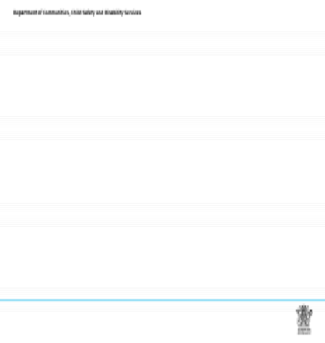
 | Slide 57 – 58  Reactive responses, Reasonable force, Prohibited practices Why is it not ok to use physical punishment?  “We have been reviewing the ways that carers/workers can respond to promote positive behaviours. It is important that the rights and dignity of the child or young person are respected.”  Ask participants to think about the sorts of punishment that might take away a child’s or young person’s rights, or might affect their personal freedom or dignity. Write responses on the whiteboard.  Examples should include:  corporal punishment  - depriving children of food or drink  - refusing or restricting contact with the child’s family  - intimate physical searches  - washing a child’s mouth out with soap  - locking a child in a room.  Ask the group how they think the community view physical punishment.  Acknowledge that many parents feel it is ok to smack a child to stop them acting in a certain way. It may immediately get a child or young person’s attention and is often seen as ok if it is done in the context of a close, loving relationship. Many parents were raised with physical punishment themselves, and we sometimes hear the view that “It didn’t do us any harm!” | Slide 57  Reactive responses  Reactive responses are defined as immediate responses where reasonable force is necessary to respond to a child or young person’s behaviour to ensure the safety of those involved while avoiding a potential escalation in the child or young person’s behaviour:  - Temporary restraint of a child or young person to prevent injury  - Removal of illegal or harmful objects  - Relocation of a child or young person to another area that provides safety  Reasonable force  Reasonable force is defined as the minimum force necessary to protect the child or young person, oneself and others from injury and harm. Where reasonable force is used, this must only be in conjunction with the use of a reactive response, and not a prohibited practice.  Slide Number: 57  Slide 58  Prohibited practices  Prohibited practices are responses to the behaviour of a child or young person which interfere with basic human rights. Unlawful and unethical practices are prohibited practices, as are practices which cause a high level of discomfort and trauma. The following is a non-exhaustive list of prohibited practices that are unlawful and not to be used by carers:  - Confinement  - Aversives (application of painful or noxious conditions)  - Mechanical Restraint  - Chemical Restraint  - Corporal Punishment  - Unethical Practices  Slide Number: 58
Why is it then not ok to use physical punishment with children in care?
“Section 122(2) Child Protection Act 1999 prohibits the use of corporal punishment or punishment that humiliates, frightens or threatens the child or young person in a way that is likely to cause emotional harm. This is a non- negotiable part of providing care to children and young people.”
Discuss each point on the handout - “Why is it not OK to use physical punishment with children in care?”

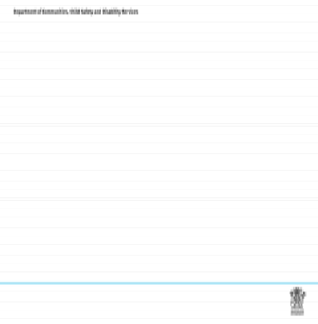
 | Slide 59  “This slide shows a continuum of responses that you can use to encourage positive behaviours. The more active you are in promoting positive behaviour, the less you may need to respond to behaviour that is out of control.”  This slide may also revisit the discussion on how teaching children and young people self-regulation benefits everyone.  Self-regulation: the person’s ability to alter their own behaviour. Self-regulation increases the degree that human behaviour is flexible and able to adapt, and involves the pursuit of many different goals, standards and ideals.  “The department may develop a behaviour support plan in the case plan, include specialist’s referrals and include the carer in strategies that de-escalate some behaviour and encourage positive behaviour.”  Refer to the back of the Practice Resource: Guide to supporting positive behaviour.  This shows how a plan can be established to modify challenging behaviours, and increase positive behaviours. | Slide 59  Range of responses to promote positive behaviours  - C h i l d as su m e s m o r e r e sp on sib i l i t y  P r o m o t i n g p o s i t iv e b e h a v io u r R e s p o n s e s f o c u s o n  r e la t i o n s h i p b u ild in g an d pr o m ot i n g s e l f  est eem  P r o m o t i n g s e l f c o n t r o l R e s p o n s e s u s e p la n n i n g an d pr epar at i o n t o av o id n e g a t i v e b e h a v i o u r s .  R e s p o n d i n g t o la c k o f c o n t r o l R e s p o n s e s u s e d ir e c t  i n t e r v ent i on t o deal w i t h b e h a v io u r s  - C ar e r ass u m e s m o r e r e sp on sib i l i t y .  Slide Number: 59
 | Slide 60  “Finally, a behaviour support plan alone is not sufficient for long-term change.  Any behaviour management approach loses its therapeutic value if used to merely control the child without supporting and understanding the child’s thoughts, feelings and goals for the behaviour. This is true for all behaviour management interventions such as logical consequences, giving choices, and negotiating. It is not necessarily the technique that makes an intervention therapeutic, it is more often the when, how, why and by whom the technique is employed that makes the difference ( Ziegler, 2005).” | Slide 60  And, finally..  A behavioural plan alone is not sufficient for long-term change.  After detecting the thoughts, feelings, people, places, and things that are triggers for the challenging behaviour, it is important to find ways to modify, decrease, or work through them so there will no longer be triggers for the child or young person’s behaviour.  Work towards making the problem behaviour  - irrelevant  - inefficient  - ineffective  Slide Number: 60
20 minutes  Slide 61 – 62 | Slide 61 – 62 Taking care of you and your family  “While we have focused on the feelings and needs of children and young people, it is still important to consider others who are affected by difficult behaviour. How do we accept and also offer support so that the whole household can continue positively after an incident of challenging behaviour?”  “Strategies to consider:  Talking things over afterwards  - Ways to overcome tensions.  - Making sure your family members are ok  - Managing stress” | Slide 61  Taking care of you and your family  - Working with traumatised children can take its toll on the most experienced carers. We may feel overwhelmed, hopeless, afraid or full of despair.  - It is difficult for us not to take children’s behaviour personally.  - We may become counter-aggressive or withdraw.  - Vicarious trauma (or secondary trauma) can have a profound effect on our mental and physical health and professional performance.  - We need to monitor our own levels of stress, maintain a healthy lifestyle, and use supervision to keep our professional perspective.  - It is important for us to work with our supervisors in order to keep a healthy perspective.  Slide Number: 61

Refer to Handout “Finding and providing support for yourself, your family, and the child or young Slide 62
person or ask participants to think of ways they may have resolved tensions in various relationships in
the past Activity for Self-Care
Activity Planning ahead: Write down/discuss in your group how you are going
to respond to your own needs:

- Who do you go to for support?
Ask participants to work in groups of 3 to discuss the ways they individually manage stress. Allow 10 • What strategies have helped overcome tension in relationships?
minutes and then report back to the larger group. • How do you make sure your family members are OK?
- What strategies help in managing stress?

Slide Number: 62
“Some calming strategies for children and young people:

Long walks
- Dancing
- Trampoline;
- Bat/ball games – totem tennis, basketball, cricket
- Play dough for younger children”
“Some calming strategies for adults:
- Physical activity - gardening, household chores, long walks
- Going to the gym
- Writing down your thoughts
- Going somewhere quiet where you can be alone
- Lying on the floor and doing breathing exercises
- Listen to soothing music.”
Stress management techniques (Refer to Handout “Managing stress.”)
Good diet - Avoid excessive use of caffeine because it is a stimulant. Drink plenty of water as headaches are often caused by dehydration and stress. Avoid refined sugar. Eat slow release foods like potatoes, cereals, and fresh vegetables
Avoid unhelpful thinking - The things we say to ourselves will affect the way we feel. For example if we constantly put ourselves down this will have a negative impact on the way we function.
Ask the group for examples of how we “punish ourselves”. How could these examples be framed in a way that is more positive about ourselves?

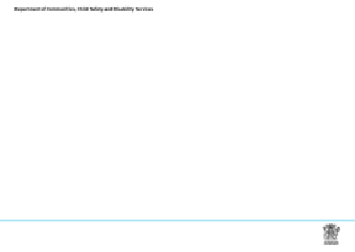

Watch out for being negative

“If something does go wrong – don’t dwell on it but think of the times when you have done a good job.

Re-frame things in a positive light. Two people may have the same stressful event and it will have a different impact on them because of the things they tell themselves about that event. One may assume blame for what has happened, ask why this is always happening to them, imagine the worst. Another person may tell themselves that this is a difficult thing but they have done the best they can, remember the way they handled something else positively, and move on to make the best of things. Remember that perfection is impossible. Are you expecting too much?”

Make sure you get enough sleep –

“Use relaxation techniques if you have trouble sleeping. You can learn these in a group or purchase or borrow some mediation exercises. Use visualisation exercises.

Access support networks themselves – friends, social groups, FAST delegates, professionals.”

Explain that in the Standard Training - Module 7 “Support, Advocacy and Self Care” stress management strategies will be discussed in more detail.
Working in a team –
“You are not expected to cope with difficult behaviours by yourself.
Carers/workers should use their support network and remember that they are part of a team that includes the child or young person and their family, an non government agency support worker, a Child Safety Officer, and other departmental staff and your employer/organisation, where relevant.
This team is constantly reassessing a child or young person’s changing needs. The care environment should respect the dignity and rights of children, young people and their families, and create an environment where their views and wishes are actively sought.
As a team member, you should actively contribute to those team processes and also seek support in a pro-active way from the team. Remember teams are about respect and each member must actively contribute to the team.
The department/your employer/organisation has a responsibility to support and train carers/workers so they provide care to children and young people in accordance with legislated standards.
Carers/workers have a responsibility to seek out training and support from the team. “

10 minutes  Slides 63 – 64 | Slide 63 Slide 63  Slide 63 “Learning Outcomes”  Module 5: Promoting positive behaviours  Explain that this module has explored some of the reasons why children and young people behave in  Learning Outcomes  different ways, and the way we all respond differently because of our own values and experiences. At the end of this module participants are able to:  - Understand that there may be a range of reasons that contribute to  “We have looked at a range of strategies to build a child or young person’s self esteem, and encourage various behaviours, e.g.  - Trauma and attachment issues  them to learn self control. We have also looked at ways to respond in situations where a child or young – Developmental issues (including social, emotional and learning)  - Behavioural reasons  person loses self control. • Understand that a caring approach includes a range of strategies to  promote positive behaviours.  - Accept the importance of carers managing stress for themselves,  Finally we have discussed different ways carers and workers can support each other while promoting their families, and the child or young person.  positive behaviours.”  Slide Number: 63  Slide 64 Where to from here? Slide 64  “This slide illustrates other pathways of training and courses available for people working with children Where to from here?  in out of home care.” Other training opportunities that may be available to you:  - Remaining modules (6 and 7) of the Quality Care Standard Training  - Advanced Training (flexible learning) e.g.:  - Attachment  - Whose problem is this?  - Seen but not heard: children who live with domestic and family violence  - Foster Parent College  - Therapeutic Crisis Intervention (TCI)  - Transforming Care  - RAP – Response Ability Pathways  Slide Number: 64  Slide 65  Slide 65 (if required) shows Reference List  Hand out Evaluation form. References  Bernard, M. E. (2006) It’s time we teach social-emotional competence as well as we teach academic competence. Reading & Writing Quarterly, 2, 103-119.  “Please complete “Worksheet Questions” for assessment purposes, and return to the trainers within 1 Bronfenbrenner, U. (1979) The Ecology of Human Development: Experiments by Nature and Design.  Cambridge, MA: Harvard University Press.  Erikson, E.H (1959) Identity and the Life Cycle. New York: International Universities Press.  week. Should there be any discussion arising from your responses, there will be an opportunity to meet Glisson, C., Dukes, D., & Green, P. (2006) The effects of the ARC organizational intervention on  caseworker turnover, climate and culture in children’s service systems. Child Abuse & Neglect: An  International Journal, 30 (8), 845-960.  with trainers for review purposes.” Holden, M. J. (2009). Children and residential experiences: Creating conditions for change. Arlington,  VA: CWLA Press.  Markie-Dadds, C., Turner, K., & Sanders M. (2009). Every Parent’s Group Workbook. The University of Queensland and Health Department of Western Australia.  Perry, B., & Pollard, R. (1998) Homeostasis, stress, trauma and adaptation: A neuro-developmental view of childhood trauma. Child and Adolescent Psychiatric Clinics of North America, 7, 33-51.  Riffel, L. (2011). Writing Behavioral Intervention Plans (BIP) based on Functional Behavior Assessments (FBA): Making Data Based Decisions to Change Behavior In Residential Settings www.behaviordoctor.org  Van der Kolk, B. (2005) Developmental Trauma Disorder. Psychiatric Annals, 401-408.  Ziegler, D. (2005) Achieving Success with Impossible Children, How to win the battle of wills. Gilbert, AZ: Acacia Publishing  Slide Number: 65
2:30pm | FINISH Thank You

