Human Services Quality Standards

Easy Read version

How to use this booklet
This information is written in an easy to read way. We use pictures to explain some ideas.
This Easy Read booklet is a summary of another document.
You can find the full document on our website at www.communities.qld.gov.au/hsqf
You can ask for help to read this document. A friend, family member or support person may be able to help you.
If you need an interpreter or translator, please call 131 450.
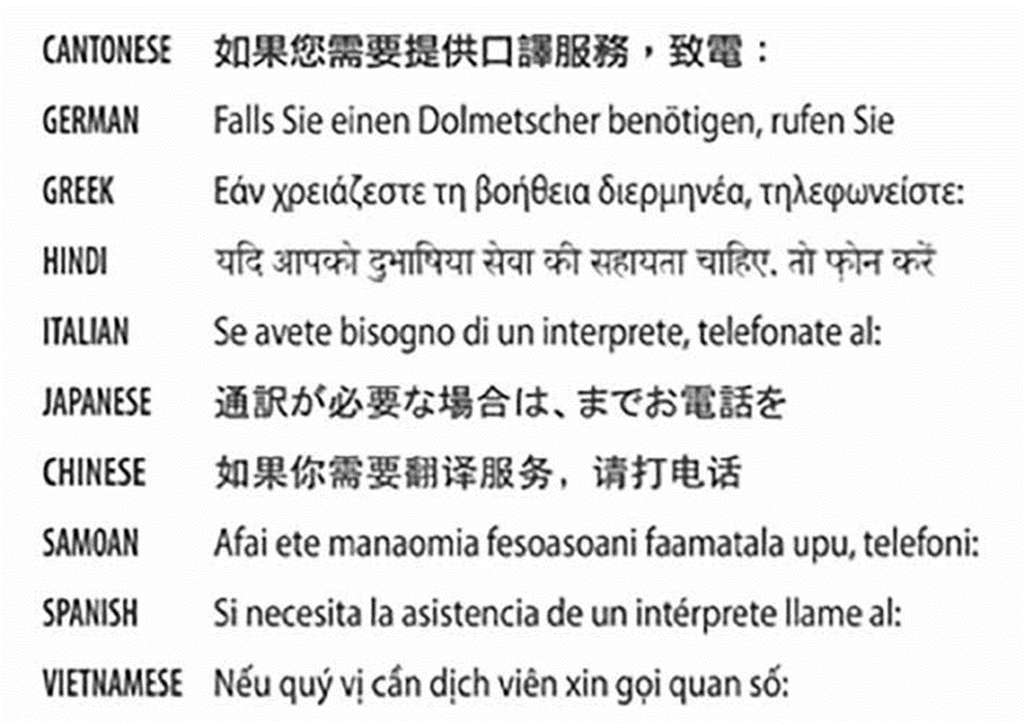

What is in this booklet?
- Who is this booklet for?
- What are the standards?
- Standard 1 Governance and management
- Standard 2 Service access
- Standard 3 Responding to individual need
- Standard 4 Safety, wellbeing and rights
- Standard 5 Feedback, complaints and appeals
- Standard 6 Human resources
- Where to get more information

Who is this booklet for?
The Queensland Government funds organisations to provide services to individuals, families and communities.
These services include:
- Support services for children and young people
- family support services
- counselling and referral services
- community supports such as neighbourhood centres
- mental health services.
This booklet is for anyone who uses any of these services.

What are the standards?
The Queensland Government wants to make sure that the services you receive are good quality.
To help make this happen, we have created the Human Services Quality Standards. These standards are like rules that service providers need to follow.
The standards are:
- Standard 1 Governance and management
- Standard 2 Service access
- Standard 3 Responding to individual need
- Standard 4 Safety, wellbeing and rights
- Standard 5 Feedback, complaints and appeals
- Standard 6 Human resources
This booklet explains more about each of the standards and what they mean for you.
Each of the standards is based on some important ideas.
These ideas are:
- human rights — everyone has the right to be treated fairly
- social inclusion — everyone has the right to be included in their community
- participation — everyone has the right to take part in making decisions about their life
- choice — everyone has the right to make choices about the services they receive.
Many of our ideas are based on the United Nations Universal Declaration of Human Rights and Queensland’s Human Rights Act. These documents explain how people must be treated fairly. The declaration is used in many countries around the world.

Standard 1 – Governance and management
Governance is how an organisation works. All service providers should have governance systems in place.
The services you receive should be well managed. Strong management leads to good services.
When you use a service, the provider should:
- have good management systems
- obey all the laws and rules that apply
- have good staff, including managers and leaders, who are experienced, skilled and supported to do their work
- keep good records of the work they do
- keep information about you safe and private
- always be looking for ways to improve how they work
- encourage people to have a say about the way that the organisation is managed
- have good ideas and plans for the future.

Standard 2 – Service access
Service providers should be fair and honest about who can use their service.
Decisions about whether or not you can use a service should be based on the kinds of services and staff available.
Sometimes there may not be enough of the right kind of services for everyone who needs them.
If you cannot use a service, you have the right to know why.
When you want to use a service, the provider should:
- have a good system in place to work out who can use their service
- work with you and find out what you need, including whether you need help because you speak another language, use a wheelchair or use sign language
- tell you if you cannot use the service, and explain why
- tell you about other services that may be able to help you if necessary.

Standard 3 Responding to individual need
The services you use should meet your needs.
You should have a say about the services you use.
For some services, other people such as your family members or carers may be able to have a say about the services if you want them to.

When you use a service, the provider should:
- respect everything about you, including:
  - your age
  - whether you are male or female
  - your cultural background
  - your religion
- get to know you and what you want to do with your life
- make a plan about what is important to you
- make sure that the services are working well for you
- include you in making decisions about the services you receive
- help you to reach your goals
- work with other services in your community if that is what you need.

Standard 4 Safety, wellbeing and rights
You have the right to be safe and treated well.
When you use a service, the provider needs to:
- do everything they can to keep you safe
- listen to you and respect your rights
- support you to make choices and decisions about what is important to you
- help you to speak up if there is a problem — this may include using an advocate, who is a person or an organisation who can speak up for you
- follow the law
- take action if they think someone is being harmed or may be harmed — this includes reporting harm and other serious matters to the police or the Queensland Government.

Standard 5 Feedback, complaints and appeals
You have the right to tell people what you think about the services you receive.
Every organisation should have a complaints and feedback process.
For some services, other people such as your family members or carers may be able to have a say about the services if you want them to.
When you use a service, the provider should:
- let you know what to do if you have a problem or complaint
- listen to you and act on your concerns
- help you if you want to tell another organisation about your problem or complaint
- let you know how you can provide feedback
- tell you how feedback helps to make their service better over time.

Standard 6 Human resources
Human resources are the people who work for an organisation. This includes staff, volunteers and contractors.
When you use a service, the provider should:
- have good systems for employing their staff and volunteers
- have good systems for contracting other organisations to provide services if they have to
- listen to their staff and have good systems to manage problems in the workplace
- make sure staff are well trained and know what to do
- have good ways to help their staff do their jobs well
- follow all the laws that apply — this may include laws about health and safety in the workplace, employment conditions and police checks for staff and volunteers.

Where to get more information
1800 034 022 (freecall)
SMS:0423 677 767
TTY: 133 677
Speak and listen: 1300 555 727
Internet relay: https://internet-relay.nrscall.gov.au
Video relay: relayservice.gov.au
hsqf@communities.qld.gov.au
www.communities.qld.gov.au/hsqf

This Easy English document was created by the Information Access Group using PhotoSymbols, stock photography and custom images, and images provided by the Queensland Government. The images may not be reused without permission. For any enquiries about the images, please visit www.informationaccessgroup.com
Images used are for illustrative purposes only. Images/Thinkstock/Getty Images and Department of Communities, Disability Services and Seniors.

