Family Support Services and the National Disability Insurance Scheme (NDIS)
General information for FaCC and IFS service providers

About the NDIS
The NDIS funds reasonable and necessary support to help children with disability or developmental delay reach their goals in a range of areas.
The NDIS helps eligible children and their families access services and support in their communities and can provide funding for disability supports like early childhood intervention therapies, wheelchairs or communication devices.
Parents with disability may receive reasonable and necessary support from the NDIS that will increase their capacity to care for their children and young people.

Access to the NDIS for children aged 0-9
Access to the NDIS for children aged 0-9 years is through the Early Childhood Approach (ECA) pathway which is delivered through an Early Childhood Partner.
Access to this pathway does not require a diagnosis. The Early Childhood partner is contacted directly where a child has or may have developmental delay or disability.
The Early Childhood Partner may:
- help the family request NDIS access and develop their NDIS plan if longer-term support is needed
- provide short-term early intervention therapy support
- provide information about mainstream supports and services for a child and their family
- make connections for the child with relevant services in their area like their community health centre or local playgroup
- coordinate a combination of these.

Access to the NDIS for children aged 9+ and adults
NDIS Local Area Coordinator Partners support children aged 9+, young people and adults to access the NDIS.
In general, accessing the NDIS involves:
- gathering eligibility evidence and completing an Access Request form
- working with an NDIA planner or Local Area Coordinator to develop a Participant Plan.

NDIS plans and support
NDIS plans are developed through a face-to-face meeting with an NDIS Planner or Local Area Coordinator. NDIS plans include reasonable and necessary supports that are specific to a person’s disability or developmental delay and can help them reach their goals.
These supports may include:
- therapy and behaviour support
- aids, equipment and consumables
- skill-building supports
- supports to help gain independence and enable sustainable caring arrangements
- home modifications and transport
- disability-related training for parents/carers

Support coordination
Support Coordinators are registered NDIS service providers who can support parents to understand and implement the funded supports in their child’s plan and link them to community, mainstream and other government services.
Support coordination may be requested during development of an NDIS plan. Families eligible for IFS support will likely require support coordination to maximise the benefits of an NDIS plan.

Managing a plan
There are three options for a family to manage their child’s NDIS funding:
- self-managed where a family takes on all the responsibility of managing the funding in the plan
- plan-managed when a provider supports a family to manage funding
- NDIA-managed where NDIA pays providers on a participant’s behalf.
Families involved with IFS services who need assistance to manage a plan will need to request plan management at the planning meeting.

How FaCC & IFS can help
Family and Child Connect (FaCC) and Intensive Family Support (IFS) services can support families by helping them navigate the NDIS process. This may include:

NDIS Access
- Supporting a family to connect with an Early Childhood Partner for children aged 0-9
- Supporting a family to connect with NDIS Local Area Coordinator, an NDIS Remote Community Connector (for Aboriginal and Torres Strait Islander families in remote locations) or NDIS office about access for a child aged 9+, young person or an adult with a disability.

NDIS Planning
- Helping a family to consider their child or young person’s disability and support needs ahead of their NDIS planning meeting, including the reasons for requesting support coordination.

Once the person has an NDIS plan
- Supporting a family to remain connected with their NDIS Local Area Coordinator.

Where there has been a change in circumstance, or the family is in crisis
- Helping a family connect with a Local Area Coordinator or their Support Coordinator to rearrange the supports within their plan to respond to their immediate needs
- Supporting a family to make a request to the NDIS for a plan review or review of a decision if required.

Disability advocates
National Disability Advocacy Program agencies can assist with issues that may arise with the NDIS or with service providers, for example, reviews of NDIS decisions or complaints about service delivery. FACC and IFS services can support families to connect with an advocate.

Contacts
National Disability Insurance Scheme:
1800 800 110 or www.ndis.gov.au

Early Childhood Partners
Local Area Coordinator Partners
National Disability Advocacy Program
Early Childhood Partners
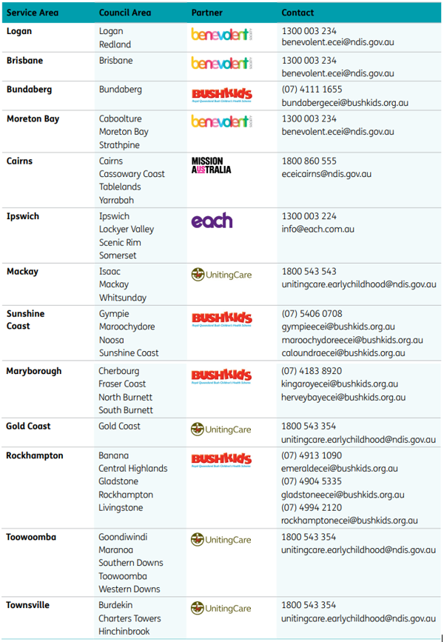
Local Area Coordinators
